
R I T
Acceptance Test
Plan

for

InserterVision Report System, Release 1.0
Revision 1.1
by VDK-RIT
05/12/2004
Revision History

Name | Date |  | Reason For Changes |  | Version
Mike Young  Adam Beck |  | 02/13/04 |  | Initial draft |  | Draft 1
Mike Young |  | 03/03/04 |  | More initial work |  | Draft 2
Mike Young  Adam Beck |  | 03/10/04 |  | Add schedule and refine |  | Draft 3
Mike Young |  | 03/15/04 |  | Add test cases |  | Draft 4
Mike Young  Adam Beck |  | 03/16/04 |  | Add more test cases and refine |  | Draft 5
Mike Young |  | 03/18/04 |  | Finish draft |  | Draft 6
Adam Beck |  | 03/19/04 |  | Few corrections to content and formatting |  | Draft 7
Mike Young |  | 03/22/04 |  | Changes from review on 03/21/04 |  | Draft 8
Mike Young |  | 05/12/04 |  | Changes from implamentation |  | Revision 1.1

Table of Contents
1. Project/System Information 3
1.1 Project Objectives 3
1.2 System Description 3
1.3 References 3
1.4 Outstanding Issues 3
1.5 Roles and Responsibilities 4
2. Test Plan 4
2.1 Scope 4
2.2 Testing Approach 4
2.2.1 Types of Testing 4
2.2.2 Level of Testing 4
2.2.3 Test Methods, Tools, and Procedures 4
2.2.4 Source of Test Data 4
2.3 Test Schedule 5
2.4 Defect Reporting and Data Recording 5
2.4.1 Defect Reporting Process 5
2.4.2 Recording Defects 5
2.4.3 Tracking Defects 5
2.4.4 Recording Test Results 5
2.5 Resource Requirements 6
2.5.1 Hardware Requirements 6
2.5.2 Software Requirements 6
2.5.3 Documentation Requirements 6
2.5.4 Test Data Requirements 6
2.5.5 Other Requirements 6
2.6 Test Environment 6
2.7 Identification of Tests 6
2.8 Acceptance Release Report 7
2.9 Corrective Action 7
3. Test Cases 7
3.1 Test Case Template 7
3.2 Test Cases 8

Project/System Information

Project Objectives
The system designed by VDK-RIT will be implemented as a functional proof-of-concept and be turned over to Videk for deployment and further development.

System Description
In the printing and mailing industry there is a need for mailers to determine if they have processed a mailing job correctly. A typical mailing facility has a number of inserters. An inserter is a machine, which takes a number of sheets (for instance credit card statements), folds the sheets, inserts the sheets into an envelope and then outputs the closed envelope (also called mail piece). It is important for the mailer to know that all mail pieces have been processed for a mailing job. A job is all the mailings done on one machine in one session. Performing manual checks on the individual pieces of a mailing job is impossible, as there are typically between 1,000 and 90,000 mail pieces in one job.
Videk, a company headquartered in Rochester, NY, delivers high-speed, real-time vision systems to the leaders in digital print and mail automation. One such system offered by Videk is InserterVision. To automate the verification of mailing jobs mailers use InserterVision.
Using InserterVision (IV), a mailer can verify that an address-bearing mail piece was correctly inserted, i.e. the address is viewable through a window envelope. First, the InserterVision system captures an image of each envelope as it exits the inserter. Next, IV analyzes the image to verify that the information needed to deliver the mail piece is visible. When the information on a mail piece cannot be read, InserterVision sends a signal that is used to mark the mail piece, divert it, or halt the line so that an operator can intervene.
Currently, scanned images collected by InserterVision during a job are not saved. Additionally, InserterVision provides no means of collecting data on jobs.
Videk’s sales department has recognized the need for such functionality and has requested a system that would save relevant scanned data to facilitate the creation of job reports. The ability to save data collected by the InserterVision and generate reports from this data would allow the end user to improve traceability of mail pieces that go through the system and analyze the quality and rate of production for the insertion process through statistics.

References
This document will reference:
- VDK-RIT Software Requirements Specification Revision 2.0
- VDK-RIT Use Case 1.0 document.
- Acceptance Release Report
- Defect Report

Outstanding Issues
None known.

Roles and Responsibilities
For this project the Test Manager will be responsible for the Acceptance Test Plan. The Testing Manager must also update the Testing Plan when there are changes made to the Acceptance Test Plan. The other team members will be executing the tests and the Test Manager will be supervising these efforts and coordinating the testing. The Quality Manager will be responsible for making sure that all defects detected are properly recorded and fixed. The team’s Development Manager will be working with the Test Manager to ensure that the team is meeting its acceptance goals during the Implementation Phase. The customer representative will be responsible for viewing and signing off on the Acceptance Test.

Test Plan

Scope
The Acceptance Test will touch on most of the use cases. Multiple data sets will be used in this test. Selection of multiple data sets in a single report will also be tested (UC-3). All sorts will be done with only a Primary Key and Secondary Key (UC-4). The only Logging Criteria tested will be logging of DBMS changes (UC-14). Creation of Templates (UC-15, UC-16, UC-17) and Modification of Templates (UC-18, UC-19, UC-20) will be tested.

Testing Approach

Types of Testing
All acceptance testing shall be functional testing. All tests will be Test to Pass.

Level of Testing
The level of testing for acceptance tests shall be at the System level.

Test Methods, Tools, and Procedures
Tests are to be run sequentially starting at Test Group Identifier 1. Any defects found will be recorded in a Defect Report. Testing will stop while defects are recorded and continue after the defect report has been written. Testing will only completely stopped if the project sponsor decides a defect is too severe to approve the Acceptance Test. No testing tools will be used during this test.

Source of Test Data
All test data sets shall be given to the team by Videk.

Test Schedule
Week 18: (4/24/04-5/1/04) Set up and test environment (2 staff-hours)
Week 19: (Monday 5/3/04) Email the customer representative to verify the Acceptance Test time
(XXXday x/x/04 00:00XM) Check Setup
(XXXday x/x/04 00:00XM) Customer representative arrival time
(XXXday x/x/04 00:00XM) Begin Acceptance Test
(XXXday x/x/04 00:00XM) Results Discussion
(XXXday x/x/04 00:00XM) Sign off
(Duration is a best guess based on previous run of tests)

Defect Reporting and Data Recording

Defect Reporting Process
When the tester finds a defect, testing will be stopped so the defect can be recorded in a Defect Report by the tester. After the Defect Report has been completed the testing will continue. However, the project sponsor may choose to stop the testing at any time if the sponsor decides the Acceptance Test has failed.

Recording Defects
The Defect Report will contain:
- Date the defect was found
- Test case that uncovered the defect
- Step in the test instructions the defect was found
- Description of the defect
- Priority and severity of the defect

The Test Manager will work with the tester to determine the severity of the bug according to the criteria set forth in the Test Plan. The Team Leader will work with the tester to determine the priority of the bug.

Tracking Defects
Each Defect Report will be given to the Quality Manager who will add the defect to the Defect Report System.

Recording Test Results
At the completion of each test case, the results will be recorded by the tester. At the completion of the tests, these reports will be compiled by the Test Manager into the Acceptance Release Report. A copy of this will be provided to the customer representative.

Resource Requirements

Hardware Requirements
The team will require at three PCs (a server and two clients) and an intranet connecting them.

Software Requirements
The server must be running Windows NT5, Apache2 Webserver with PHP4 support, and have a MySQL 4 database installed. The client PC must be running one of the following Web browsers: Microsoft Internet Explorer versions 5.0 and 6.0, and Netscape versions 6.1 - 7.

Documentation Requirements
The Acceptance Test Plan, Acceptance Release Report, and Defect Report form will be available during the Acceptance Testing.

Test Data Requirements
Test data sets will be given to the team by Videk prior to the start of testing. They will consist of at least three test sets. These test sets will conform to the schema shown in the SDS.

Other Requirements
The team will require a room for themselves and their sponsor to conduct the tests. The Test Manager and Quality Manager must be present as well as another team member to perform the tests. The customer representative will also be present.

Test Environment
The test environment shall be set up at least a week in advance of the Acceptance Test by the Testing Manager and Team Leader. The environment shall consist of one PC running as a server and the other as a client making requests on the system. The status of the test environment will be confirmed prior to the test on the day of the Acceptance Test.

Identification of Tests
Identifier | Test name | Objective
1.1 | Logs on to System | To access the information in the system.
2.1 | Logs off the System | To leave the system and return restrictions to access.
3.1, 3.5 | Chooses a Data Set | To display the data sets of the User's choice.
3.3 | Chooses a Sort | To select the Sort criteria.
3.2 | Chooses a Template | To display the data set of the User's choice.
3.4 | Prints Report | To print a copy of the report without navigational controls.
4.3 | Deletes a Data Set | To remove the Data Set from storage.
4.1 | Exports Data Set | To export the Data Set to the file system.
4.2 | Imports Data Set | To import the Data Set from the file system and return it to the DBMS for use.
5.1 | Create New User Account | To create a new User account.
5.2 | Modify a User Account | To modify an existing User account.
5.3 | Delete a User Account | To delete an existing User account.
6.1 | Configure Logging | To set the actions to be logged if any.
7.1 | Create Standard Template | To create a new template for reports.
7.2 | Create Advanced Template | To create a new template for reports.
7.3 | Create Combined Template | To create a new template for reports.
8.4 | Delete Template | To delete an existing template.
8.1 | Modify Standard Template | To modify a template.
8.2 | Modify Advanced Template | To modify a template.
8.3 | Modify Combined Template | To modify a template.
9.1 | Display System Help | To display the User help pages

Acceptance Release Report

The VDK Acceptance Release Report will contain a summary of the results of the Acceptance Test.

Corrective Action

All defects found during the Acceptance Test will be documented and fixed regardless of time constraints. If the sponsor will not sign off on the Acceptance Test, a new date and time will be chosen to rerun the test.

Test Cases

Test Case Template

[Test Group Identifier] [Test Group Name] | Requirements Tested: [Identifier(s) for requirements covered by this test case]
[Test Group Identifier].[Test Identifier] [Test Name]
Preconditions: [System state at start of test]
Instructions: [Step-by-step]
Acceptance Criteria: [Visible criteria that determines success/failure of the test case]
Special Notes: [Anything special to note about this test case i.e. related/dependent test cases]

Test Cases

1 User Logs on to System | Requirements Tested: 3.1.1
1.1 User Login
Preconditions: User is presently not logged onto the system. The user is at the login page for the system.
Instructions:
- Enter a valid Username in the appropriate text box
- Enter the correct Password for this Username in the appropriate text box
- Select the “Login” button
Acceptance Criteria:
1. The user is taken to the List Data Sets page.
Special Notes:

2 User Logs out of System | Requirements Tested: 3.1.2
2.1 User Logout
Preconditions: The user is logged into the system. The user is at the main page.
Instructions:
- Select the “Logout”
- Select “Ok” in the confirmation window
Acceptance Criteria:
1. The user is brought to the Login page
Special Notes:

3 User views a Report | Requirements Tested: 3.1.3
3.1 User Selects a Single Data Set
Preconditions: A valid user is logged onto the system. The user is on the List Data Sets page. The system has Data Set 1 available for viewing.
Instructions:
- Select Data Set 1
- Select the “Save & Display” button
Acceptance Criteria:
1. Data Set 1 is displayed.
2. The data set is formatted according to the default Template.
Special Notes: Related Cases – 3.2, 3.3, 3.4

3 User views a Report | Requirements Tested: 3.1.4
3.2 User Selects a Template
Preconditions: A valid user is logged onto the system. The user is on the List Templates page. The system has Test Template1 available. The user has selected Data Set 1.
Instructions:
- Select Test Template1 from the list of Templates
- Select the “Save & Display” button
Acceptance Criteria:
1. Data Set 1 is displayed formatted according to Test Template1.
Special Notes: Related Cases – 3.1, 3.3, 3.4

3 User views a Report | Requirements Tested: 3.2.3
3.3 User Prints Report
Preconditions: A valid user is logged into the system. The user is on the Report page. The user has Data Set 1 selected. The user has Test Template1 selected.
Instructions:
- Select “Printer Friendly Version”
- Select the “Print” option on the browser
- Select “Ok” to print the report
Acceptance Criteria:
1. The report is printed without the navigational controls showing.
Special Notes: Related Cases – 3.1, 3.2, 3.3

3 User views a Report | Requirements Tested: 3.1.3
3.4 User Selects Multiple Data Sets
Preconditions: A valid user is logged into the system. The user is on the List Data Set page. The user has Data Set 1 selected. The user has Test Template1 set.
Instructions:
- Select Data Set 1 and Data Set 2
- Select the “Save & Display” button
Acceptance Criteria:
1. The report is displayed with Data Set 1 and Data Set 2 formatted according to the Test Template 1.
Special Notes: Related Cases – 3.1, 3.2, 3.3

4 Data Set Management | Requirements Tested: 3.2.2
4.1 User Exports a Data Set
Preconditions: A valid user, with Manager Level Permissions, is logged into the system. The user is on the List Data Set page.
Instructions:
- Select the “Export” button on the Data Set 2 row
- Name the file “Test Data Set2” and place it in the “My Documents” folder
- Select “Ok” in the file pane
Acceptance Criteria:
1. The file named “Test Data Set2” should be in the “My Documents” folder of the local file system.
Special Notes: Related Cases – 4.2

4 Data Set Management | Requirements Tested: 3.2.1
4.2 User Imports a Data Set
Preconditions: A valid user, with Manager Level Permissions, is logged into the system. The user is on the List Data Set page.
Instructions:
- Select the “Import Data Set” button
- Select the file “Test Data Set2” from the “My Documents” folder in the file pane
- Select “Ok” in the file pane
- Navigate to the Data Set Selection page
Acceptance Criteria:
1. Data Set 2 is one of the Data Sets listed as an available Data Set.
Special Notes: Related Cases – 4.1

4 Data Set Management | Requirements Tested: 3.2.3
4.3 User deletes a Data Set
Preconditions: A valid user, with Manager Level Permissions, is logged into the system. The user is on the List Data Set page.
Instructions:
- Select the “Delete” button on the row of Data Set 4
- Select “Confirm” on the verification window
Acceptance Criteria:
1. Data Set 4 is no longer in the list of Data Sets.
Special Notes:

5 User Account Management | Requirements Tested: 3.3.1
5.1 Create a User Account
Preconditions: A valid user, with System Administrator Level Permissions, is logged into the system. The user is on the Admin page.
Instructions:
- Select “Create New User”
- Enter a new User ID, User Name, and Password.
- Set Permission Level to “None” and Access Level to “USER”
- Select “Save Account” button
- Logout of the system
- Log back into the system using the new Username and Password
Acceptance Criteria:
1. The List Data Set page is displayed.
2. The available controls are Standard User controls only.
Special Notes: Username used in this case shall not already be a Username in the system.
Related Cases – 1.1, 2.1, 5.2, 5.3

5 User Account Management | Requirements Tested: 3.3.2
5.2 Modify a User Account
Preconditions: A valid user, with System Administrator Level Permissions, is logged into the system. The user is on the Admin page.
Instructions:
- Select edit icon on the row of the user User from Test Case 5.1
- Give User Template Permission
- Select “Ok”
- Logout of the system
- Log back into the system using the Username and Password from 5.1
- Select “Templates” from the menu bar
- Select “Standard Template” from dropdown list
- Select “Create Template” button
Acceptance Criteria:
1. The Create Standard Template page is displayed.
Special Notes: Related Cases – 1.1, 2.1, 5.1, 5.3

5 User Account Management | Requirements Tested: 3.3.3
5.3 Delete a User Account
Preconditions: A valid user, with System Administrator Level Permissions, is logged into the system. The user is on the Admin page.
Instructions:
- Select delete icon on the row of the User from Test Case 5.1
- Select “Ok” in the confirmation window
Acceptance Criteria:
1. The User from Test Case 5.1 is no longer in the list of users on the Admin page.
Special Notes: Related Cases – 5.1, 5.2

6 Configure Logging | Requirements Tested: 3.3.5
6.1 Set Logging Level
Preconditions: A valid user, with System Administrator Level Permissions, is logged into the system. The user is on the Admin page.
Instructions:
- Select “Access Data Sets” criteria only in the System Logging Criteria section
- Unselect all other Logging criteria
- Select “Save Log Settings” to confirm
- Select “Data Sets” button from the menu bar
- Select Data Set 3
- Select the “Save & Display”
Acceptance Criteria:
1. The logfile has recorded in it that Data Set 3 has been viewed.
Special Notes: Related Cases – 5.1

7 Template Management | Requirements Tested: 3.4.1
7.1 Create Standard Template
Preconditions: A valid user, with Template Permissions, is logged into the system. The user is on the List Template page. The user has selected Data Set1.
Instructions:
- Select “Standard Template”
- Create template specified in Appendix A as Test Template2a
- Select “Save Template” when finished
- Select Test Template 2a from the Template list
- Select the “Save & Display” button
Acceptance Criteria:
1. Data Set 1 is displayed formatted according to Test Template2a.
Special Notes: Related Cases – 3.2

7 Template Management | Requirements Tested: 3.4.2
7.2 Create Advanced Template
Preconditions: A valid user, with Template Permissions, is logged into the system. The user is on the Template Management page. The user has selected Test Data Set1.
Instructions:
- Select “Create Advanced Template”
- Create template specified in Appendix A as Test Template3a
- Select “Save Template” when finished
- Name the file “Test Template 3”
- Select the “Ok”
- Navigate to the Template Selection page
- Select Test Template3 from the Template list
- Navigate to the Report page
Acceptance Criteria:
1. The data is formatted according to Test Template3a.
Special Notes: Related Cases – 3.2

7 Template Management | Requirements Tested: 3.4.3
7.3 Create Combined Template
Preconditions: A valid user, with Template Permissions, is logged into the system. The user is on the Template Management page. The user has selected Data Set. Test Template2 and Test Template3 have been created successfully.
Instructions:
- Select “Create Combined Template”
- Create template specified in Appendix A as Test Template4a
- Select “Save Template” when finished
- Name the file “Test Template4”
- Select the “Ok” button
- Navigate to the Template Selection page
- Select Test Template4 from the Template list
- Navigate to the Report page
Acceptance Criteria:
1. The data is formatted according to Test Template4a.
Special Notes: Related Cases – 3.2, 7.1, 7.2

8 Template Modification | Requirements Tested: 3.4.4
8.1 Modify Standard Template
Preconditions: A valid user, with Template Permissions, is logged into the system. The user is on the List Templates page. Test Template 2a has been created successfully.
Instructions:
- Select the edit icon on the row of Test Template 2a
- Modify template as specified in Appendix A as Test Template 2b
- Select “Save Template” when finished
- Select Test Template 2b from the Template list
- Select the “Save & Display” button
Acceptance Criteria:
1. The data is formatted according to Test Template2b.
Special Notes: Related Cases – 3.2, 7.1

8 Template Modification | Requirements Tested: 3.4.5
8.2 Modify Advanced Template
Preconditions: A valid user, with Template Permissions, is logged into the system. The user is on the List Templates page. Test Template 3a has been created successfully.
Instructions:
- Select the edit icon on the row of Test Template 3a
- Modify template as specified in Appendix A as Test Template 3b
- Select “Save Template” when finished
- Select Test Template 3b from the Template list
- Select the “Save & Display” button
Acceptance Criteria:
1. The data is formatted according to Test Template 3b.
Special Notes: Related Cases – 3.2, 7.2

8 Template Modification | Requirements Tested: 3.4.6
8.3 Modify Combined Template
Preconditions: A valid user, with Template Permissions, is logged into the system. The user is on the List Templates page. Test Template 4a has been created successfully.
Instructions:
- Select the edit icon on the row of Test Template 4a
- Modify template as specified in Appendix A as Test Template 4b
- Select “Save Template” when finished
- Select Test Template 4b from the Template list
- Select the “Save & Display” button
Acceptance Criteria:
1. The data is formatted according to Test Template 4b.
Special Notes: Related Cases – 3.2, 7.3

8 Template Modification | Requirements Tested: 3.4.7
8.4 Delete a Template
Preconditions: A valid user, with Template Permissions, is logged into the system. The user is on the Template Management page. Test Template 4b has been created successfully.
Instructions:
- Select delete icon on the row of “Test Template 4b” from the list of templates
- Select “Ok” in the verification window
Acceptance Criteria:
1. Test Template 4 is no longer available on the list of templates
Special Notes: Related Cases – 7.3

9 Set Report Header | Requirements Tested:
9.1 Set Report Header
Preconditions: A valid user, with System Administrator Level Permissions, is logged into the system. The user is on the Admin page.
Instructions:
- Select “Company Header” button
- Fill in fields as specified in Appendix A as Test Header 1
- Select “Save Header” when finished
- Select “Data Sets” from the menu bar
- Select any of the available data sets
- Select the “Save & Display” button
- Select “Printer Friendly Version”
Acceptance Criteria:
1. A report is displayed with the header on the top of the page.
Special Notes:

10 Display System Help | Requirements Tested: 5.4 Usability-1
10.1 Display System Help
Preconditions: A valid user is logged into the system. The user is on the main page.
Instructions:
- Select “Help” button from the
Acceptance Criteria:
1. A system help page is displayed.
Special Notes:

Appendix B: Test Templates
Test Template 2a
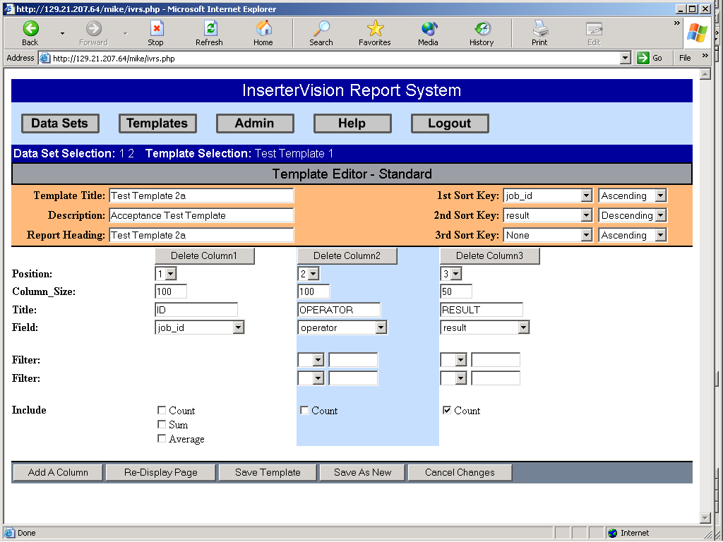

Test Template 2b
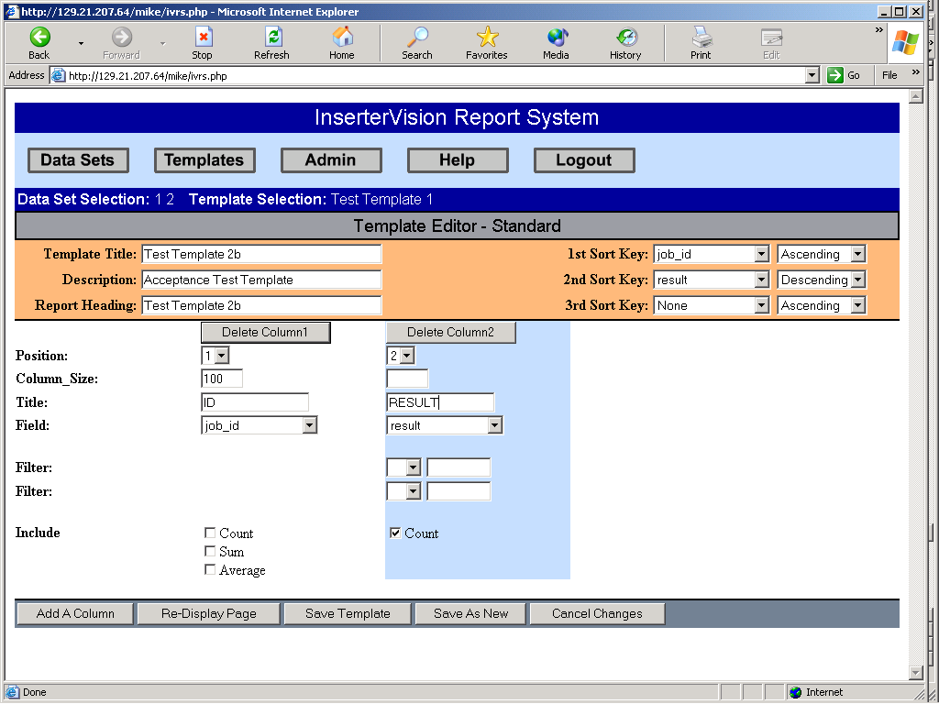

Test Template 3a
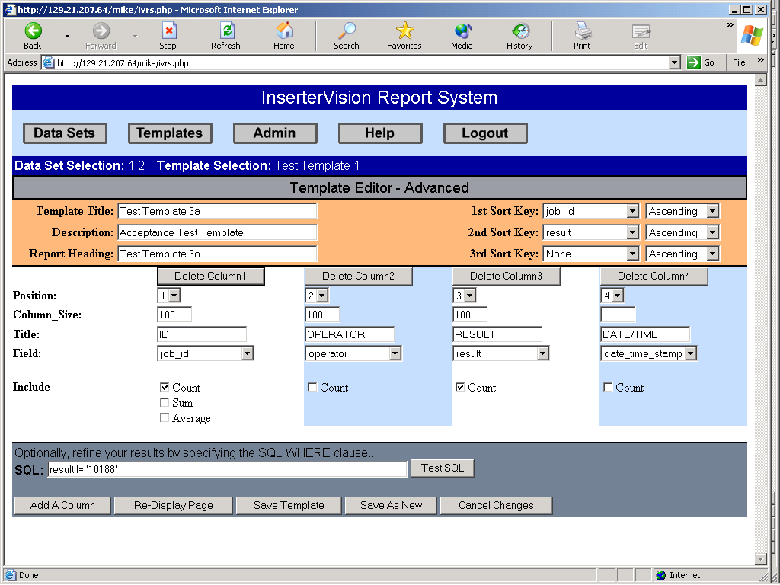

Test Template 3b
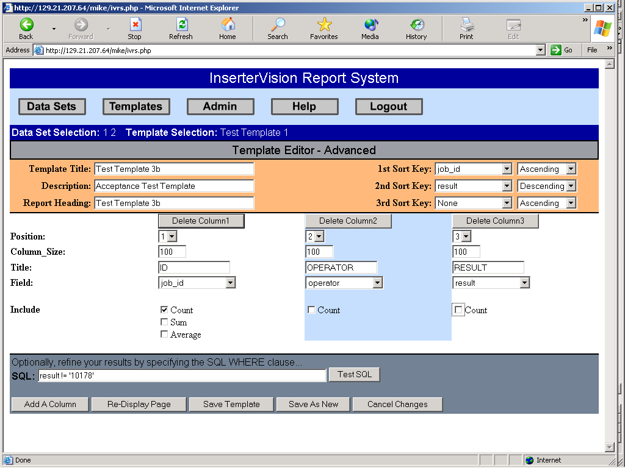

Test Template 4a
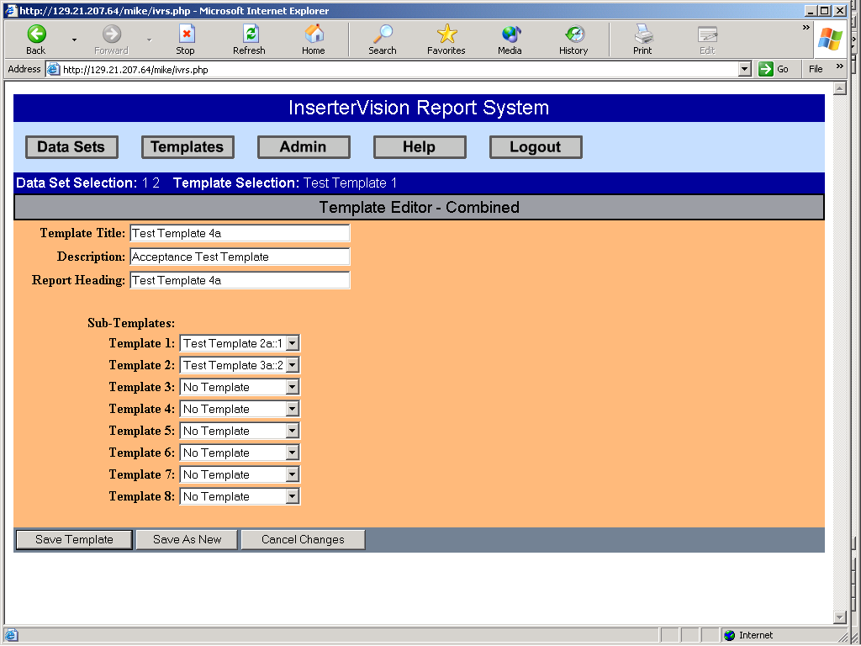

Test Template 4b
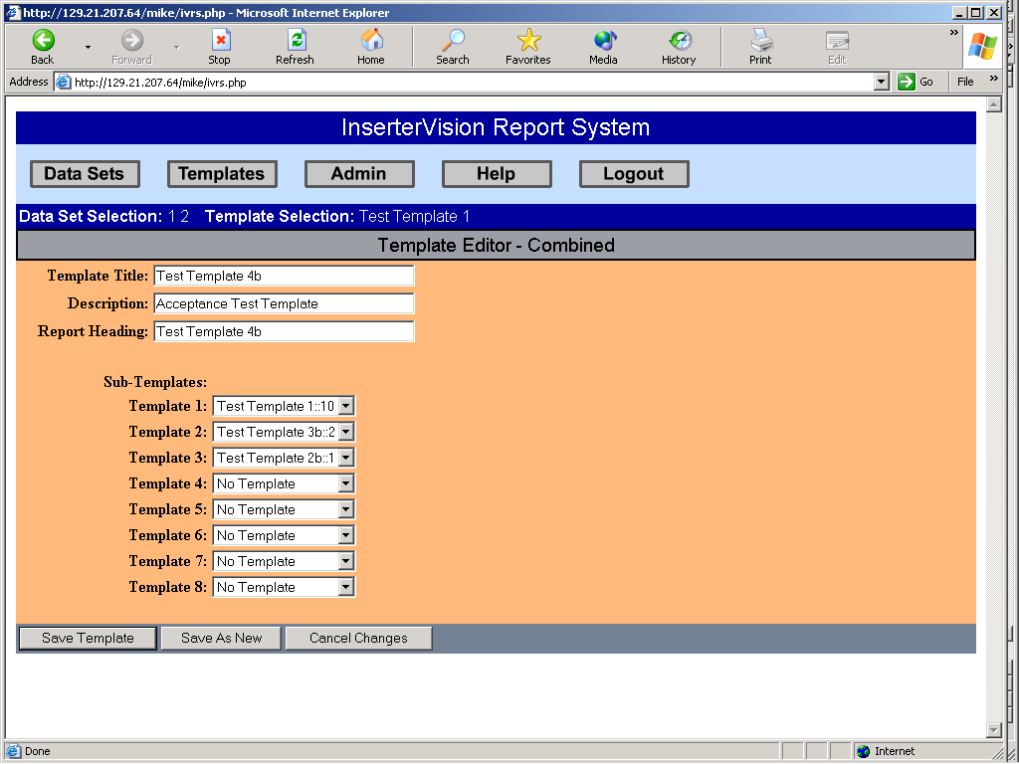

Test Header 1


