/
Design
FARA Registry Project

v 5.7

EDS \ RIT \ FARA

Wednesday, July 29, 2026

Document Control

Primary Owner: Tracy Rericha
tmk1698@rit.edu
Secondary Owner: Steve Coad
src9472@rit.edu
Inquiries to: Tracy Rericha
tmk1698@rit.edu

Change History
Published / Revised Date | Version # | Author | Section /  Nature of Change
01/25/06 | 1.0 | Tracy Rericha | Initial compile of Business / Technical design merged document.
01/26/06 | 1.0 | Tracy Rericha | Continued compile of merged document based on team feedback.
02/04/06 | 2.0 | Tracy Rericha | Reorganized document structure, included modules, began adding content from team meeting
02/04/06 | 2.1 | Steven Coad | Edited architecture and modules section, added DB diagram.
02/07/06 | 2.2 | Elaine Simone | Expanded the architecture section to include notes.  Included Flow diagram
02/07/06 | 2.3 | Sandy Morris | Added design for modules 2
02/07/06 | 2.4 | Elaine Simone | Vertical slices of architecture view added to modules.  Moved modules to own section
02/07/06 | 2.5 | Elaine Simone | Removed headings from requirements numbers
02/07/06 | 2.6 | Elaine Simone | Updated Flow (forgot some pages)
02/08/06 | 2.7 | Elaine Simone | Added design for modules 8, 10
02/09/06 | 2.8 | Elaine Simone | Added desgin for module 9
02/09/06 | 2.9 | Sandy Morris | Added design for modules 1 and 5
02/09/06 | 3.0 | Tracy Rericha | Added design for modules 2.6 and 2.7, integrated modules 2.1, 2.3, and 2.4
02/10/06 | 3.1 | Tracy Rericha | Updated module 2.4, organized document for consistency
02/11/06 | 3.2 | Tracy Rericha | Added updated data model
02/13/06 | 3.3 | Elaine Simone | Changes after prelimary review for  Architecture write up and  Modules 8-10
02/14/06 | 3.4 | Sandy Morris | Updated modules 2.2 & 2.5 incorporating John’s feedback
02/14/06 | 3.5 | Elaine Simone | Redid some of the highlighting to call out Johns concerns that’s still have text in the document
02/14/06 | 3.6 | Steven Coad | Added Web.config and encryption information, made fixes
02/17/06 | 3.7 | Sandy Morris | Updated modules 2.2 & 2.5 after review
02/ | 3.8 | Sandy Morris | Updated modules 2.2 & 2.5 after acquiring Jen’s & RIT team’s feedback
02/21/06 | 3.9 | Elaine Simone | Updates to modules 8, 9, 10 | Removing Question Text from Architecture Section and 8, 9, 10
02/21/03 | 4.0 | Steven Coad | Reordered Modules to match the new order in the modularity document (more logical flow)
02/22/06 | 4.1 | Tracy Rericha | Updated Admin and Query modules according to changes noted in the design review
02/22/06 | 4.2 | Steven Coad | Brought in new DB model and made some changes based on review
02/24/06 | 4.3 | Elaine Simone | Re-review, minor changes
02/24/06 | 4.4 | Sandy Morris | Added missing requirement to Module 2
02/24/06 | 4.5 | Elaine Simone | Minor updates to complete re-review
03/01/06 | 4.6 | Sandy Morris | Removed all traces of HIPAA from the document (with the exception of that which is mentioned in the data model) as we are now using ‘Informed Consent’ in its place, also changed ‘Edit Registrants’ tab to ‘Registrants’
03/13/06 | 4.7 | Elaine Simone | Making changes based on feedback  Contingency for allowing RC’s to edit their passwords added (account info functionalty is implemented in further releases). F11.031.000  Bringing design associated with requirement F11.025.00 to match accepatance criteria better.  Possible solution for F4.005.001 Presented.  F8.017.000 possible formatt suggested (tab delimited)  Still question on F3.003 acceptance criteria.
03/15/06 | 4.8 | Elaine Simone | Updated contingency plan for allowing RC’s to edit passwords in F11.029.000 under the authentication module.  Updated Informed Consent/HIPAA information F3.003.000. Noted that the Informed Consent screen is presented each time a patient logs in. The date of acceptance is recorded in the database. Changed bConsentAccept field from bit to dateTime value, now dateConsentAccept to record this information.  Also pasted in latest database model information from FARA DB Model.
03/20/2006 | 4.9 | Steven Coad | Added approved DB Model information
03/21/2006 | 5.0 | Steven Coad | Updated DB model
03/22/2006 | 5.1 | Steven Coad | Updated DB model
03/27/2006 | 5.2 | Steven Coad | Updated after Module 1 review.
04/05/2006 | 5.3 | Elaine Simone | Updated with changes to Module 4, data entry logic
04/17/2006 | 5.4 | Sandy Morris | Updated changes to Module 10; new verbage provided by Jen for the links, site description, informed consent and the new header/footer and reminders on the home page.
04/17/2006 | 5.5 | Tracy Rericha | Updated for Module 5 and 6 design updates/changes
4/24/2006 | 5.6 | Tracy Rericha | Changed references from HIPAA to Informed Consent and deleting patients to disapproving patients in Modules 5 and 6.
04/26/2006 | 5.7 | Sandy Morris | Updated document to reflect new ‘Other’ country and region requirements

Review and Approval History
Required reviewers for the document in question should be indicated by placing an "X" next to their name in the following table. In the column entitled "vote" record each reviewers vote using the following letters (shown below) to indicate their approval, disapproval or submission of changes needed to garner their approval:
A - Approved
C - Changes were submitted and will constitute approval of the reviewer if incorporated
D - Declined (This vote requires an explanation indicating why approval was denied.)
Required reviewers who have not responded by the deadline set will be considered to be in agreement with the contents of the document under review.
Organization\Role | Reviewer/Approver | Required | Vote
FARA | Jen Farmer
EDS | John Manos
EDS | Michelle Whalen
Table of Contents
Document Control ii
Change History ii
Review and Approval History iv
Design 6
1 Architecture 6
1.1 Deployment View 8
1.2 Web.config 8
1.3 Encryption 8
1.4 Web Application View 9
2 Development Modules 11
2.1 Database 11
2.2 User authentication/login 12
2.3 Data Entry View 15
2.4 Data Entry Logic 21
2.5 Patient Update 24
2.6 Coordinator – Patient Review 27
2.7 Admin 36
2.8 Query 38
2.9 Registry Auto-maintenance 41
2.10 Static site content 43
2.11 Non-Modular Specifications 49
3 Database Model 50
4 Process Flow Diagram 54

Design

Architecture

The requirements of the FARA Registry clearly lead to three qualities. Security, Usability, and modifiability. Each quality leads to certain tactics for the system to achieve these qualities.

Security
Because the Registry will contain Personal Health Information it must be secured. Access to patients records must be restricted. Only designated Registry Coordinators and Administrators will be able to view all patient information. A Patient (and/or Guardian) should be the only other person to view his or her information.

One way to ensure security is by Resisting Attacks. This can be accomplished through a variety of means. Authenticating Users: Users will have to log in to view Patient information. This goes for Patients viewing their own information or Registry Coordinators and Administrators performing look-ups or queries on the system. Users whose accounts have been set to disabled will not be able to log in. These users that do wish to enter the system again will have to contact a Registry Coordinator to be enabled. Authorize Users: The system will differentiate between different user types. Certain functions will only be available to certain users. Users must have the right authorization level to perform certain actions. Maintain data confidentiality: Passwords shall be encrypted in the system. No User type shall be able to view this information. While users are logged into the system, the Secure Hyper Text Transfer Protocol (https) will be used. Maintain data integrity: The system does not have a software check for integrity. This is achieved through human intervention, the Registry Coordinators who monitor information and contact and speak with Patients to ensure data integrity.

Another way to ensure security is to have a way to Recovering from an Attack. Identification: Audit Trail: Each patient record shall have a change log, detailing any changes made to that patient record, and which User made them.

Usability
Since the system will primarily be a means to gather and then organize information. The system must be easily usable or patients will not use the system. Usability is especially a concern for Friedreich Ataxia patients who suffer loss of muscular control. To make a highly usable system, developers must make considerations at every level of development, not just architecture. However some architectural tactics that help follow.

One method to enhance usability is to Separate User Interface. Users will not be interacting directly with the database. The web interface provides a layer between the human interactions and the database. Users will not have to know how to run queries directly with the database, or enter information; this will be done through a User Interface that a user recognizes.

Another way is to Support User Initiative. This means that the system will support actions initiated by the user. Cancel: The system allows the user to cancel at any time before information is submitted into the system. Change: The system allows a user to go in and change non clinical information. Other information, a user would have to contact a Registry Coordinator to perform the changes.

The system must also support actions initiated by the system. Support System Initiative. Maintain a task model: The system is aware of what task the user is performing by the screen the user is on in the navigation. Context help will be provided. Maintain a user model: The system takes into consideration the muscular control Friedreich Ataxia patients. The Interface shall have proportionally bigger buttons, and further spaced apart so that a user can clearly click on a region of the screen, not mistaking it for another region. The system also takes into consideration the different classes of users, imposing more lenient authentication for Patients who will not be interacting with the system as often as Registry Coordinators and Administrators. Maintains a system model: The system provides a progress indicator for patients entering information.

Screen Layout Properties
Screen width | 770 pixels
Font Size | 14 pt
Font Type | Microsoft Sans Serif
Label Example
Text Box Example | 
Button Example | 

Modifiability
As the system is in production the needs may grow and change. The system specifically must be able to handle the addition of new questions. It also must consider it growing in size and handle the addition of new Registry Coordinators. It needs to be able to react to its growing and changing scope.

One tactic to increase modifiability is to Localize Changes. By doing this if changes need to be made they will only have to occur within a small slice of the system. Maintain Semantic Coherence: Modules will be self contained. Anticipate Expected Changes: Although effort will not be spent implementing requirements that are out of scope for Release 1.0 of the FARA Registry Project, they will be considered during the design phase. Not explicitly design for, but the way in which the system is designed will take into consideration these future changes. Specifically the addition of more Registry Coordinators, new questions, and reporting functionality.

Another method is to Prevent Ripple Effect. This means to make sure that systems are not so coupled that a change to one part will not require changes to several others portions of the system. Hide Information: Private information is hidden behind interfaces, with only the minimum necessary information made public. Maintain Existing Interfaces: Interfaces shall not change, Intermediary Interfaces can be used instead, wrappers, if a different interaction with a component is needed. Restrict Communication paths: Communication paths will happen through vertical cuts of functionality of the system. Use an Intermediary: Intermediaries can be used to manage dependencies between different components or modules.

Deployment View

The system, once deployed, will be residing on a hosting services’ web server. There will be the registry data contained within a database, the registry application, and the reminder and email services.

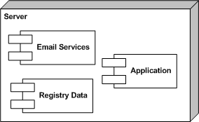

Web.config

The Web.config file in ASP.NET is a special configuration file, written in XML, that contains setup information for a web application. In ASP.NET, there is one Web.config file for each web application. This file can contain database, session, error, and authentication setup as well as many other advanced setup features.

For our use, the Web.config file will contain the database connection setup as well as the selection of the authentication method. We will be setting our application to use forms authentication.

This text is a placeholder for the connection string TBD upon deciding on the web host.

Encryption
The application will make use of synchronous encryption as provided for in the .NET framework. There will be one key used for both encryption and decryption.

Web Application View

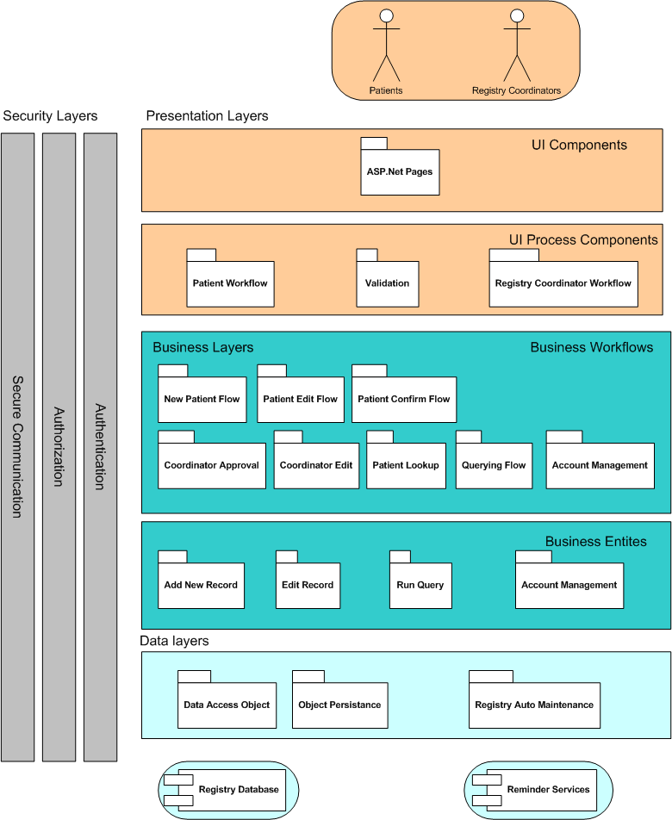

The web application architecture was driven by the qualities and tactics described in section 1.0. The architecture was also driven by “Application Architecture for .NET: designing Applications and Services”. The system is broken into three tiers, Presentation, Business Logic, and data. Security concerns cross cut these layers, which is why they are along the side. Connections between layers and components are not shown here for simplicity. Communication only happens with the layer directly below (or above) in a traditional layered architecture.

The UI Components Layer is the one that contains what will be available on the client’s machine, through the web browser.

The UI Process Components are the Presentation components that reside on the server. These components interact with the below business logic layers to determine what is the correct thing to display within the browser pages, in the UI Component Layer. It also receives the input provided by the user in the UI Component Layer and sends it down the appropriate path through the layers. The user type will dictate which component (Patient, or Registry Coordinator) will be used. The Validation component also sits in this layer, performing the validation on user inputs. It resides in the component because validation is performed on the server-side.

The Business Workflows layer contains a package for all the actions all users can perform on the system. The first row is actions that a Patient can perform. The second row is actions that a Registry Coordinator can perform. These actions must interact with the system actions in the Business Entities layer to accomplish user requests.

The Business Entities layer contains components for each action the system performs. It is through this layer that the data layer is accessed.

The data layer contains the components that access persistent data of the system. Data Access Objects are used to communicate with the Registry database. Registry Auto-Maintenance and the Reminder Service components are the parts of the system that do automatic checking on the database. These components are responsible for the email reminders and setting off accounts to inactive then disabled.

Development Modules

Database

This is the physical database itself and the scripts used to set it up/populate it. This also encompasses the stored procedures, data access objects, and ADO.NET components to interact with the stored procedures.

F7.014.000:  All field-specific detailed requirements shall be documented in the FieldAttributes.xls document. | The database will be created and populated with several scripts.  - There will be a script that will create the tables. This will be named “FARA_Registry_CreateTables”. Some sample pseudocode follows:  if( table exists ) {  drop table  }  create table (field 1 specification,  field 2 specification)  - There will be a script to install the default admin and registry coordinator. This will be named “FARA_Registry_Default_AdminUser_Setup”.  This text is a placeholder for the pseudocode for the scripts, it will be detailed once final web host selection is made.  - See section 3 - Database Model for database details

User authentication/login
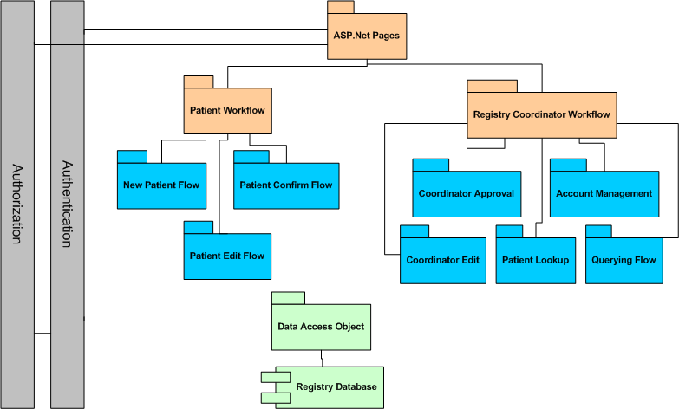

This is composed of all the login and security issues.

F11.026.000:  Authentication information shall consist of a password | Everyone has to use a password to access any information stored on the system. The password will be alphanumeric and between 6-8 characters in length, with no special characters.  When the user attempts to log in the status of the user will be checked to ensure that it is set to ‘active’. The ‘status’ field in the ‘User’ table of the database determines the status of the user.
F11.027.000:  The system requires Registry Coordinators and Administrator accounts to meet stronger password requirements | Because they have the ability to view the information of many people, the account for the registry coordinators/administrators must be more secure than a patient.  - 8 – 10 characters  - Alphanumeric character class  - One capital letter  - No special Symbols
F11.028.000:  The system shall lock out users trying to log in after a predefined number of times | The system will maintain a counter of the number of times a user has tried to log in within a certain timeframe. If the count exceeds a pre-set number, then the account will be marked as locked out, and even the correct password will not allow access. For patients, this pre-set number is 10 attempts. For the coordinators, the pre-set number is 4 attempts.
F11.029.000:  An existing user shall be able to retrieve his or her authentication information after the user answers a security question | There will be a security question and answer set up during the initial registration. If a user forgets their password, a link will be provided to a form where they can answer the security question. A right answer will reset the password at random, and email the new password to the associated email address (given at registration time). There will be an option within the Returning Patient user interface to allow them to change their password. It will prompt them for the current password, then the new password twice.  Since the user’s email address is the user id for the login, they will be given a “forgot which email?” link/prompt which will allow them to enter a first and last name to have the system send out a reminder email if the user is in the system.  Security questions:  - What is your mother’s maiden name?  - What city were you born in?  - What was your first pet’s name?  - What is your favorite color?  - Where did you go to high school?  Password Retrieval for the Registry Coordinator in the First Release. This issue arose because the functionality for Registry Coordinators to maintain and edit Account information was deferred to a later release.  On the Password Reset tab of Administrator interface there will be fields for which a Registry Coordinator can change his or her password.  Username (entered twice)  Current Password (entered twice)  New Password (entered twice)  The Registry Coordinator’s authentication retrieval information (security question and answer) will be hard coded, so that the Registry Coordinator can use the interface to reset his or her password if it is forgotten.
F17.045.000:  Patients, Registry Coordinators, and the Administrator shall login through the same interface | All users have one common point of login to the system, The system will know what the user level is, and provide the appropriate UI.  The Link to the login screen is in the header of the website. The Login screen has the header, footer, and links sidebar of the main page. Instead of content, there are two fields, username and password, and a button to submit them.
F17.045.001:  The System shall have an authentication method that distinguishes between Patients, Registry Coordinators and the Administrator | The ‘level’ field in the ‘User’ table of the database will contain the user level. The system will use that user level to distinguish between these roles.

Use Case

Brief description | A user logs in to the Registry
User type | Patient, Registry Coordinator
Basic Flow of Events | - User chooses the login link  - User fills out username and password, clicks on “log in”  - User is taken to the appropriate screen for their user level
Alternate Flows | 2b. User fills out incorrect username, clicks on “log in”  3b. User is returned to the login page with an indication that the username field was incorrectly entered  2b. User fills out incorrect password, clicks on “log in”  3b. User is returned to the login page with an indication that the password field was incorrectly entered
Extension Points | N/A
Preconditions | User is not logged in.
Postconditions | User is logged in.
Additional Info | N/A

Data Entry View
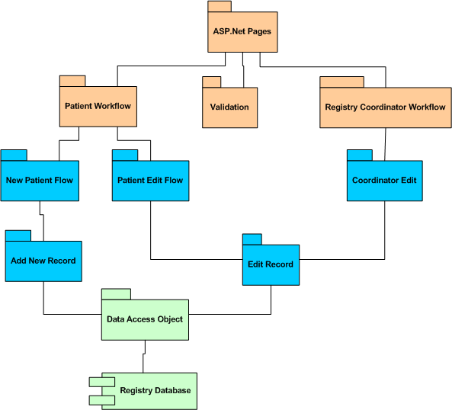
The same process is used to make new patients and edit old either from their login or the coordinator’s.

Object Diagram

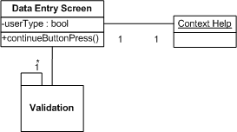

F6.008.000:  All field-specific detailed requirements shall be documented in the FieldAttributes.xls document. | Fields will be distributed and presented as described in the FieldAttribute.xls document.  Fields designated as Registry Coordinator / Administrator only will be viewable from the Account Info page for those user types.  Change Log  Communication Log  Account Disable
F14.036.000:  Each field shall have an instruction. | The text for each field instruction is detailed in the FieldAttribute.xls document.  It will be displayed in two ways  - A Tool Tip will be used beside each field  - It will be in the help window that is associated with each data entry screen
F14.038.000:  Every page will have instructions explaining to the Patient what the purpose of the page is and what is needed from him or her to complete that step in the process. | The text of these instructions will be on the help window that is associated with each data entry screen.
F6.009.000:  International patients will be accounted for. | On the demographics screen the patient will choose a country. This will drive what the region label is set to and what the regions drop down displays.  For counteries for which regions are not defined a text box will display instead.  First Name - text box  Last Name - text box  Address (2 lines) - text box  Town/City - text box  <Region Label>- a drop down for the countries, their region labels and their regions (if they are defined) are dictated in the file:  FARA patient registry country list.doc  Postal Code - text box  Phone number - text box and don't specify the format - text box  Date of Birth - drop down DD for day, drop down month for month, drop down YYYY for year  Email address - text box
F6.009.001:  International patients with a country not listed in the country drop down list will be accounted for. | On the initial information screen the patient will select ‘Other’ in the country drop down list. This will trigger a hidden ‘FreeformCountry’ text box to be shown with a label of ‘Other’. Changing the country dropdown to something other than ‘Other’ will hide the label and textbox.  On the Guardian and Demographic screens the user’s selection of ‘Other’ will trigger the dynamic region label to be set to ‘Region’ and the hidden ‘FreeformRegion’ text box to be shown.
F6.009.002:  International patients whose country of origin have no regions defined in our database will be accounted for. | On the initial information screen the patient may select a country from the dropdown that we do not yet have regions defined for. To prevent the user from being met with an empty dropdown list. Instead that dropdown will be hidden and the ‘FreeformRegion’ text box will be shown instead.
F6.009.003:  International patients refer to regions in different ways and this shall be accounted for. | The region label will be dynamic and will change based on the user’s country of origin. Whenever a country is added to the database the definition of the region label for that country is also required.
F11.024.000:  Authentication information shall include a username in the form of an email address. | The username field is not editable. It is populated by the email address provided in the initial submission. To change the username a Patient must set the ‘Link Email to Username’ field to yes.
F15.040.000:  There shall be a confirmation screen to allow for over viewing information before changes are submitted. This screen shall be printable. | 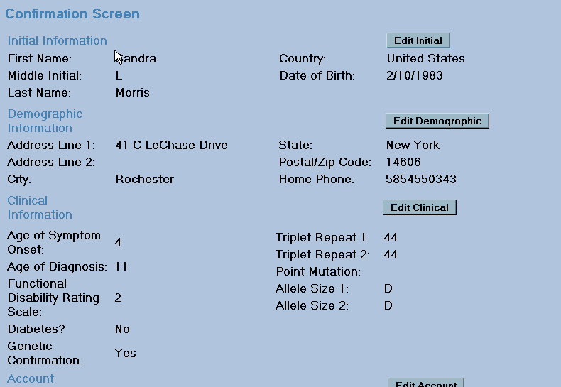

Use Case

Brief description | Patient reviews information before submission
User type | Patient
Basic Flow of Events | Patient reviews information  Patient navigates back to demographics screen to make a change  Patient returns to confirmation screen  Patient chooses to submit information
Alternate Flows | Patient chooses to change nothing, and skips right to submitting information
Subflows | Patient makes changes to demographical information
Preconditions | Patient has accepted the Informed Consent Agreement  Patient has concluded information entry
Postconditions | Patient data is submitted  If a new Patient, patient account is set to pending

Use Case

Brief description | A Patient enters demographical information
User type | New Patient
Basic Flow of Events | Patient enters demographical information  Patient chooses to continue to next screen
Alternate Flows | If Patient’s value for Country is not United States, then the International demographic screen is displayed, not the US demographical screen
Preconditions | Patient has given a value for Country  Patient has accepted the Informed Consent Agreement
Postconditions | Patient has submitted demographic information

F13.034.000:  Areas that cannot be edited by the Patient will be grayed out. | Depending on the userType fields will or will not be editable.  Permissions on fields are detailed in the FieldAttributes.xls document.

Use Case

Brief description | Patient returns to edit clinical data
User type | Returning Patient / Registry Coordinator
Basic Flow of Events | Patient overviews current data  Patient wants to edit clinical data.  Clinical data Fields are not available for editing  Patient contacts Registry Coordinator for help
Subflows | Registry Coordinator edits Patient data
Preconditions | Patient has successfully logged in  Patient has accepted Informed Consent agreement
Postconditions | New clinical data is submitted

Use Case

Brief description | Registry Coordinator edits Patient data
User type | Registry Coordinator
Basic Flow of Events | Registry Coordinator looks up Patient  Registry Coordinator overviews account information  Registry Coordinator navigates to clinical data page  Registry Coordinator makes changes to clinical information  System presents a confirmation page  Registry Coordinator submits changes
Preconditions | Registry Coordinator has name or username of record he or she wants to make changes to
Postconditions | New clinical data is submitted

P1.047.000:  The system must be accessible and functional when visited with common web browsers. | Targeted Web browsers: Internet Explorer 4.x, Mozilla 1.7, Firefox 1.5  The system will strive to meet the Web Content Accessibility Guidelines described in WCAG 1.0 http://www.w3.org/TR/WCAG10/

D1.049.000:  Information that must be collected from the patient for the registry shall be entered using multiple screens instead of one large screen to minimize the use of scrolling top to bottom, right to left. | There are X screens in the information entry process. The FieldAttribute.xls document details which fields shall appear on which screen. The screens are:
  Initial Screen | Required
  Guardian Screen | If Patient Age < 18
  Informed Consent | Required: text dependant on Patient age
  Demographics | Required (dynamic fields based on country selected)
  Clinical Part 1 | Required
  Clinical Part 2 | Required
  Account Information | Required

Use Case

Brief description | Patient Joins Registry
User type | Patient
Basic Flow of Events | Patient enters Initial Screen data  Patient accepts Informed Consent agreement  Patient enters demographical Screen data  Patient enters clinical Screen data  Patient enters Account Information Screen data  System presents a confirmation page  Patient chooses to submit data
Alternate Flows | If Patient age is less then 18, then Guardian Screen must also be completed (between Initial Screen and Informed Consent agreement)  If a field on a screen does not meet validation requirements, the new patient must fix those fields before moving on with the process  Which demographical Screen is presented is determined by a Patient’s Country (provided in the Initial Screen)  A user can navigate backwards and make changes to any previously completed section before information is submitted.
Preconditions | Patient has chosen to join Registry
Postconditions | Information is submitted  Patient Record is set to Pending

Use Case

Brief description | User Edits Patient data
User type | Patient, Registry Coordinator
Basic Flow of Events | User overviews Patient data  User navigates to demographic screen  User makes changes to some fields  User returns to confirmation screen  User chooses to submit data
Alternate Flows | Patients will not be able to change some fields upon return. This information is detailed in the FieldAttributes.xls document
Preconditions | User has authorization to view the record  User is viewing the record
Postconditions | Information is submitted, overwriting previous information

D2.050.000:  All screens for the registry shall be easy to read and uncluttered. | The font used will be Microsoft Sans Serif 14 pt.
D5.052.000:  The site shall have a navigation/progress indicator. | 
D5.055.000  Buttons on the page will have directional arrows to show the user which direction the button’s action will take them in the process. | Actions that will either bring a user forward or backwards in the process will have arrows, like in the example below to show which direction the user is going in.

Data Entry Logic

Validation and logic related to the inputs.

F6.010.000:  Validation shall be done on a page-by-page basis. | Using .net validators. Validators reside on data entry pages. They are evaluated when the button to continue is pressed. First Validation is done on the client side, before information is posted back to the server side. Then a final validation check is done on the server side.  Types of Validators that will be used and pertinent properties  - BaseValidators – All inherit from this one  - .ControlToValidate – element that is being validated  - .ErrorMessage – Text for *Validation Summary  - .Text – Text displayed by control element  - RequiredFieldValid – used to make sure the user has entered intput  - .Initial Value – initial text in field, but still checks for user input  - CompareValidator – used to compare contents a value  - .ControlToCompare – the other element to compare to  - .Operator – how values are compared  - .ValueToCompare – when comparing with literal  - .Type – String, Integer, etc.  - RangeValidator – used to ensure value is within indicated range  - .Maximum Value – max value  - .Minimum Value – min value  - .Type – String, Integer, etc.  - RegularExpressionValidator – used to ensure value matches expression.  - .ValidationExpression – written in RegEx syntax  - defaults  - Multinational Phone  - Multinational Postal Code  - Internet Email address  - Internet URL  - CustomValidator  - .ClientValidationFunction – name of script to execute on validation  - .ServerValidate – event handler for server side.  *Validation Summary is location where all Error Messages on a page reside. All Messages will reside in a single place, with only markers (?) beside the field to indicate which did not pass validation
F4.005.000:  There shall be a check to make sure that the provided guardian is over 18 years of age. | Translate guardian birthdate -> guardian age.  If ( age < 18 )  Goto GuardianErrorPage  Else  Goto demographicPage

Use Case

Brief description | A Patient entered guardian age
User type | Patient
Basic Flow of Events | A Patient fills in a value for Guardian Age  Patient selects to continue to next screen
Preconditions | Patient has completed the Initial Screen  Patient’s age is less then 18
Postconditions | If value supplied is < 18  An error is displayed  The user cannot continue to next screen  Else  Informed Consent screen is presented

F3.003.000:  User must accept Informed Consent to participate in the Registry | If Next ButtonSelected  If (New Patient)  goto demographic screen  Else // returning patient  goto confirmation screen  The Informed Consent page is presented each time a patient logs in. The date of last acceptance is recorded in the database.  dtDateConsentAccept = currentDate

Use Case

Brief description | A user accepts the Informed Consent agreement
User type | Patient
Basic Flow of Events | Patient Overviews statement on the screen.  Patient selects Accept  Patient selects to continue
Alternate Flows | If a Patient is under age 18 (determined from age field) then the statement is changed to be targeting the guardian, since this is who must accept the agreement
Preconditions | Either 1) A New Patient has completed the Initial Screen or  2) A Patient has returned, logging into the Registry
Postconditions | The Patient can enter and/or change his or her information in the Registry

Use Case

Brief description | A user does not accept the Informed Consent agreement
User type | Patient
Basic Flow of Events | Patient Overviews statement on the screen.  Patient selects decline  Patient selects to continue
Alternate Flows | If a Patient is under age 18 (determined from age field) then the statement is changed to be targeting the guardian, since this is who must accept the agreement
Preconditions | Either 1) A New Patient has completed the Initial Screen or  2) A Patient has returned, logging into the Registry
Postconditions | The next screen presented is a page explaining the consequences of a user declining the Informed Consent agreement.

F11.023.000:  Authentication fields will be entered twice for validation purposes. | For email address and password a CompareValidator is used.  .ControlToValidate is the email / password text box  .ControlToCompare property is set to the other text box.  .Operator is equal

Use Case

Brief description | A user enters authentication fields
User type | Patient
Basic Flow of Events | Patient enters in an email.  Then enters email in the second field.  Patient enters in a password  Then enters password in the second field.
Preconditions | Patient has completed all screens through the Clinical Screen
Postconditions | Authentication values are checked  If ( first field == second field)  Values are written to storage  Patient is presented with confirmation screen  Else  Patient is presented with error message and cannot continue

D5.053.000:  The user shall have the option of canceling at any point and all information will then be lost. | Values of fields are not written to session variables until user has chosen to go to the next screen (press the “continue” button), and all fields on that screen have passed validation. The session variables are written to the registry on submission of data after the confirmation page.  When the Cancel button is selected all session variables are reset to blank.

Use Case

Brief description | User Cancels
User type | New Patient
Basic Flow of Events | Patient chooses to cancel
Subflows | Patient closes browser  Patient navigates backwards in process  Patient navigates to another website.
Preconditions | Patient has entered some information
Postconditions | All information is lost

Patient Update
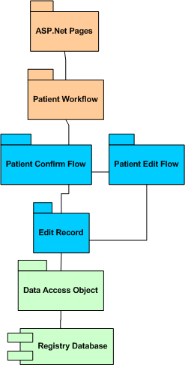
This is the returning patient logic.

F9.018.000:  The patients will have to actively confirm that his or her information is up to date when they receive the email reminder every year. | When patient returns && lastUpdated is greater then 11 months  After Informed Consent confirmation screen accepted  A modified confirmation screen is presented. It contains:  - One button to simply confirm,  - A button for each data screen, so that Patient can proceed to edit records on the appropriate screen.  - A cancel button.

Use Case

Brief description | Patient confirms that information is up to date
User type | Returning Patient
Basic Flow of Events | Patient reviews information  Patient chooses to Confirm that information is up to date
Preconditions | LastUpdated field date is atleast 11 months ago  Patient has logged in  Patient has accepted Informed Consent statement
Postconditions | LastUpdated field is replaced with the current date  Patient is presented with confirmation screen

Use Case

Brief description | Patient edits data
User type | Returning Patient
Basic Flow of Events | Patient reviews information  Patient chooses to edit information  Patient submits changes
Preconditions | LastUpdated field date is atleast 11 months ago  Patient has logged in  Patient has accepted Informed Consent statement
Postconditions | Changes are written to Patients record  LastUpdated field is replaced with the current date

F11.025.000:  If the user wishes to change their email address her or she will be given the option of resetting that new email address to their username or keeping the old email address as their username. | A button appears for returning patients under the text fields to enter their new e-mail address (twice) which says ‘Change to User ID.’ Once they click on it, a label and a field of two radio buttons will appear which asks, “Change E-mail to user ID?” If user selects ‘Yes,’ this value is stored and when they confirm their information, the change will be made.

Use Case

Brief description | User changes email address
User type | Patient
Basic Flow of Events | User selects to submit Account Info  When box is presented user selects either Yes or No
Preconditions | Patient has entered in a new email address
Postconditions | When the user submits Account Info a box appears asking if the user would also like to change username.  If the User selects Yes  Username = new emailaddress  Else  Nothing changes

F3.005.000:  User declining of Informed Consent shall receive an alert letting them know they will not be able to participate in the registry; if they are returning their account is then disabled. | After the user clicks on ‘Decline,’ an alert will pop up with the text:  "You have selected to decline the informed consent agreement. It is required that all individuals entering the registry grant their consent that their information may be shared under the terms of the Informed Consent Agreement. We cannot allow you to registr with us unless you do so."  After receiving this message, the new registrant will be directed back to the home page and will not be allowed to continue on in the registry process. The returning registrant’s account will be disabled, as they have declined to consent their information being shared for the purpose of the registry.

Coordinator – Patient Review
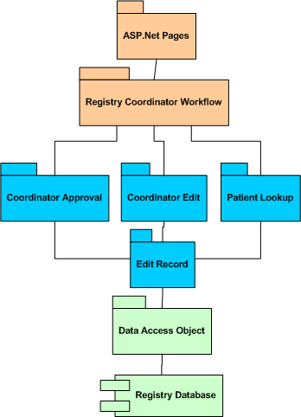

This module contains the coordinator’s patient approval and editing.

D5.054.000:  The System shall provide navigation for Registry Coordinator and Administrator Actions. | The method that will be used for navigation for the registry coordinator and the administrator will be the use of tabs.  The navigation tabs for the registry coordinator will be as follows:  - Home  - Welcome message to the registry coordinator: ‘Welcome Back XXX!’ where XXX is the registry coordinator’s username.  - Number of pending registrants: ‘There are currently X registry requests pending your approval’. Where X is the number of pending registrants.  - Registrants  - List of pending patients  - ‘Patient Lookup’ link on the right side  - Clinical Trials Query  - Query options  The navigation tabs for the administrator will be as follows:  - All of the tabs provided to the registry coordinator  - Password Reset  Note: Account disabling and Registry Coordinator – only fields (such as the account disable, change log & communication log) will be located on the ‘Account Information’ page that will appear just before the confirmation screen in the patient data pages flow.  Initial Screen -> * -> Account Information Screen -> Confirmation Screen

F6.011.001:  The system shall provide a message detailing the number of pending patients upon log in. | The main page that is displayed after the registry coordinator logs in will display text inside the main panel:  Welcome back to the FARA registry! You have X number of patients that are pending your approval before their information can be added to the registry.  Where X is the number of patients that are new registrants whose information must be reviewed by the registry coordinator before their information can be included in the queries.  The way that we will get the number of pending registrants will be to run a query on the database which will return the number of users that are currently stored there who have a status of pending.

F6.011.000:  The system shall provide a list of Pending Patients. | A patient’s status will be defined in the ‘User’ table of the database in the ‘status’ field. Possible values of status are ‘active’, ‘pending’, ‘disabled’, ‘delinquent,’ ‘disapproved,’ and ‘lockout’. Pending means that a patient’s information has not yet been approved by the registry coordinator and therefore is not included in the clinical trials queries.  To access the page: A logged in registry coordinator will click on the ‘Registrants’ tab.  Format of this page: There will be a link to the ‘Patient Lookup’ for patients that are considered ‘active’.  To the left of the screen will be a header ‘Pending Patients’ and below it will be the grid with the list of the patients whose status is currently listed as ‘pending’.  The list will be populated using the following algorithm:  If (currentPatient.status = ignoreCase(‘pending’))  addToPendingList (currentPatient)  The format of the Pending Patient List will display as follows:  User ID First Name Last Name  The list will be ordered alphabetical by Last Name.  Beneath the ‘Pending Patients’ scroll box there will be a button ‘Review Patient’ as well as a button ‘Disapprove Patient.’  To exit the page: The user may use the tabs provided to the registry coordinator for a means of navigation or they may click on the ‘Review Patient’ button to be taken to the selected patient’s individual record on the confirmation page.

Use Case

Brief description | The registry coordinator views a list of pending patients. They can then select a pending patient from that list.
User type | Registry Coordinator
Basic Flow of Events | User elects to view the list of pending patients by selecting the tab ‘Registrants’.  User selects a patient from the list and click on the ‘Review Patient’ button beneath the list of pending patients.  User is taken to the ‘Confirmation Screen’ that will display all of the information that was entered by the patient when they registered with the patient registry.
Alternate Flows | User supplies invalid login information.
Extensions | User confirms the patient’s information.  User edits the patient’s information.
Preconditions | They have accessed the FARA patient registry site and have logged in as a registry coordinator.
Postconditions | They are taken to the ‘Confirmation’ screen for the selected patient.

Sequence Diagram

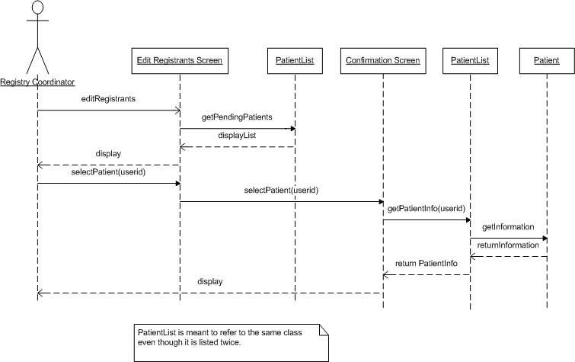

F6.012.000:  Registry Coordinators shall have to approve new patients before entry into the Registry. | To access this page: The registry coordinator selects a patient from the pending patient list and clicks on the ‘Review Patient’ button beneath the list. They are taken to the confirmation screen holding the individual patient’s information.  Format of the page: The information will be displayed on the page as is detailed in Requirement #F15.040.000, Module #2.9.  Beneath the information there will be two buttons ‘Confirm Information’ and ‘Cancel. If the user selects ‘Confirm Information’ the patient’s status in the database is changed from ‘pending’ to ‘active’ as their information has now been approved (unless they have selected to disable the user’s account on the Account Information page, which is reached by clicking ‘Edit Account’ on the confirmation page). The patient’s information then will be included in the registry’s queries.  currentPatient.setStatus(‘active’)  If the user selects ‘Review Patient they will be taken to the confirmation page for the patient’s registry data and may edit the patient’s record.  To leave the page: The user must click on ‘Confirm Information’ or ‘Cancel to leave the confirmation page.

Use Case

Brief description | Registry Coordinator Confirms Pending Patient Information
User type | Registry Coordinator
Basic Flow of Events | User selects a patient from the pending patients list and clicks ‘Review Patient’  User is taken to the pending patient’s information on the ‘Confirmation Screen’  User deems the information is correct and they click on the ‘Confirm’ button
Alternate Flows | User sees that the information is not correct and chooses to edit the patient’s information by clicking the ‘Edit’ button
Preconditions | User has accessed the list of pending patients.
Postconditions | The patient’s record has been successfully approved.

Sequence Diagram

F7.013.000:  Registry Coordinators shall be able to perform patient look-ups. | The registry coordinator will have the ability to limit the active patient list by last name, country, and country division.  To access the page: A logged in registry coordinator will select the ‘Edit Registrant’ tab and click on the ‘Patient Lookup’ link on the left sidebar of that screen.  Format of this page: There will be a header ‘Patient Lookup’ and beneath it will be three search fields that will allow the user to narrow the list of patients provided in the ‘active’ patients grid. Beneath these three search fields (last name, country, and date of birth) there will be a ‘Search’ button and a grid with the ‘active’ patient list that meets the search criteria. By default, all patients with a status of ‘active’ will be listed initially. Beneath the ‘active’ patient grid there will be a button that says ‘Edit Patient Information’.  The default for the search fields will be as follows:  Last name: Left blank and all will be selected.  There will be a pattern match provided to aid the user in selecting the last name of the patient. For example, entering ‘O’ and clicking on the ‘Sort List’ button will produce a patient list of those whose last name starts with ‘O’.  Country: The drop down will display all countries from the database  Date of Birth: The three drop downs will display dates to be selected.  The algorithm for populating the active patient list is as follows:  If ((currentPatient.status = ignoreCase(‘active’)) &&  (currentPatient.lastName = selectedLastName ||  selectedLastName = ‘’) &&  (currentPatient.country = selectedCountry ||  selectedCountry = ‘All’) &&  (currentPatient.dateOfBirth = dateOfBirth ||  dateOfBirth = ‘All))  addtoActiveList (currentPatient)  To leave the page: The user may use the tabs provided in the interface for navigation or they may click on the ‘Edit Patient Information’ button to be taken to the confirmation page for that patient’s registry information.

Use Case

Brief description | Registry Coordinator Looks Up An Individual Active Patient’s Information
User type | Registry Coordinator
Basic Flow of Events | User clicks on the ‘Patient Lookup’ link and is taken to the ‘Patient Lookup Screen’  User limits the list of patient’s names by selecting country ‘United States’  User then limits the list by selecting country division ‘New York’  User selects a name from the displayed list  User clicks on the ‘Edit’ button  User is taken to the ‘Initial Screen’ of the patient’s information
Alternate Flows | User limits the list of patient’s names by selecting a country other than the United States.  User limits the list of patient’s names by selecting a country division other than ‘New York’
Preconditions | User is logged in and has accessed the ‘Registrants’ tab of the registry coordinator interface.
Postconditions | User has accessed the patient’s information

Sequence Diagram

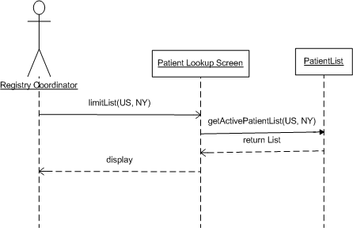

F13.035.000:  Registry Coordinators shall be able to edit any field of Patient data. | Patient Data is considered to be the data on all of the screens in the patient registry process (Initial Screen, Guardian Screen, Demographics Screen, Clinical Information Screen, Account Information Screen). It can be accessed via the confirmation page.

Use Case

Brief description | Registry Coordinator Reviews Pending Patient Information
User type | Registry Coordinator
Basic Flow of Events | User views the pending patient’s information on the ‘Confirmation Screen’  User clicks the ‘Edit Information’ button and is taken to the ‘Initial Screen’ of the Patient Information Screen and can edit any fields they choose  User clicks on the ‘Next’ button and is taken to the ‘Guardian Information’ Screen and can edit any fields they choose  User clicks on the ‘Next’ button and is taken to the ‘Demographics Information’ Screen and can edit any fields they choose  User clicks on the ‘Next’ button and is taken to the ‘Clinical Information’ Screen and can edit any fields they choose  User clicks on the ‘Next’ button and is taken to the ‘Account Information’ Screen and can edit any fields they choose  User clicks on the ‘Next’ button and is brought to the ‘Confirmation’ screen  User clicks on the ‘Confirm’ button
Subflows | At any point the user may choose to revert back to the previous step in the process by clicking on the ‘Back’ button.
Preconditions | The registry coordinator has accessed the patient’s record.
Postconditions | The patient’s record has been successfully edited & approved.

F5.006.000:  Patient Records shall have a change log. | The change log shall consist of a read only field that details the history of changes to the patient record. It will be located on the ‘Account Information’ page.  The ‘Patient History’ table will hold all changes associated with a user’s account. To populate the change log a query will be run on the ‘Patient History’ table using the userid as a means of obtaining all of the changes to a patient’s record.  There will be an entry into the ‘Patient History’ table and therefore the change log when:  - Date of Change  - Changed By User ID  - Changed Field Name  - Previous Value  - New Value  - User e-mail address

F5.007.000:  Patient accounts shall have a communication log to allow registry coordinators to add notes about a patient. | The communication log shall be a simple text area that will only be visible to registry coordinators when they access the ‘Account Information’ page. The text area will have a character limit of 250 characters.

F11.030.000:  Registry Coordinators shall have the ability to disable accounts. | The method for disabling accounts shall be done using a radio button that will be located on the ‘Account Information’ page.  Once the account is disabled using the radio button then the account status will be set to ‘disabled’ and the registry information for that patient will not be included in the registry’s clinical trials queries. However, the patient’s information will still be present in the registry.  currentPatient.setStatus(‘disabled’)  Once the account is disabled the change log will be updated.

F6.013.000:  The system shall provide a mechanism to disapprove non-approved patients from the pending list. | Underneath the Patient Pending list and next to the ‘Review Patient’ button there will be a button called ‘Disapprove Patient.’ Once clicked, that patient’s account status will be set to ‘disapproved’ in the database and they will no longer show up in the patient pending list. However, their information will still be present in the registry, just as disabled patients.

Admin
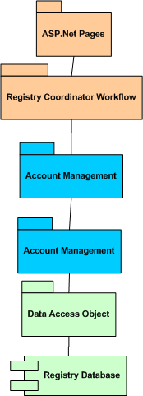

This is the extra admin privilege over the normal registry coordinator. For this release, it consists of the password reset functionality. This is intended to be used if there is a problem with the security-question driven password reset functionality.

Sequence Diagram

F11.031.000: The Administrator account will have a screen with the ability to reset passwords. | If (admin_logged_in = true && navigated_Page = PasswordReset && reset_pass_val = true) {  password is reset  }  When the e-mail is triggered upon the admin deciding to reset a password at the Password Reset page, the system will generate a default password for the patient whose password must be reset.  Once the e-mail is sent, the patient is expected to log in using the default password and to change their password once again back to a password of their choice. This will be stated in the e-mail that will be sent to the patient so they will know what to do upon receiving the new default password.

Use Case

Brief description | Administrator resets a password
User type | Administrator
Basic Flow of Events | Administrator navigates to password reset page  Administrator resets password with default and is directed to confirmation page
Preconditions | Administrator is notified by patient or by Registry Coordinator to reset a patient or Registry Coordinator’s password  Administrator is logged in
Postconditions | Patient or Registry Coordinator’s password is reset to a default value which the patient or Registry Coordinator must manually change (an e-mail is triggered upon the password reset notifying them to do so)

F17.043.000: The Administrator role shall manage all types of accounts. | A separate account must be created to hold both the registry coordinator’s functionality as well as additional tasks to create new registry coordinator and patient accounts, to perform password reset functions on those accounts, and to generally manage all accounts  Release 1.0 includes the ability of the Administrator role to create new Registry Coordinator roles; however, currently only one Registry Coordinator role exists and is needed.

Use Case

Brief description | Administrator manages all account types (patient and Registry Coordinator)
User type | Administrator
Basic Flow of Events | Administrator has all the functionality of Registry Coordinator accounts, but with the additional capability to administer new accounts and manage them
Preconditions | None
Postconditions | Administrator account is created and can manage all other accounts

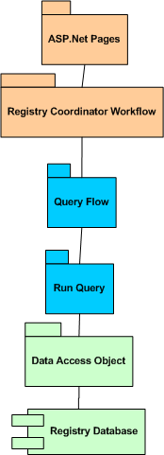
Query

This is the querying engine.

Detailed Architecture Diagram

F7.014.000: Administrator and Registry Coordinators shall be able to query the Registry based on certain fields. | If (admin or rc_logged_in = true && navigated_Page = Query && query_button = selected) {  Query is run  Query results are returned  }  One page will allow for a mix of AND and OR conditions unless it becomes too confusing, if so we will separate these out to two different pages that will handle each – final decision deferred until development.  The results will be returned as a simple grid within Excel, with column headers for each attribute queried on. The column headers would be bolded, or stand out in some similar way. Then, the repeating data will be listed under the column for each attribute queried on. Excel provides for columns to be sortable, so we will not provide a sorting mechanism.

Use Case

Brief description | Registry Coordinator or Administrator queries the registry database on specified fields
User type | Registry Coordinator or Administrator Administrator
Basic Flow of Events | Based on the fields documented in the Field Attribute document, the Registry Coordinator or Administrator may query the database on a certain field, for example, region. Another example which includes the use of functionality for AND-ing and OR-ing fields would be as follows; Registry Coordinator or Administrator would select region AND genetic confirmation
Alternate Flows | If no information for a field which was chosen to query on is available, a message will be returned notifying the Registry Coordinator or Administrator.  If no information for one of the fields chosen in an AND or OR combination, only those fields which do have information will be returned, and a message will be returned notifying the Registry Coordinator or Administrator that there was no information for that field.
Preconditions | Registry Coordinator or Administrator is logged in  Registry Coordinator or Administrator has navigated to the query screen
Postconditions | Query has been run  Query results have been returned

Use Case Diagram

F8.017.000: The system shall support the exportation of Query Results. | If (rc_logged_in = true && navigated_Page = Query && query = run and results = received && export = selected) {  Results are exported to Excel document  }  Users will be able to select the directory in which the results will be saved, along with the file name.  For this release, Excel will be the only document format that will be supported by the exporting functionality. The format of exported data will be tab delimited.

Use Case

Brief description | Registry Coordinator or Administrator exports query results
User type | Registry Coordinator or Administrator
Basic Flow of Events | After the query has been run and the results (if any) have been returned, the Registry Coordinator or Administrator may export those results or choose to print them. The Registry Coordinator or Administrator chooses the name and location of the exported document.  The fields that appear in the final results for the query screen and the exported document, including the queried data, are indicated in the Field Attribute document.
Preconditions | Registry Coordinator or Administrator is logged in  Registry Coordinator or Administrator has run query and received results (if any)  Registry Coordinator or Administrator has chosen to export results
Postconditions | Results have been exported to Excel document

Registry Auto-maintenance
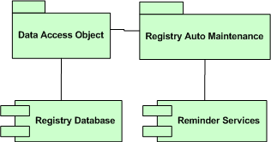

This is the automated task that checks the date of entry with the current date to discover and deal with delinquent accounts. It generated reminders and sets status.

This task, because of task scheduling constraints imposed by the production web hosting environment, will be initiated by the registry coordinator by a new button control in their user interface. This can be run more than once per month, but will only generate one email reminder per month for a user. That way, this task cannot be run time after time and generate many yearly reminder emails to one user.

F10.020.000:  A yearly email reminder will be sent to the patients reminding them to update their information | Equaling a month means within the x month after dateLastUpdated  monthlyReminderSent is reset for each reminder  For each active patient record in the database:  If( today – patient.dateLastUpdated = 11 months  AND !patient.monthlyReminderSent)  then send reminder email  endif
F10.021.000:  A patient will receive consecutive email reminders that will remind him or her to update his or her information before his or her account is disabled due to inactivity | Equaling a month means within the x month after dateLastUpdated  monthlyReminderSent is reset for each reminder  For each active patient record in the database:  If( today - dateLastUpdated = 11 months + 1 month  AND !patient.monthlyReminderSent)  then send second reminder email  endif  For each active patient record in the database:  If( today - dateLastUpdated = 11 months + 2 months  AND !patient.monthlyReminderSent)  then send last reminder email  endif  For each active patient record in the database:  If( today - dateLastUpdated = 11 months + 3 months  AND !patient.monthlyReminderSent)  then send last reminder email  endif  For each active patient record in the database:  If( today - dateLastUpdated = 15 months  AND status != inactive )  then set account status = inactive  endif
F10.022.000:  If the patient fails to update his or her information annually his or her account will be disabled due to inactivity | For each inactive patient record in the database:  If( today - dateLastUpdated = 18 months  AND status != disabled )  then set account status = disabled  endif

Static site content

This is composed of all the error messages, descriptions, help text, header/footer, main site description, and links. This is just HTML (wrapped in asp).

F1.001.000:  The process shall be web-based and indexed by major search engines. | Key words for internet search provided by Jen Farmer:  Friedreich’s Ataxia, Friedreich Ataxia, ataxia, patient registry, registry, clinical trial, FARA  Google allows you to add a site to its index using this page:  http://www.google.com/addurl/?continue=/addurl  Yahoo allows you to add a site to its index using this page:  http://search.yahoo.com/info/submit.html  In addition to submitting the site to these search engines we will also use meta tag keywords to encourage search engines to pick up the site. But our primary means of having them recognize the site shall be through the title’s relevancy.  The general format we will use will be:  <HEAD>  <TITLE>Friedrich’s Ataxia Research Alliance Patient Registry</TITLE>  <META name=”description” content=””>  <META name=”keywords” content=”Friedreich’s Ataxia, Friedreich Ataxia, ataxia, patient registry, registry, clinical trial, FARA”>  </HEAD>

D6.056.000:  A header/footer similar to those found on the FARA website will be used on the home page and subsequent pages. | The header for the site shall consist of:    The footer for the site to be displayed on all pages of the website including the home page:    Main – Will take the user back to the homepage of the registry site  Help – This will be a link to the ‘context help’ popup window which displays a description of the page stating the overall purpose the page as well as all of the tool tips for the fields displayed on this page. This help page will attempt to answer any questions that are being asked regarding that particular page.  Links – This is a link to a page containing just the sister links dealing with FARA, along with other educational websites. The links contained on this page will be identical to the links specified in the right sidebar of the home page and detailed in Section 1.1.4.1 above.  Contact Us – This will be a link that will open a screen in the same window that will display the contact information for the FARA Patient Registry.  The information that will be displayed will be:  Friedreich's Ataxia Research Alliance  2001 Jefferson Davis Highway  Suite 209  Arlington, Virginia 22202  USA  Phone: (703) 413-4468  Fax: (703) 413-4467  Email: fara@FAResearchAlliance.org  Web Site: http://www.FAResearchAlliance.org  You can signup to receive email updates from FARA. Just visit the FARA website and follow the links for our electronic mail list - called e-bulletins. FARA e-bulletins can be received by patients, family and friends.  Feedback – This will link to an email link that will open an email window that will send an email to Jen Farmer with the subject line ‘Feedback’.  Note: Selecting a link on the footer will open a separate popup window that will not affect what the user is doing and will cause no loss of information by clicking on it. This will enable the user to continue doing what they are doing without loosing the information they currently have.

F9.019.000:  The home page will have reminders to Patients that they need to keep their information up to date. | This wording will be located directly underneath the header on the main page right before the site description.  The text will consist of:  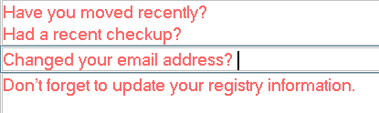

F2.002.000:  The website shall display information about who the registry is looking for and general information about it. | On the main page of the website in the main section directly under reminders in requirement F9.019.000 this text will be displayed.  Text provided by Jen Farmer:  Welcome to the Friedreich’s Ataxia Research Alliance (FARA) patient registry. The purpose of the registry is to collect some basic information on individuals with FA. This information will be used to facilitate and expedite clinical trials and get us all closer to treatments for FA. Basically, this is a way for you to get your name and contact information to researchers who will be conducting clinical research trials. Recruitment for clinical trials can often take a long period of time especially for a rare disease like FA. Your participation in this registry could help speed up that process considerably, because your information would be shared with scientists and companies recruiting patients for FA clinical trials in the near future.  This registry is only for individuals diagnosed with Friedreich’s ataxia. The homepage of this website also includes information on other patient registries and clinical trials.  Preparing to register: When you register you will be asked about your contact information and about your diagnosis. For example, there are questions about your age of onset and genetic testing for FA. For individuals less than 18 years of age, we request that your parent or guardian provide consent for entrance into the registry.

F16.042.000: Links/News/Education Resources will only be made available to the patient on the home page and the page after confirmation of information. | On the right sidebar of the main page these links will be displayed In the Links popup window in the footer these same links will be displayed along with their associated descriptions.  As of right now it will be HTML wrapped into asp.net but in the future we may want to make this more dynamic and have it in an html file so it is easier to maintain.  Text provided by Jen Farmer:  View from the home page on the left of the screen  Links and Resources  Here are some links to resources for additional information regarding patient registries and clinical trials. Some of the sites allow you to search for current clinical trials for a specific disease.  Other Registries  www.cooperative-ataxia-group.org/participate.htm  Clinical Trials  www.clinicaltrials.gov  www.centerwatch.com  www.clinicaltrials.com  www.fda.gov/oashi/clinicaltrials/default.htm  www.clinicalstudyresults.org  View from the Links button at the bottom of all screens  Links and Resources  Here are some links to resources for additional information regarding patient registries and clinical trials. Some of the sites allow you to search for current clinical trials for a specific disease.  Registries  www.cooperative-ataxia-group.org/participate.htm - The National Ataxia Registry serves people who have been diagnosed with Hereditary or Sporadic Ataxia. This is a link to other patient registry for patients with all types ataxia. We encourage individuals with FA to consider participation in this registry as well as the FARA patient registry.  Clinical Trials  www.clinicaltrials.gov - ClinicalTrials.gov provides regularly updated information about federally and privately supported clinical research in human volunteers. This site also has educational information about clinical research.  www.centerwatch.com - CenterWatch.com is a Clinical Trials listing service. You can use this site to find a wealth of information about clinical research, including listings of more than 41,000 active industry and government-sponsored clinical trials, as well as new drug therapies in research and those recently approved by the FDA.  www.clinicaltrials.com -  is a source for comprehensive information for current clinical trials being conducted nationwide. This site has contact information for more than 30,000 health agencies and support groups across more than 3,000 cities in the United States.  www.fda.gov/oashi/clinicaltrials/default.htm - A website from the US Food and Drug Administration (FDA) with information about clinical trials.  www.clinicalstudyresults.org - The ClinicalStudyResults.org site is a central, widely accessible, web-based repository for clinical study results in a reader-friendly, standardized format.

F14.037.000:  An email link will be provided to the Patient in the event that he or she needs help understanding something. | An email link will be provided at the top of the following pages directly underneath the header. Depending on the page where the email link is clicked the e-mail’s subject header will vary.  Informed Consent confirmation screen – email subject header will read ‘Informed Consent Inquiry’  All pages of the registering/updating information process (Initial Screen, Guardian Screen (if applicable), Demographic Screen, Clinical Screen, Account Info Screen) – email subject header will read ‘<screen title> Inquiry’  Guardian error screen – email subject header will read ‘Guardian Age Inquiry’  Confirmation screen displayed at the conclusion of the registration/updating process – email subject header will read ‘General Registration Inquiry’  The text to be displayed will be:  If you need help or have questions about the patient registry feel free to contact the registry coordinator via email <email link>email address</email link>.

F3.004.000:  User declining of Informed Consent shall lead to explanation page. | Text to be provided by Jen Farmer.  To get to the page: Once the user clicks the ‘Decline’ button on the ‘Informed Consent’ screen they will be taken to an explanation page, which will display in the same window as the ‘Informed Consent’ screen.  Format of this page: The header followed by an email link (explained in requirement #F14.037.000) followed by the explanation text.  To leave the page: Beneath the explanation text there will be a button ‘Return to Home’ that will take the user back to the main page of the registry site.  Note: We will need to record a user’s consent to be in the registry. The informed consent document detailing the wording of this agreement is in a separate document entitled ‘introandconsent april 3.doc.

F4.005.001:  In the event that the guardian’s date of birth is not valid (< 18) all information entered will be lost and the user will be rerouted to an error page. | As the user attempts to submit a guardian age that is less than 18 a warning will popup that says:  You have entered an invalid guardian age. It is required that all individuals entering the registry be 18 years of age or have a parent or legal guardian entering information on behalf of individuals less than 18 years of age.  The error explanation text will be the same as in the warning message.  To get to the page: The user must have entered a date of birth less than 18 for the guardian date of birth on the ‘Guardian Screen’ and hit the ‘Next’ button.  Format of this page: The header followed by an email link (explained in requirement #F14.037.000) followed by the explanation text.  To leave the page: Beneath the explanation text there will be a button ‘Return to Home’ that will take the user back to the main page of the registry site.

F14.039.000:  Should an error occur clear, concise error messages will be used to inform the user. | All error messages will be documented in the requirements that they are associated with. They will be stated clearly so as to ensure that the text is approved. The error messages will also be documented in the unit test cases so as to ensure that they are clear enough for the user to understand.  For all system generated exceptions we will be using try/catch blocks to ensure that they are captured and reported to the user/developer as they happen in a way that can be clearly understood so the issue may be resolved and handled by the system gracefully.

Non-Modular Specifications
The following requirements are responsibilities of other parties, or do not fall under any of the design modules. However, they are part of the scope of the first release.

D3.051.000:  A process shall be documented so that a question may be added/modified/deleted by a developer for the registry forms. | The coding of the fields for capturing information will be well documented; data entry modules shall include comments on how to add new questions.

F18.046.000:  People must be able to access the Registry website from the FARA website. | As part of the deployment plan, we will have to coordinate with the person responsible for maintaining the existing FARA website. They will have to add a link to the registry site.

I1.048.000:  The System shall be stand-alone and will not interact with any other system. | We will not need to conduct regression testing on other systems. We will not need to work with any existing systems.

PI1.058.000:  There are minimal constraints for date and time of deployment | Once the testing has been accomplished, the only constraint for deployment is that the RIT team is still in the Rochester area long enough to provide initial support.
PI2.059.000:  Once data is entered it must be stored in a secure location. Physical location depends on architecture structure defined, and must also meet HIPAA requirements for PHI (personal health information). | The EDS/FARA members responsible for the hosting contract will ensure that the hosting company provides sufficient security to comply with the laws.
PI2.060.000:  A secure connection will be used after the user has logged in. | From the time that they click on the Register or Login links, the web server will use a HTTPS connection. Any certificate needed will be obtained when the web host is finalized.
PI3.061.000:  Successful completion of UAT testing is required before the solution is implemented into production. | The deployment plan will not go into effect until we have a customer signoff on the system.
PI4.062.000:  Training materials and a user manual shall be completed and delivered with the product. | These materials will be provided for Registry Coordinator functions. Help functionality for patients has been provided for in Module 10.
PI5.063.000:  Successful dry run using the model office environment. | EDS will provide the model office environment. This will allow us to do a final “live” test on the system prior to going live.
PI6.064.000:  Architectural design will dictate the PI requirements. | Once EDS/FARA has determined the final hosting architecture, that will be the main physical requirement.
PI7.065.000:  There is no one-time data load to initially load data into the database. | There will be no data collection en masse from any existing information storage.

Database Model

The user account table is the central important part of the system. It contains the account information and ties everything together. Once this is set up when a user registers, it should generally only need to be changed if they alter an email address or change a password. There are seven foreign keys: bySecurityQuestion, byAccountLevel, byAccountStatus, byReferralType, byDemographicsID, byGuardianDemoID, and byClinicalID. The byDemographicsID key associates a user to their demographic information, and if there was a guardian the byGuardianDemoID associates that user to the guardian’s demographic information (this will be null if there is no guardian).

Field | Data Type | Size | Required?
IbyUserID | Byte (Auto-Increment) | - | Y (index)
user_emailAddress | Varchar | 70
user_loginName | Varchar | 70 | Y
user_loginPassword | Varchar | 8 | Y
bySecurityQuestion | Byte | - | Y
securityAnswer | Varchar | 40 | Y
byAccountLevel | Byte | - | Y
byAccountStatus | Byte | - | Y
bSendAdditional | Bit | - | Y
byReferralType | Byte | - | Y
byDemographicsID | Byte | - | Y
byGuardianDemoID | Byte | - | N
byClinicalID | Byte | - | Y
dtDateLastModified | Datetime | - | Y
dtDateMonthlyReminderSent | Datetime | - | N

The change log table is meant to capture the information for changes made to a user’s information. There will be a one-to-one correspondence between fields changed and entries. Entries are associated with the user that had the change done and the user that made the change. The GroupByChangeAction field is an ID that groups changes together in the action that was performed.

Field | Data Type | Size | Required?
IInChangeID | Integer (Auto-Increment) | - | Y
InGroupByChangeAction | Integer | - | Y
dtDateOfChange | Datetime | - | Y
byUserChanged_userID | Byte | - | Y
byChangedBy_userID | Byte | - | Y
changed_fieldName | Varchar | 30 | Y
previousValue | Varchar | 100 | Y
newValue | Varchar | 100 | Y

The communications log table provides a way for Coordinators to add notes to a patient that are visible to the coordinator-only.

Field | Data Type | Size | Required?
IbyCommunicationID | Byte (Auto-Increment) | - | Y
dtDateOfEntry | Datetime | - | Y
byUserLogOwner_userID | Byte | - | Y
byEnteredBy_userID | Byte | - | Y
logEntryText | Varchar | 250 | Y

The security question table is a lookup table for the security question text.

Field | Data Type | Size | Required?
IbySecurityQuestion | Byte (Auto-Increment) | - | Y
questionText | Varchar | 100 | Y

The account level table is a lookup table for the account level text. There are three account levels - Patient, Coordinator, and Admin

Field | Data Type | Size | Required?
IbyAccountLevel | Byte (Auto-Increment) | - | Y
levelDescription | Varchar | 100 | Y

The account status table is a lookup table for the account status text. There are four account statuses - Pending, Active, Delinquent, and Disabled.

Field | Data Type | Size | Required?
IbyAccountStatus | Byte (Auto-Increment) | - | Y
statusDescription | Varchar | 100 | Y

The referral table is a lookup table for the “referred by” text.

Field | Data Type | Size | Required?
IbyReferralType | Byte (Auto-Increment) | - | Y
referralDescription | Varchar | 100 | Y

The Consent table captures their acceptance of the Consent statement. This table used to be the HIPAA table, but was renamed per comments raised in the design review meeting.

Field | Data Type | Size | Required?
IbyConsentID | Byte (Auto-Increment) | - | Y
byUserID | Byte | - | Y
dtDateConsentAccept | Datetime | - | Y

The demographics table has demographic information for both the United States and for non-US patients. It allows for freeform entry of country and region if it is not a part of the pre-populated listings.

Field | Data Type | Size | Required?
IbyDemoID | Byte (Auto-Increment) | - | Y
byCountryID | Byte | - | N
freeformCountry | Varchar | 50 | N
firstname | Varchar | 100 | Y
chMiddleInitial | Varchar | 1 | N
lastname | Varchar | 100 | Y
dtDateOfBirth | Datetime | - | Y
byAge | Byte | - | Y
addressLineOne | Varchar | 100 | Y
addressLineTwo | Varchar | 100 | N
city | Varchar | 100 | Y
byRegion | Byte | - | N
freeformRegion | Varchar | 50 | N
postalCode | Varchar | 10 | Y
chPhoneNumber | Char | 12 | Y

The country table is another lookup table, for the country name, phone country code, and the label to use for the country’s region field (i.e. State, Province, etc…).

Field | Data Type | Size | Required?
IbyCountryID | Byte (Auto-Increment) | - | Y
countryName | Varchar(100) | - | Y
chPhone_CountryCode | Char | 2 | Y
regionFieldLabel | Varchar | 20 | Y

The regions table is used to map regions to countries, and label the regions.

Field | Data Type | Size | Required?
IbyRegion | Byte (Auto-Increment) | - | Y
byCountryID | Byte | - | Y
regionName | Varchar | 100 | Y

The clinical table has the clinical information about the patient. Because the FARA customer has said that some fields depend on each other, and the patient might not know all the information, most of the fields in this table are not mandatory.

Field | Data Type | Size | Required?
IbyClinicalID | Byte (Auto-Increment) | - | Y
byAgeOfOnset | Integer | - | N
byAgeOfDiagnosis | Integer | - | N
bGeneticConfirmation | Bit | - | Y
chTripletRepeat1 | Char | 4 | N
chTripletRepeat2 | Char | 4 | N
chPointMutation | Char | 10 | N
chAlleleSize1 | Char | 10 | N
chAlleleSize2 | Char | 10 | N
bFamilyMember | Bit | - | Y
enumWhichMember | Byte | - | N
byDisabilityStatus | Byte | - | Y
bDiabetes | Bit | - | Y

The disability status rating scale is another lookup table, for the disability status scale. For more information on this scale, see the “Functional Rating Scale for FA” document available on the senior project site (http://www.se.rit.edu/~cortez) listed under the Requirements section of the Documents page.

Field | Data Type | Size | Required?
IbyDisabilityStatus | Byte (Auto-Increment) | - | Y
statusDescription | Varchar | 100 | Y

The family member table is another lookup table for the type of relationship to the patient.

Field | Data Type | Size | Required?
IbyDisabilityStatus | Byte (Auto-Increment) | - | Y
statusDescription | Varchar | 100 | Y

Process Flow Diagram

