Prototype 1

Common
Home
Login
Bad Login

New Patient
Consent
Enter Demographic Information
Enter Clinical Information
Enter General Information
Confirm Information Entry
Process Complete

Returning Patient
Returning Patient Information Overview
Update Demographic Information
Update Clinical Information
Update General Information
Confirm Information Update

Registry Coordinator
Main Screen
New Registrants Pending
Confirm Patient Registry
Edit Demographic Information
Edit Clinical Information
Edit General Information
Edit Information Update
Query
Query Results
Statistical Reports

Home:
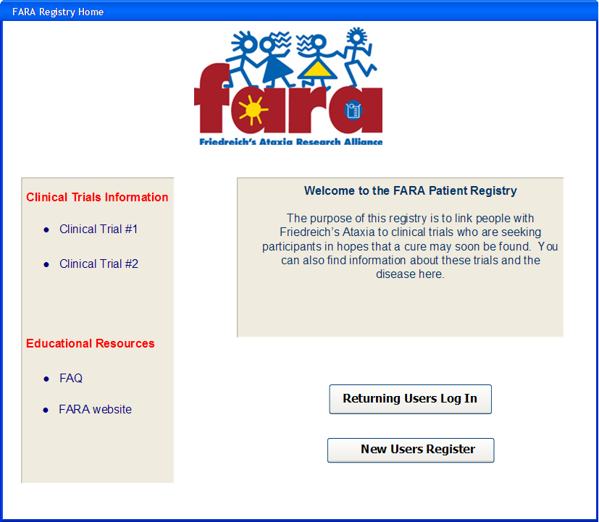
Login:
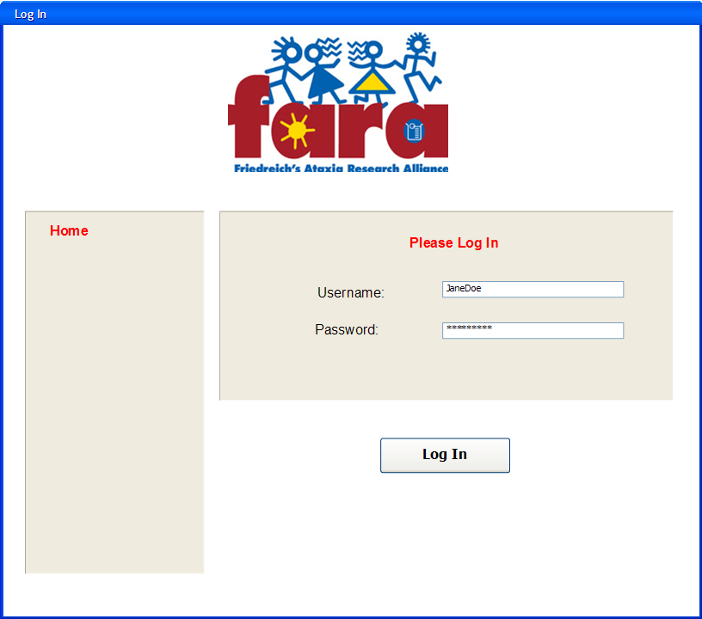
Bad Login:
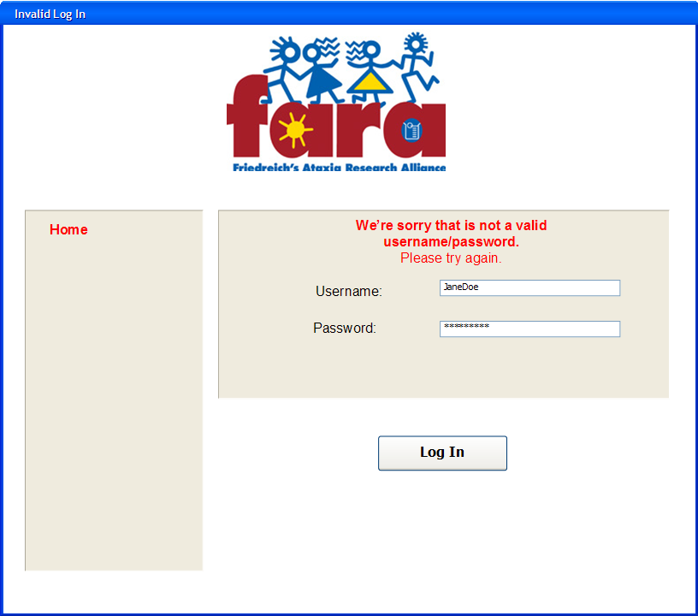
Consent:
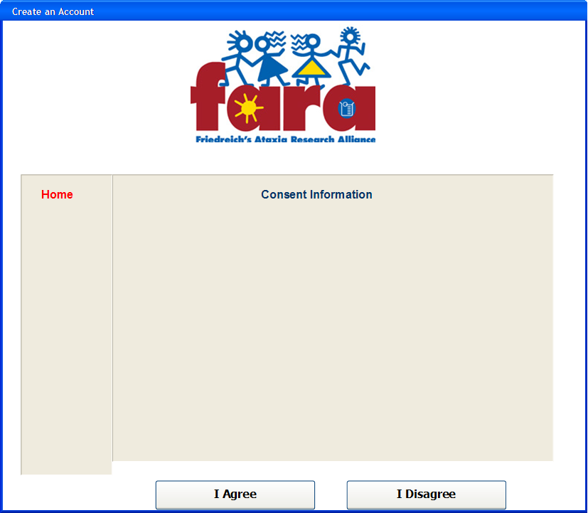
Enter Demographic Information:
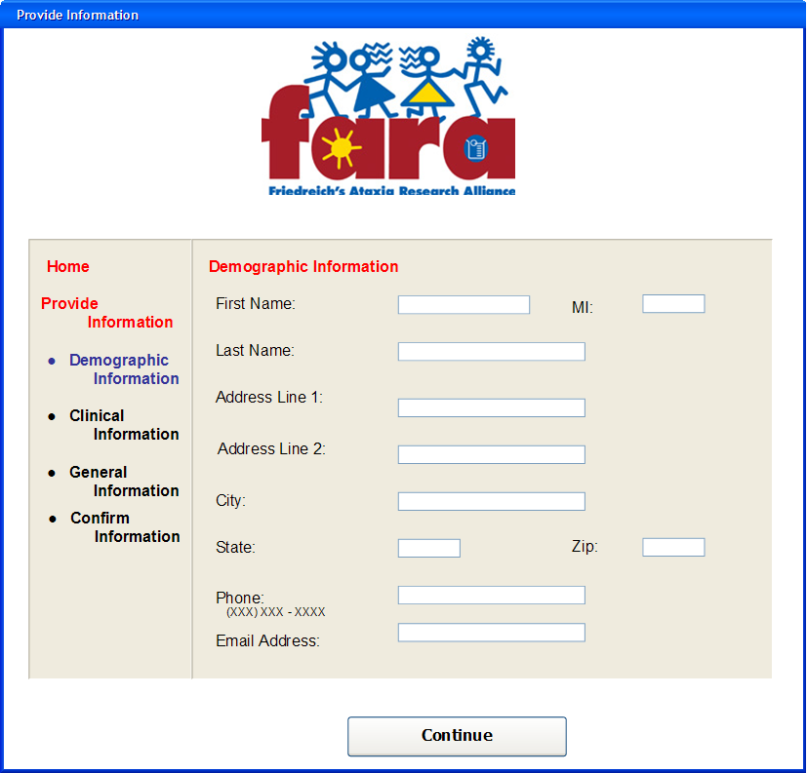
Enter Clinical Information:
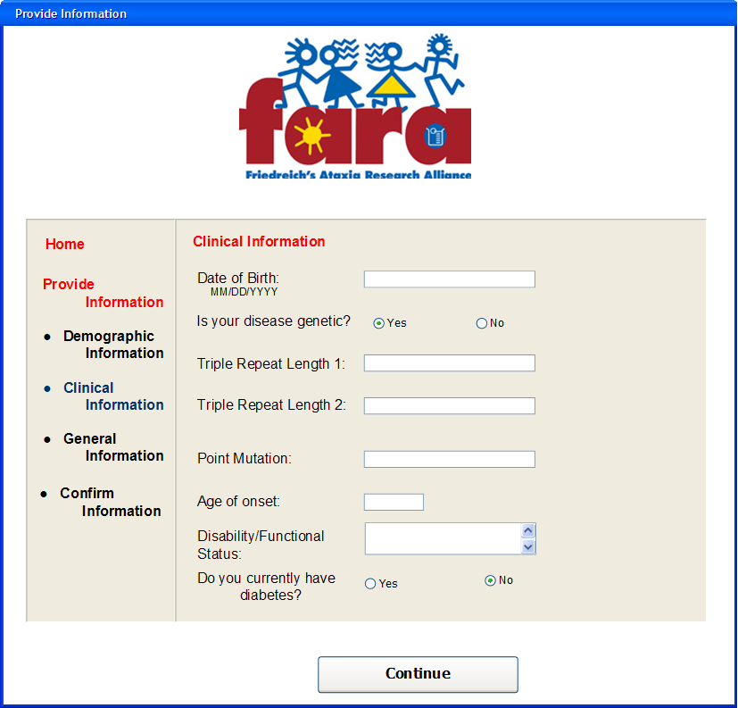
Enter General Information:
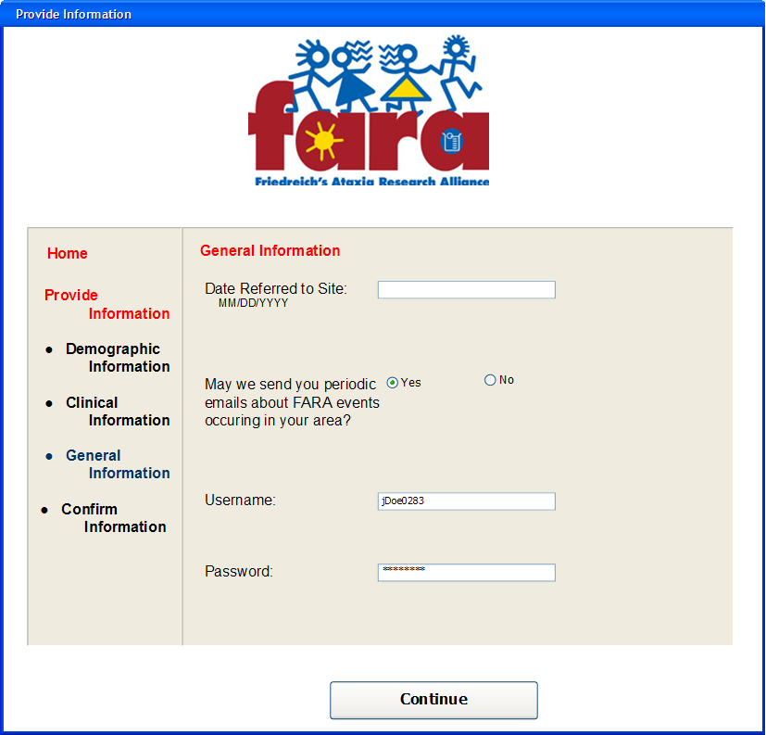
Confirm Information Entry:
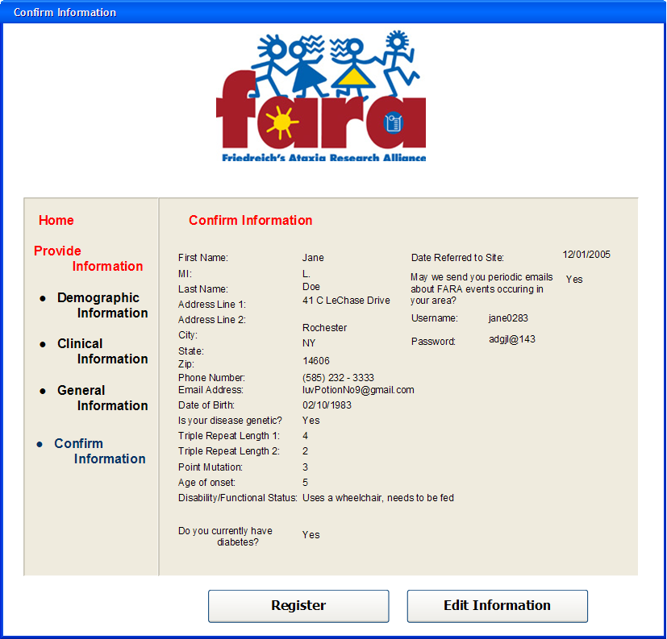
Process Complete:
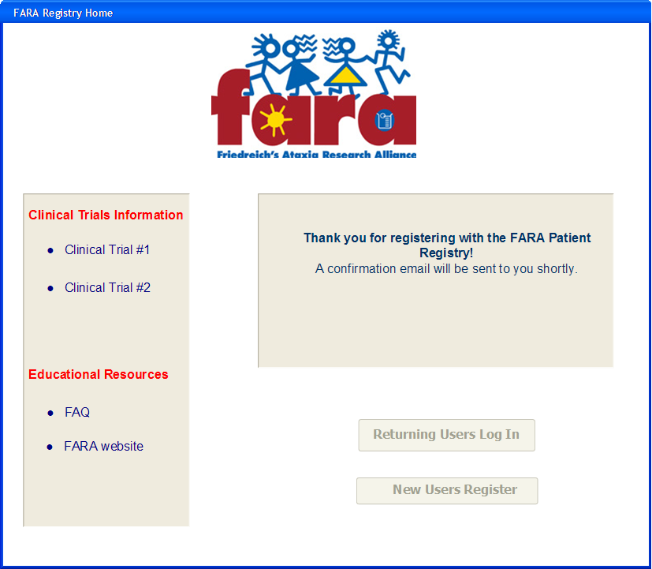
Returning Patient Information Overview:
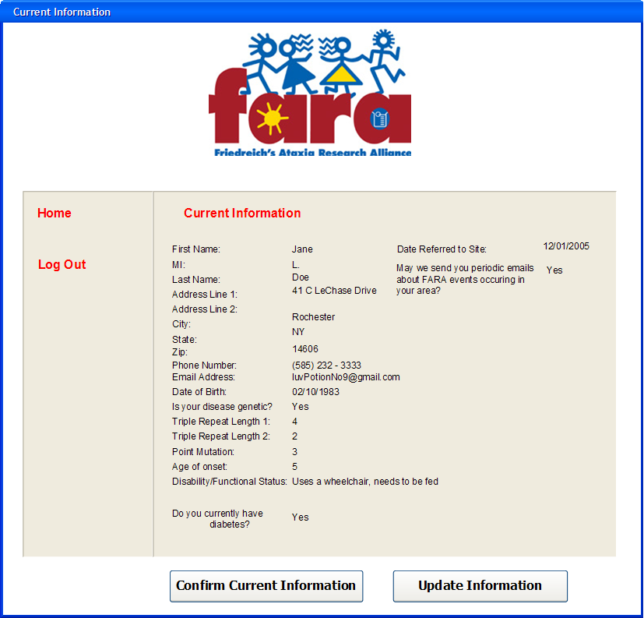
Update Demographic Information:
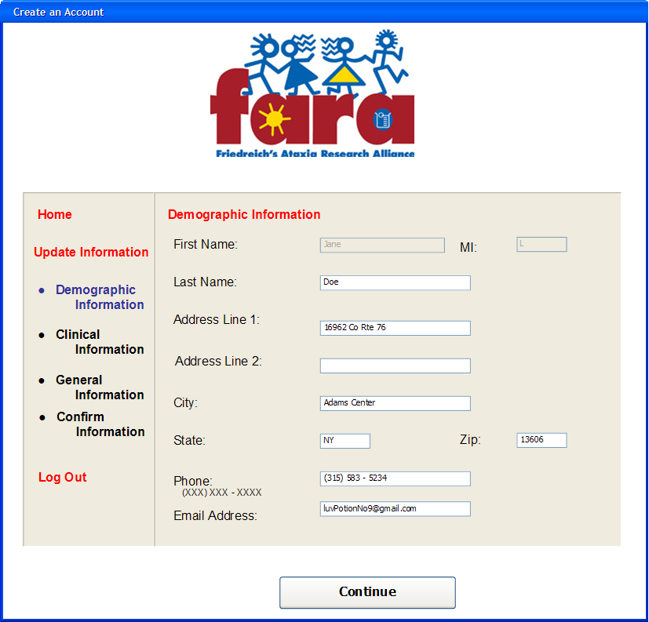
Update Clinical Information:
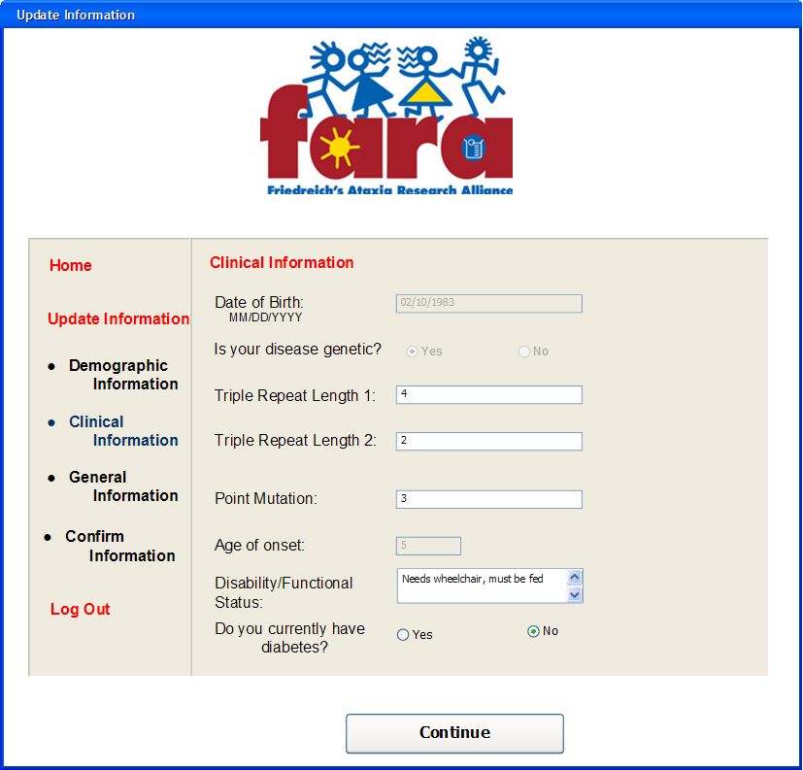
Update General Information:
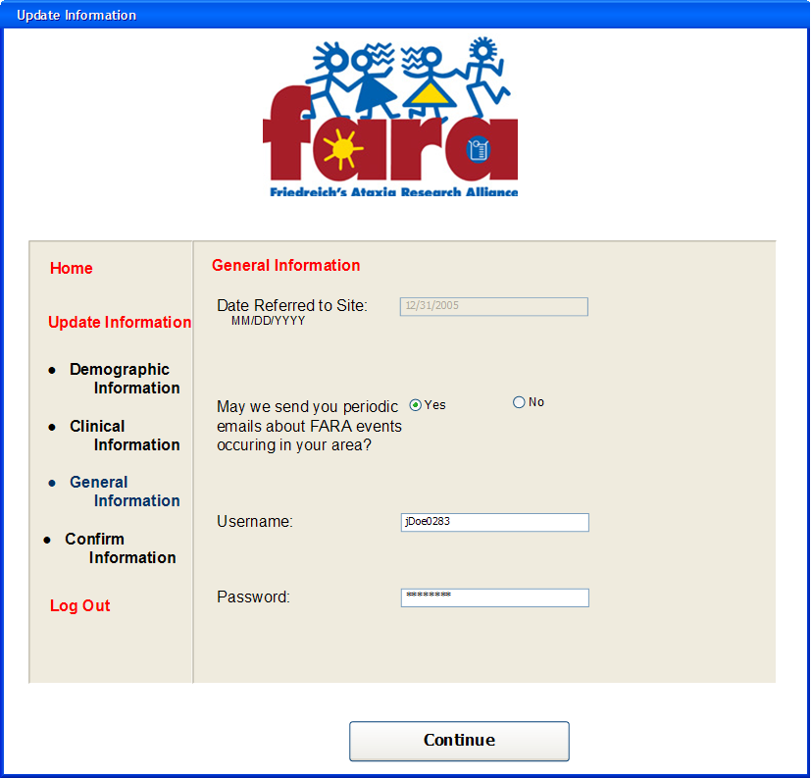
Confirm Information Update:
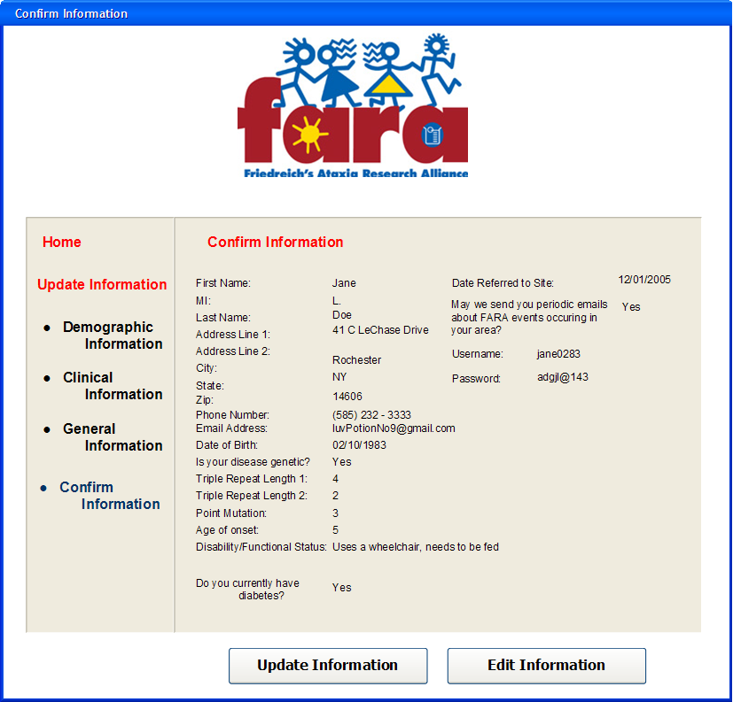
Main:
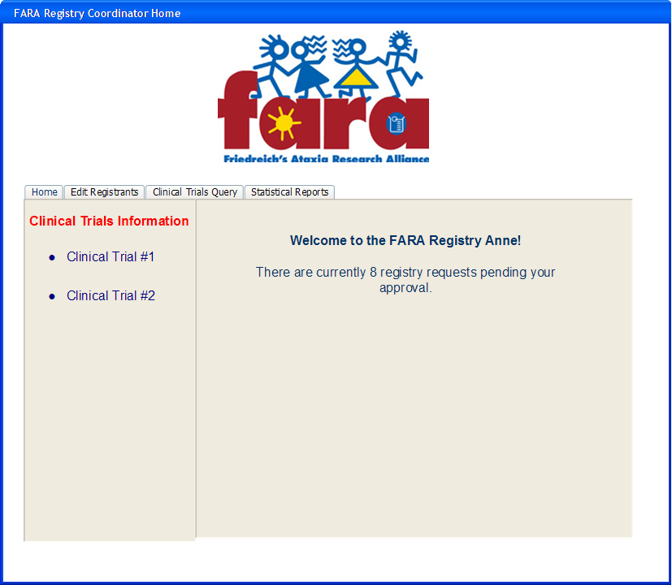
New Registrants Pending:
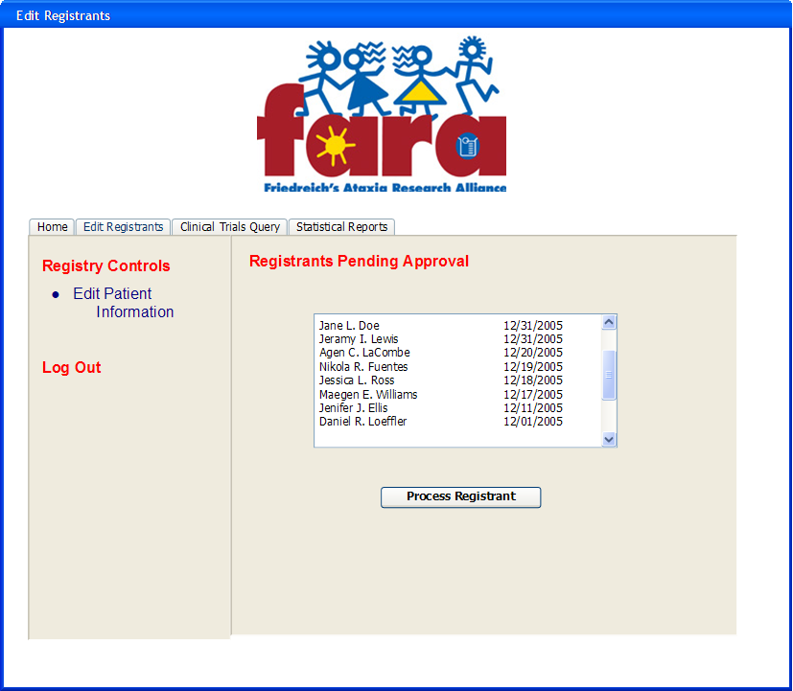
Confirm Patient Registration:
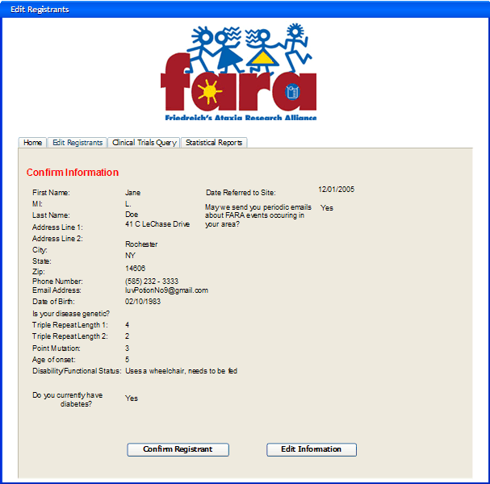
Find Patient:
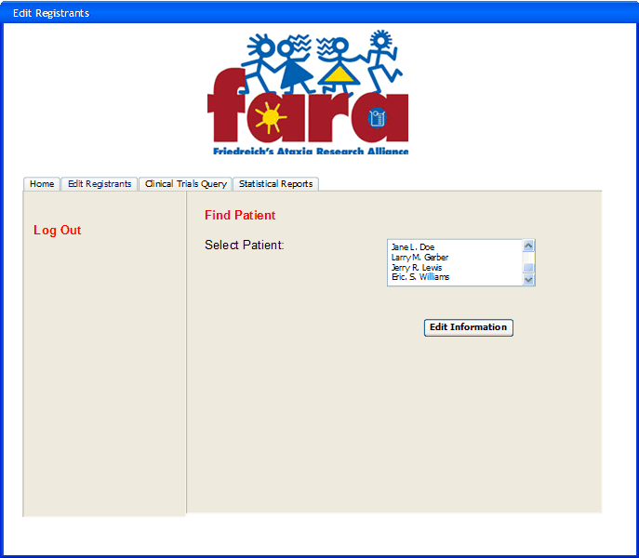
Edit Demographic Information:
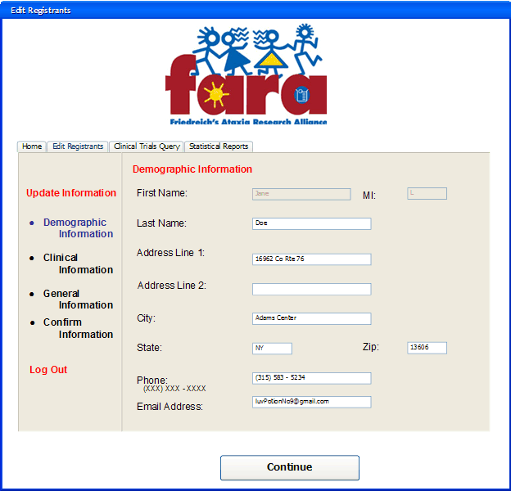
Edit Clinical Information:
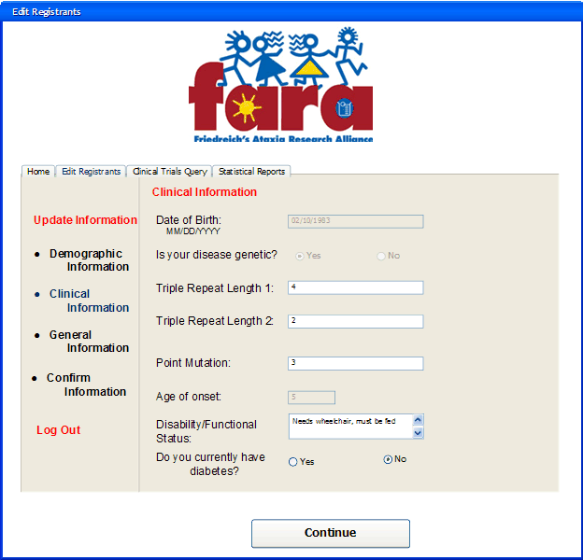
Edit General Information:
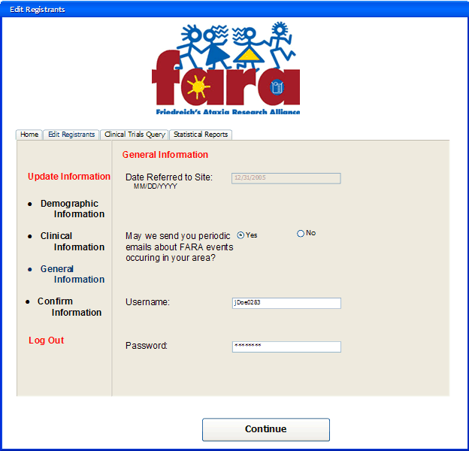
Query:
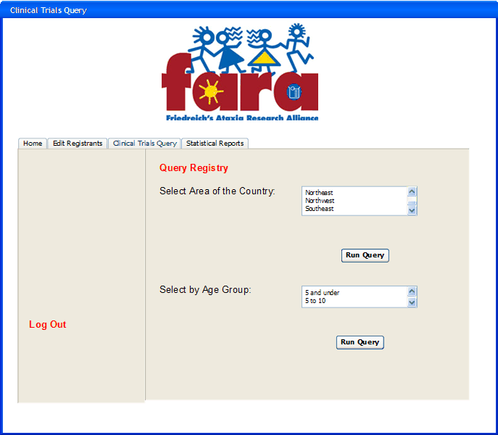
Query Results:
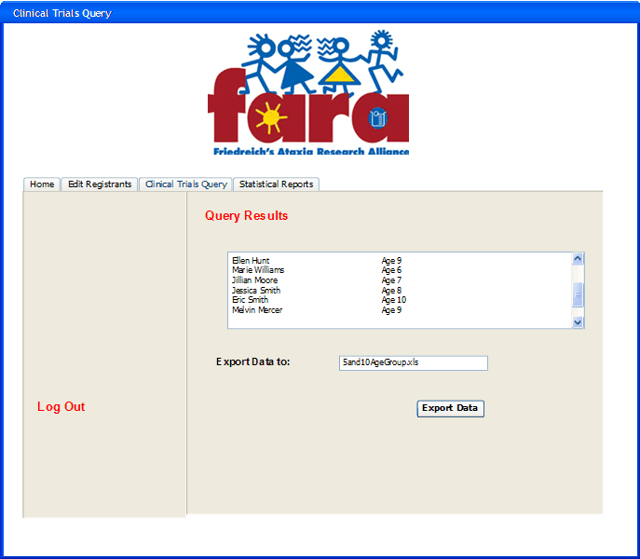
Statistical Reports:
