Prototype 2

Common
Entry Page
No Pin
Password Reminder

New Patient
Consent
Enter Information
Guardian Information Needed
Enter Guardian Information
Confirm Information Entry
Process Complete

Returning Patient
Update Information
Confirm Information Update

Registry Coordinator
Main Screen
Edit Information
Query
Query Results
Statistical Report Generation
Statistical Reports

Entry Page
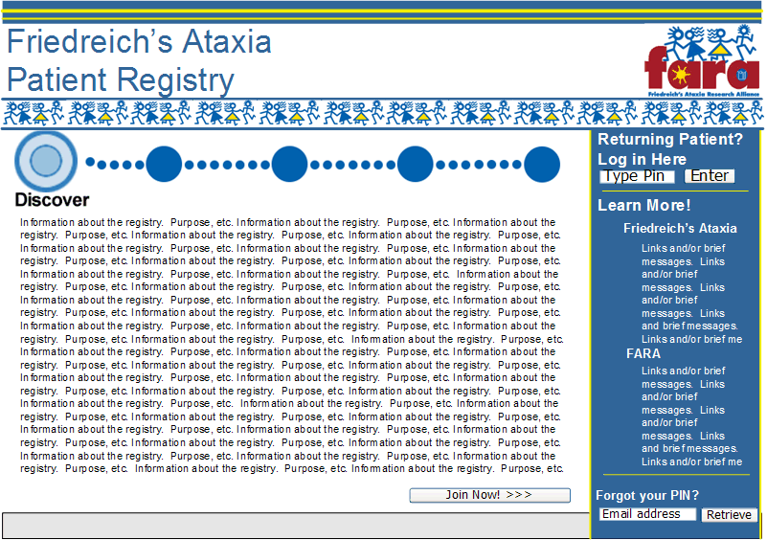
No Pin:
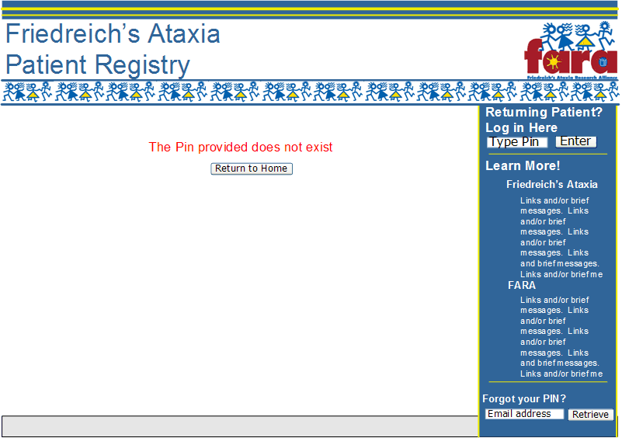
Password Reminder:
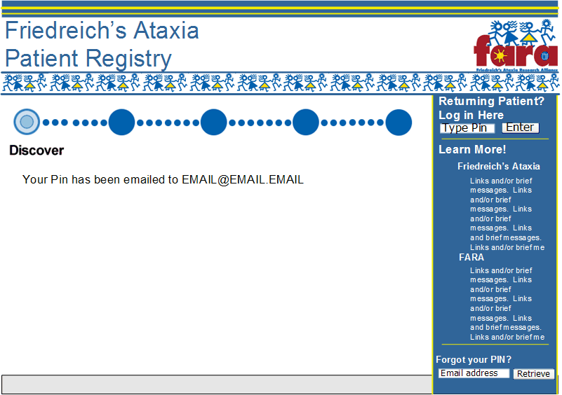
Consent:
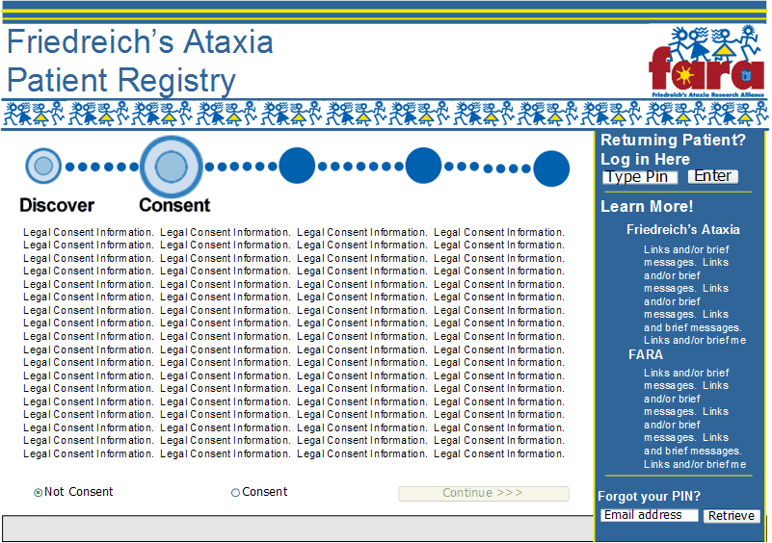
Enter Information:
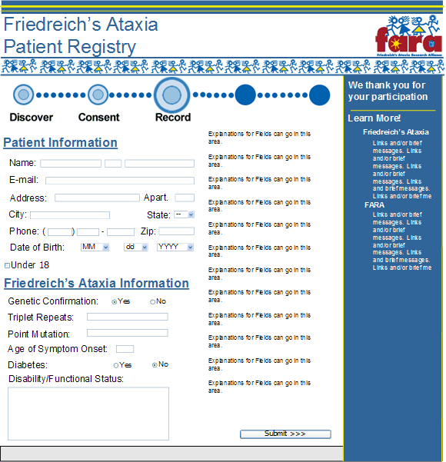
Guardian Information Needed:
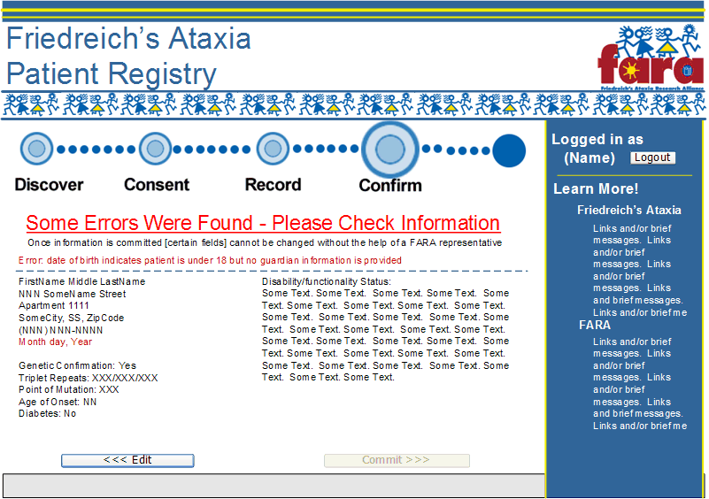
Enter Guardian Information:
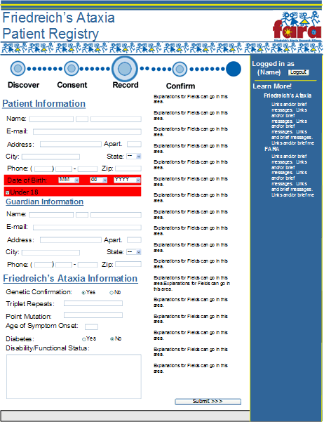
Confirm Information Entry:
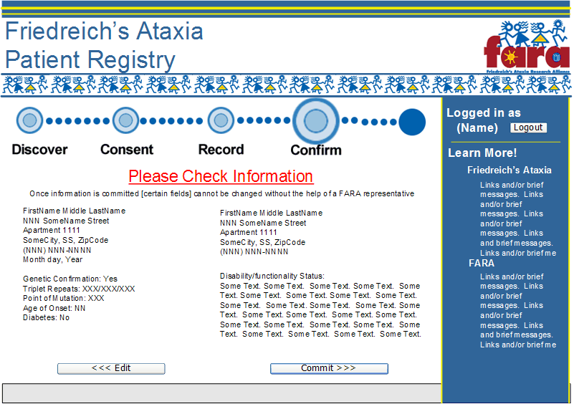
Process Complete:
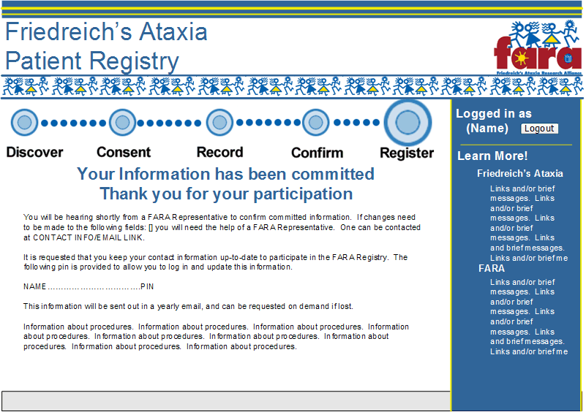
Update Information:
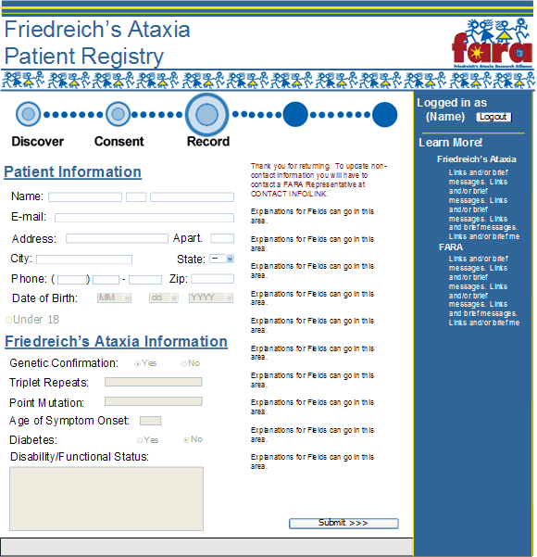
Confirm Information Update:
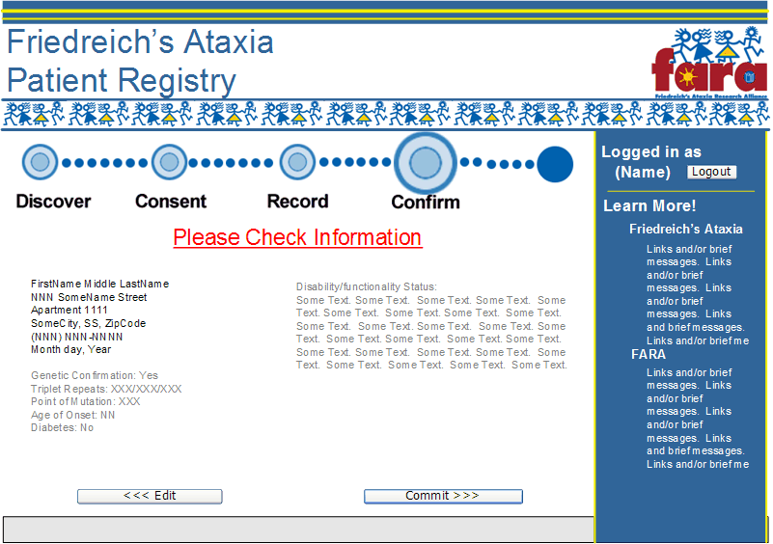
Main:
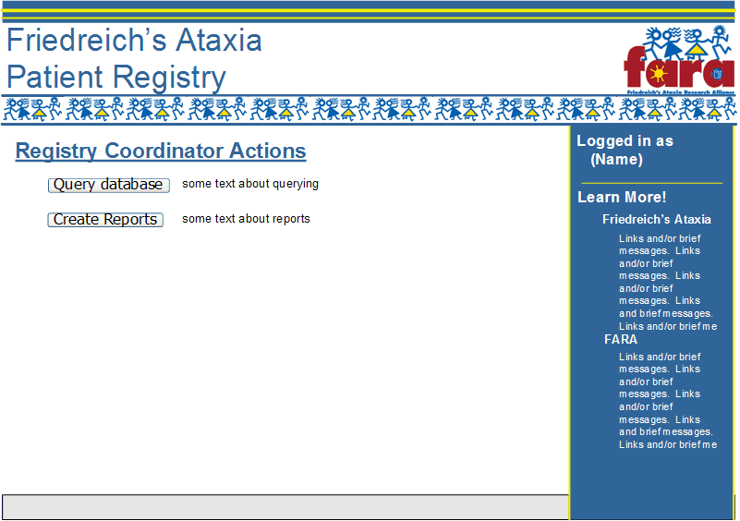
Edit Information:
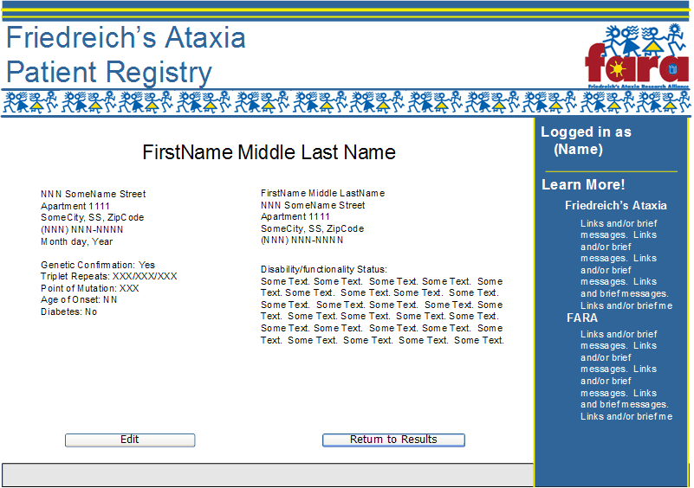
Query:
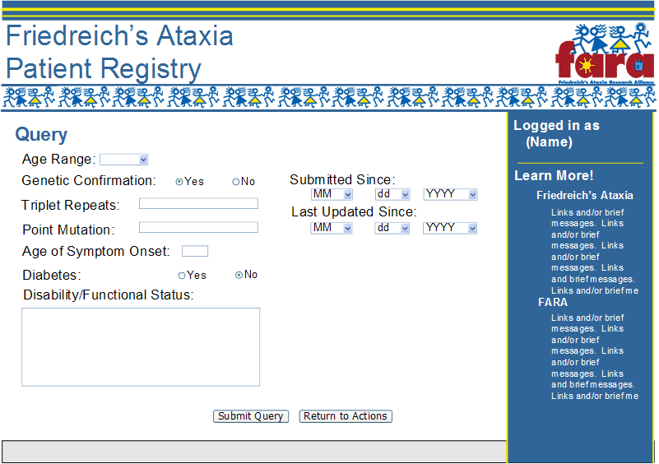
Query Results:
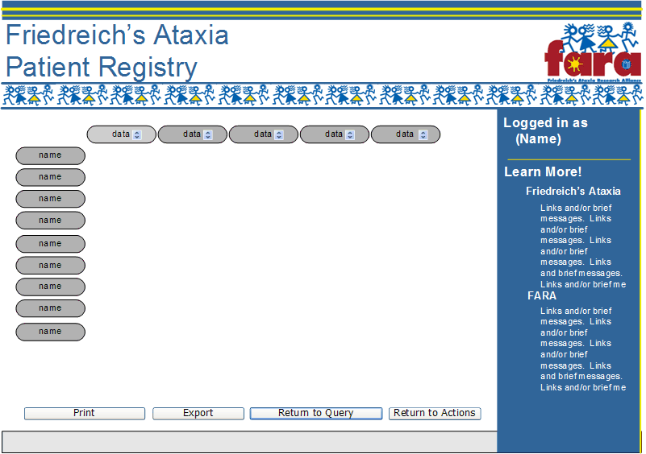
Statistical Report Generation:
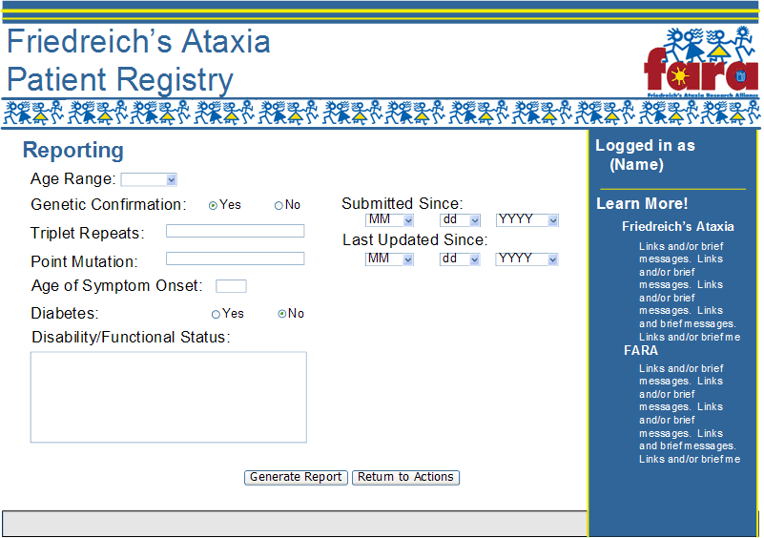
Statistical Reports:
