Prototype 3

Common
Home
Bad Login

New Patient
Consent
Enter Information
Confirm Information Entry
Process Complete

Returning Patient
Update Information
Information Update Complete

Registry Coordinator
Home
Register as Coordinator
Confirm Entry
Process Complete
Edit Information
Edit Complete
Query
Query Results

Home:
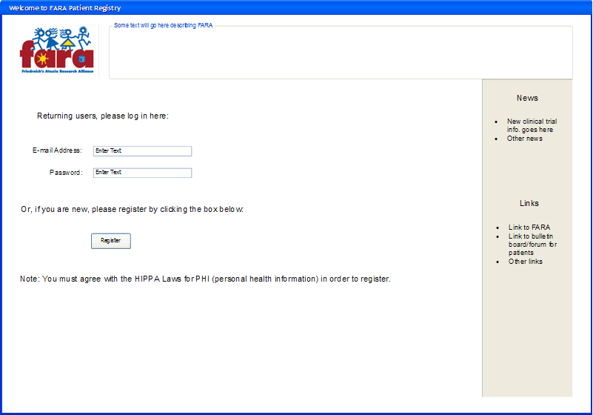
Bad Login:
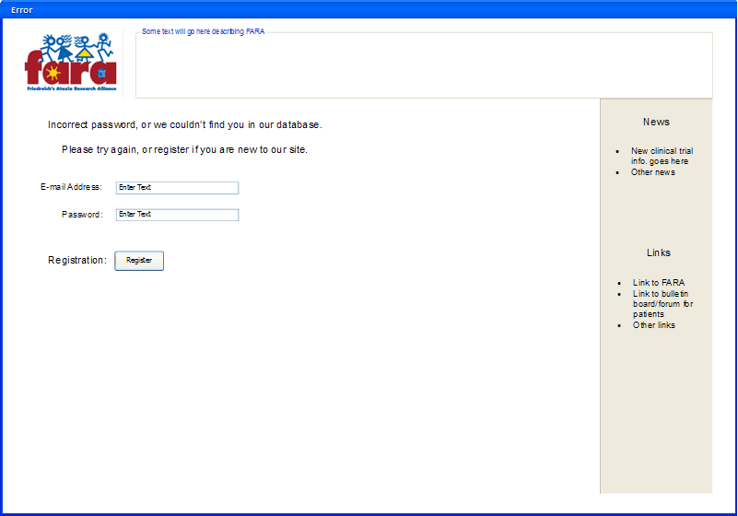
Consent:
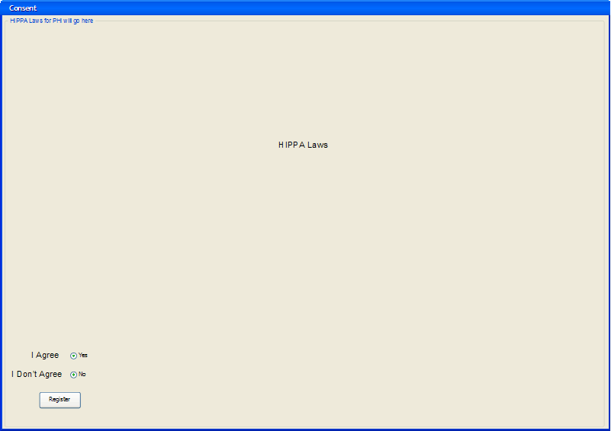
Enter Information:
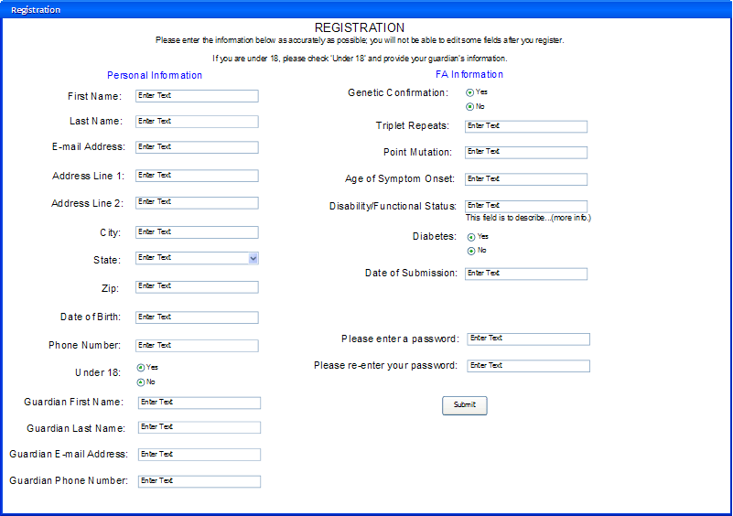
Confirm Information Entry:
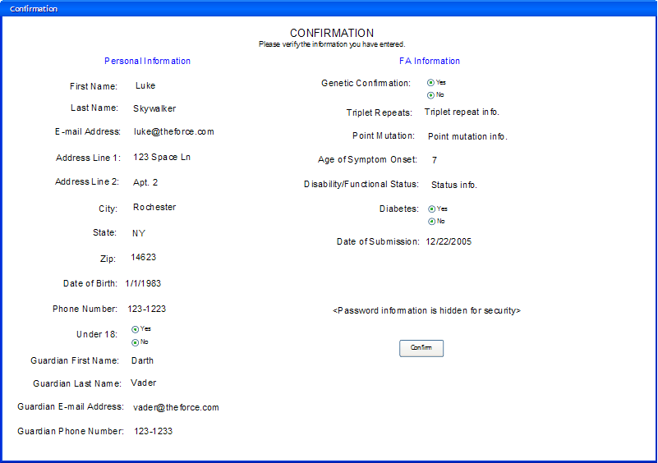
Process Complete:
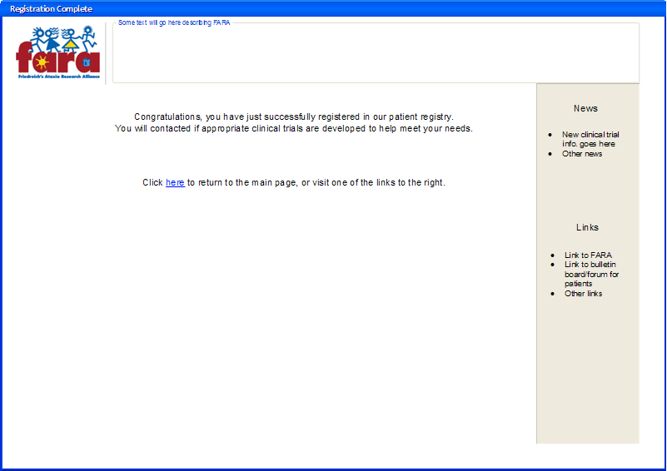
Update Information:
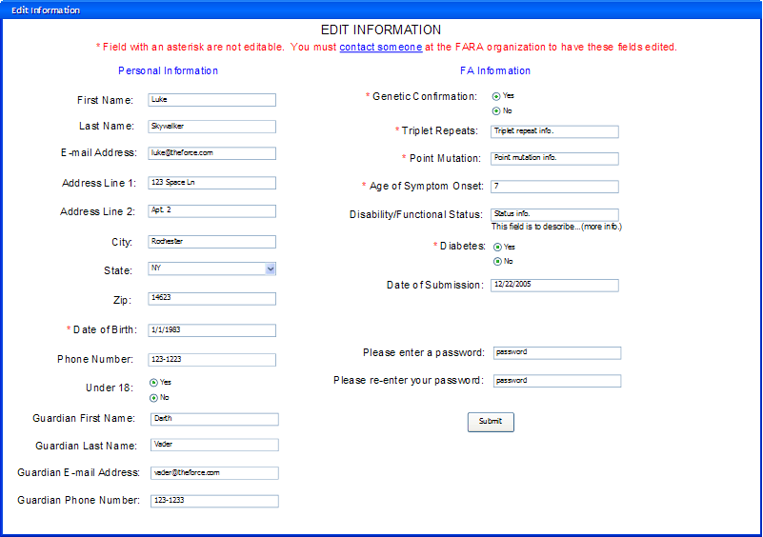
Information Update Complete:
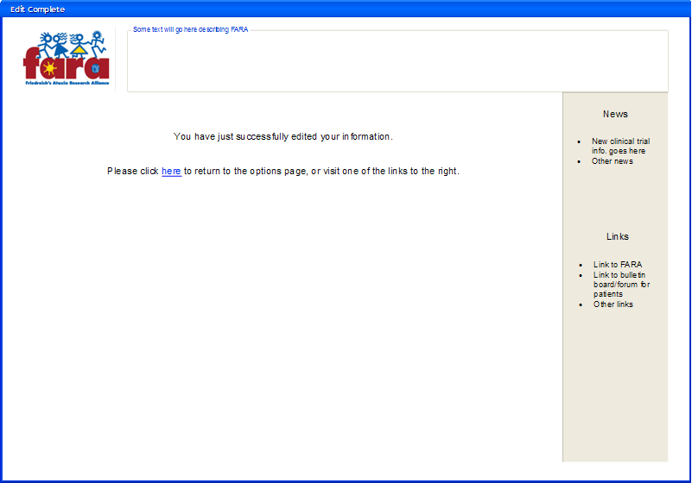
Main:
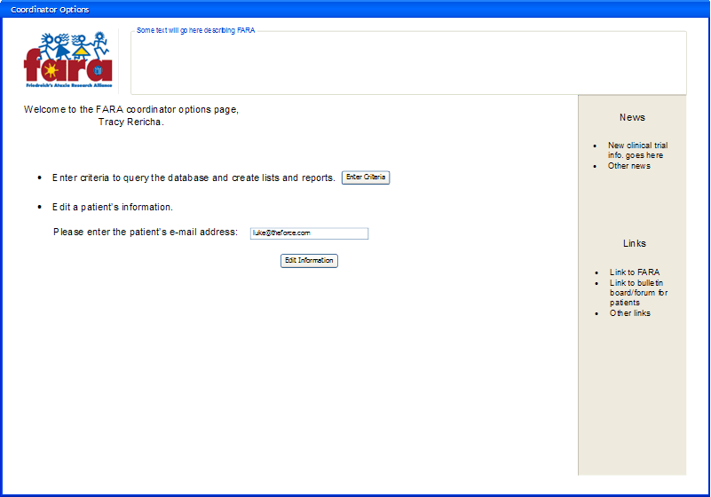
Register as Coordinator:
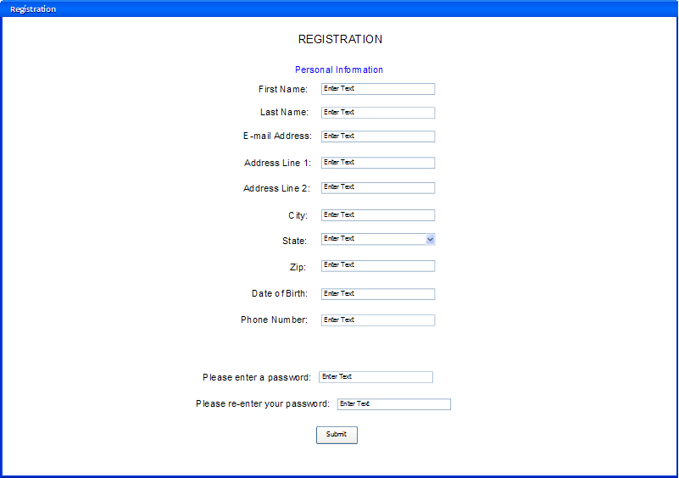
Confirm Entry:
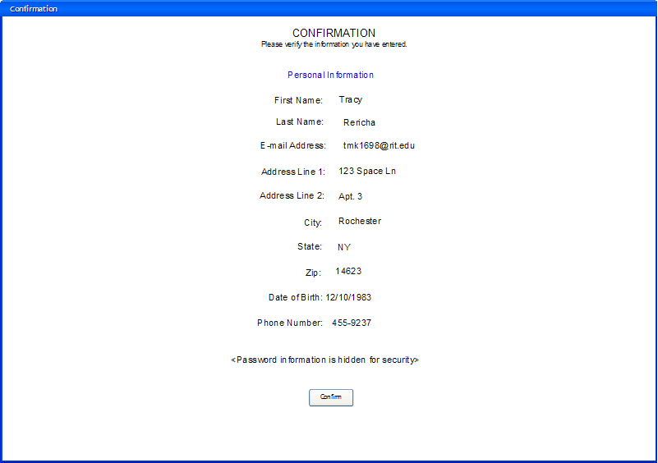
Process Complete:
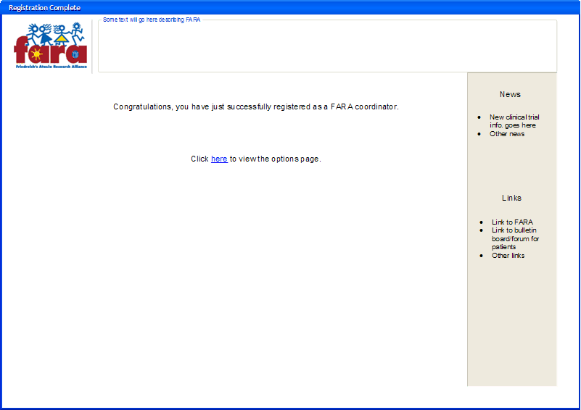
Edit Patient Information:
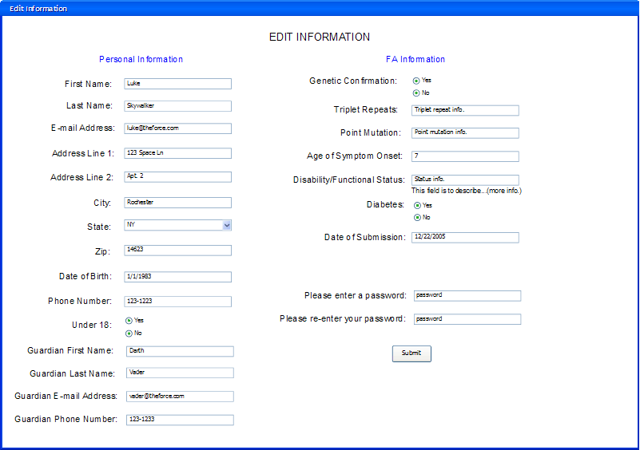
Edit Complete:
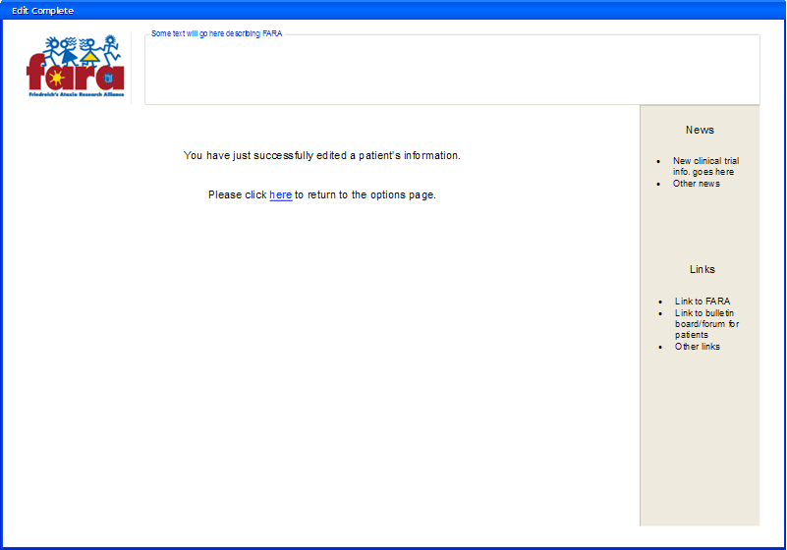
Query:
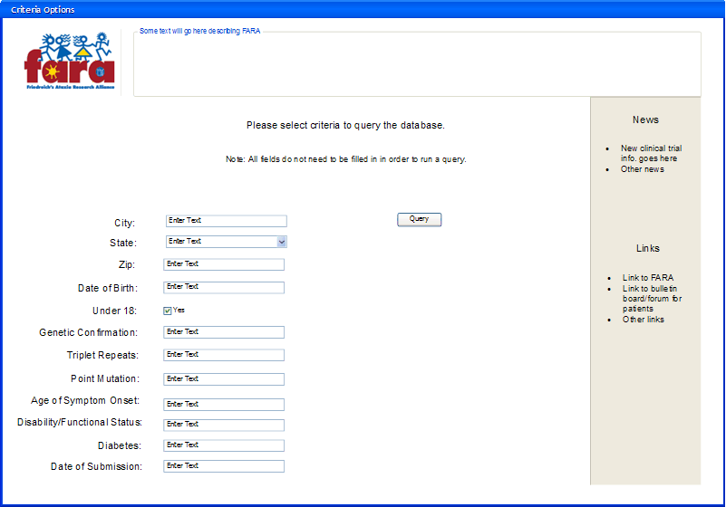
Query Results:

