Project Plan

for

Wegmans Deli Kiosk
Version 1.1
Prepared by DELI-cious Developers
Rochester Institute of Technology
September 15, 2013

Table of Contents
1. Process 3
1.1 Methodology 3
1.2 Project Management 3
2. Deliverables 6
2.1 Weekly Deliverables 6
2.2 Project Deliverables 6
3. Schedule 10
4. Schedule Timeline 11
5. Risks and Mitigation 12

1. Process

1.1 Methodology
The team has decided to use the incremental build model for the process methodology of the project. An incremental build model utilizes an iterative development process, building off of previous progress. This model combines the elements of the waterfall model with the iterative philosophy of prototyping. At the end of each stage, more functionality and features are added until the product is ultimately finished. The success of this model is tied closely to the fact that it involves both development and maintenance.

Because of various unknown aspects in the project, we feel it is beneficial to utilize prototypes, build on feedback and previous experience for each revision of the project. Additionally, there are many constraints placed on the system by the sponsor. Many of these constraints involve technologies that the team has not worked with before. By doing staged releases, the team will be able to generate a working prototype early in development, which will help the team to ensure that the final product will be able to work within the specified constraints.

Unlike scrum sprints, where individual features are prioritized, the focus will be on mitigating known risks, and evolving the working prototype during each iteration. This will help both the development team, and the stakeholders to understand where the project is going, and adjust accordingly.

For more information about the incremental build model and our research into alternate process models, please refer to the Process Methodology.docx.

1.2 Project Management
The team will use many different technologies and mechanisms to track progress, document the various aspects of the project, and ensure that the project stays on track.

Technologies
Microsoft Project
Microsoft Project will be used to track the team’s progress during the project’s lifecycle. There the team will define tasks for the project which will be assigned to each team member and tracked. Additionally, Microsoft Project provides the ability create charts and setup a web interface that the project sponsor and team coach can access in order to track the team’s progress.

Weebly.com
The team must maintain a project website in order to provide visibility to project sponsor and the Software Engineering department. Also, this website gives the team a place to post their documentation and project progress. Weebly.com is a free web application used for building websites quickly and easily. Additionally, it allows you to export all of the code so that you can place it on your own web server after creating the site.

Google Drive
The team will have a great deal of documentation that will need to be maintained and collaborated on by each team member. Google Drive will allow the team to create documents and collaborate on them.

Lucid Chart
In addition to the documentation that will be handled by Google Drive, the team will need to generate numerous diagrams and will use Lucid Chart to make them. Lucid Chart is a web application that allow people to make diagrams online and collaborate on them much like you would in Google Drive.

Process
Meetings
The team will hold two meetings every week, on Tuesdays and Thursdays. The Tuesday meeting will function as a meeting for the team and the team coach. During these Tuesday meetings, the team will discuss project progress and determine what they want to accomplish for the rest of the week. Thursday meetings will be the time set aside to meet with the project sponsor. In these meetings, the team will discuss the project’s progress and determine the next steps for the project. Additionally, the team will hold extra meetings as necessary.

Start and End of Each Week
The team has decided that the start of each week will be on Mondays and that each week will end on Sunday. That means that all week for the previous week must be completed at the end of Sunday night, including, updating the team time tracking and project metrics.

Time Tracking
At the beginning of each week, each team member will estimate the tasks that they need to complete for the week, along with the time estimates for each task. At the end of the week, each member will record their actual time that spent during the week.

Project Metrics
Each week, the team will track various metrics that relate to the project. These metrics will include things such as the total number of tasks estimated versus the total number completed for each week, among others.

Roles
Dan Larsen - Team Coordinator/Leader
Jared Schutt - Website Coordinator
Timothy Heard - Sponsor Communicator
Warren Shaw - Meeting Scribe

2. Deliverables

2.1 Weekly Deliverables

Deliverable | Description
Time Tracker | The team will estimate tasks for each week and then record the actual time spent on each task.
Project Metrics | Team will record various metrics for the project each week. These metrics will include metrics for the project process, technical approach, and individual metrics.
Project Website | The team will maintain a public website where they can display their documentation and allow the project sponsor to view the project’s progress.
Weekly Sponsor Meeting Agenda | The team will create an agenda for each sponsor meeting. They will finish this agenda and send it out to the sponsor by the end of Tuesday, each week.

2.2 Project Deliverables

Deliverable Date | Deliverable Name | Description
8/26 | Start of Iteration 1 | Start of project iteration
9/9 | Questions Elicitation | The team will discuss plans for the project with the project sponsor, record these answers, and analyze them for the next stage of development
9/9 | Project Synopsis | The team will define the vision and purpose for the project and make it available to all project stakeholders.
9/16 | Process Methodology | The team will evaluate different process methodologies and select one which the team deems to be the most appropriate. The selected methodology will be formally documented and discussed with the project sponsors.
9/30 | Project Scope and Technology Complete | The team will determine the scope for the final product and all of the prototypes leading to it. Additionally, the team will determine the technologies that will be used for the final solution.
9/23 | Software Requirements Specification | The team will organize and refine the project requirements into an organic document that will be revisited during each iteration of the project lifecycle.
9/30 | Requirements Review | The team will define set requirements for the system that shall be reviewed by the project sponsor
9/30 | Start of Iteration 2 | Start of project iteration
10/7 | Architectural Review | The team will hold an Architectural Review with the project sponsors. The feedback from this review will help the team complete the final design.
10/11 | Mid-Term Peer Evaluation | Team members must submit peer reviews of each of their team members at the mid-point of the Fall Semester.
10/14 | Architectural Design Complete | The team will complete the architectural design and deliver an architectural design document.
10/14 | Start of Iteration 3 | Start of project iteration
10/24 | Mid-term project review with coach and sponsor | Half way through the fall semester, the team coach and project sponsor will review the team’s progress and make any necessary changes to improve the team’s process and/or project plan.
11/1 | Interim presentation scheduled | The team will schedule
11/4 | Prototype 1 | The team will deliver a “working” prototype at the end of each iteration. Each prototype will build upon the progress of the previously delivered prototype. This will be the first prototype of the project lifecycle.
11/4 | Start of Iteration 4 | Start of project iteration
11/28 | Draft interim presentation | The team will have a draft of the presentation completed by this date.
12/9 | Prototype 2 | The team will deliver a “working” prototype at the end of each iteration. Each prototype will build upon the progress of the previously delivered prototype. This will be the second prototype of the project lifecycle.
12/9 | Begin Formal Usability Testing round 1 | The team will perform formal usability tests after the completion of the 2nd prototype.
12/9 | Start of Iteration 5 | Start of project iteration
12/14 | Interim Presentation | The team will give their presentation at the end of the semester.
12/14 | End of Semester evaluations | The team will conduct self evaluations at the end of the first semester
12/20 | Formal Usability Testing round 1 complete | The team will complete usability testing for the first semester.
1/30 | Project Plan Updated for Second Term | The team will readdress the project plan for the second semester and make any necessary adjustments.
3/3 | Prototype 3 | The team will deliver a “working” prototype at the end of each iteration. Each prototype will build upon the progress of the previously delivered prototype. This will be the third prototype of the project lifecycle.
3/3 | Start Formal Usability round 2 | The team will perform a second round of usability testing after the completion of the 3rd prototype.
3/3 | Start of Iteration 6 | Start of project iteration
3/14 | Mid-term Peer Evaluations | During the second semester, the team will need to evaluate each of their team members and submit these to the Software Engineering Department.
3/20 | Mid-term project review with sponsor and coach | The team will evaluate the project progress with the team coach and sponsor, in order to make any necessary adjustments.
3/20 | Complete Usability Testing round 2 | The team will complete usability testing for the second semester.
4/4 | Project poster concept | The team will need to create a concept for their project poster. This will include a wireframe and plan for the project poster.
4/10 | Preliminary project poster | The team will create a draft of the project poster.
4/14 | Prototype 4 | The team will deliver a “working” prototype at the end of each iteration. Each prototype will build upon the progress of the previously delivered prototype. This will be the fourth prototype of the project lifecycle.
4/14 | Start of Final Iteration | Start of the last project iteration
4/17 | Project poster delivered to Senior Project Coordinator | The team will deliver the project poster to the Senior Project Coordinator.
5/10 | Give final presentation | The team will show their final presentation to the other project teams and sponsors.
5/17 | Draft technical report | The team will need to create a draft of the final technical report that will be given to the project sponsor.
5/19 | Final Release | The final product and all accompanying documentation will be handed into the project sponsor.
5/19 | Final Technical Report | The final version of the technical report to be given to the project sponsor.
5/19 | Final Evaluations | The team will conduct final evaluations for the team.

3. Schedule

This is a rough schedule that is subject to change:

Date | Milestone
8/26 | Project Start
9/9 | Questions Elicitation
9/16 | Process Methodology Complete
9/23 | Requirements Review
9/30 | Requirements Complete
10/7 | Architectural Review
10/14 | Architecture Locked, Development Started
11/4 | Prototype 1

4. Schedule Timeline
For a full timeline of the project, please refer to ProjectTimeline.jpg

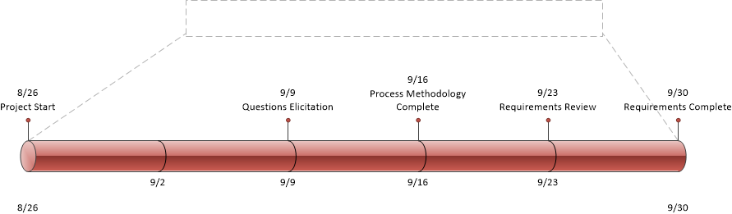

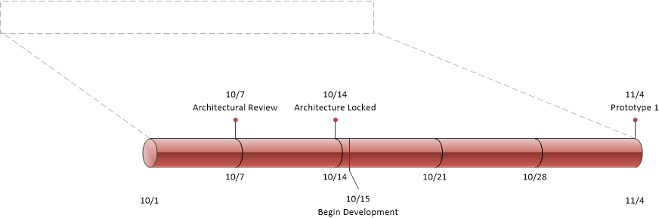

5. Risks and Mitigation
Please refer to Risk Management spreadsheet. (Risk Management.xlsx)

