Prototype
V1.0

The following screen shot is a rough mock up of the initial game screen.
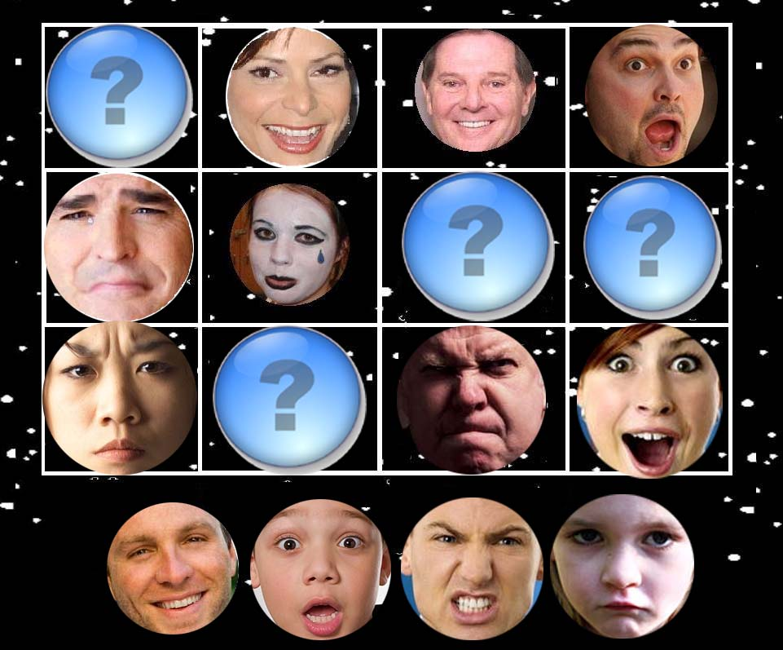
Players will be presented with a grid( sized 3x4, up to 5x5 ) of faces. Faces will depict an emotion and will be grouped into horizontal and vertical rows of 3. One face from each group of emotions will be removed and replaced with a question mark. The faces that are removed will be placed under the grid. Players will select faces and place them into the correct position on the board.
(Missing from the above mockup is a score bar )
Notes: We may also include a written description under each face on the bottom ( happy, surprised, etc).
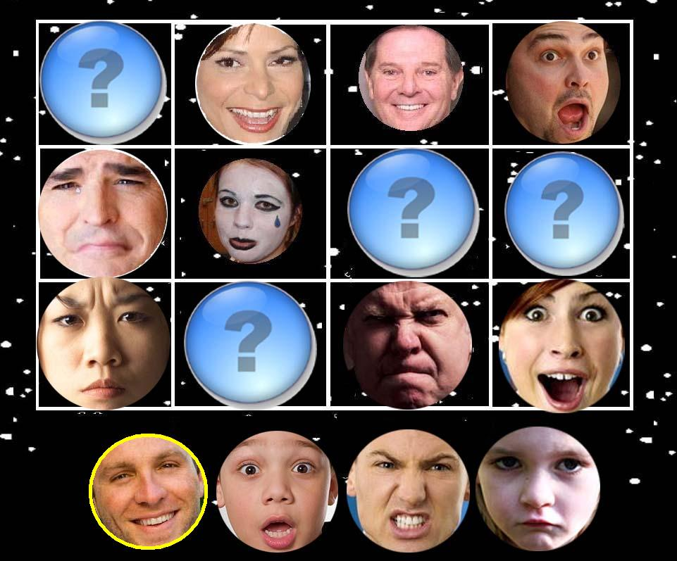
In the above screen, a player has selected the Happy face.
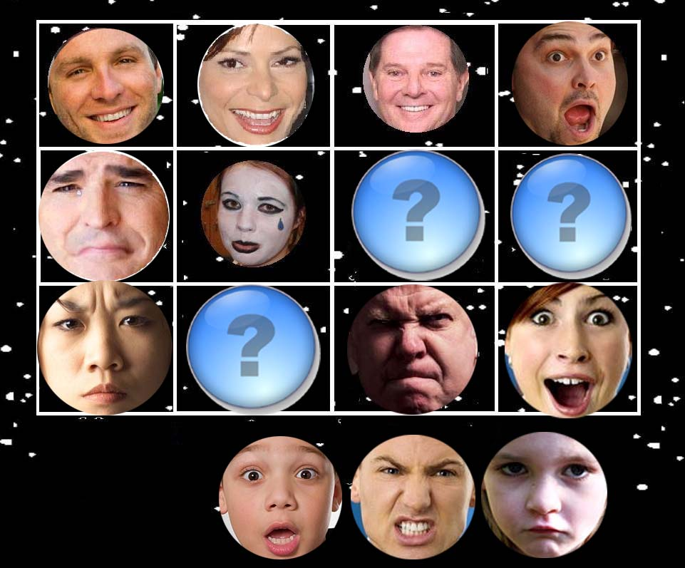
The player then selects the proper location for the face. The player continues the process for each missing face and then clicks on a “Submit” button that will appear at the bottom of the page. Faces that are placed can be moved again, so that the player can correct their mistakes before submitting.
The players score will be increased by a bonus for filling in all missing spots correctly the first time. Points will be subtracted for each incorrect guess. When the board is cleared, a new board will be drawn with a similar grid. The grid size may increase to increase difficulty. ( With a 4x5, or 4x4 board there will be extra faces which may increase difficulty.) Also, the number of faces available to place on the board may increase so that there are faces available do not all belong. This will help eliminate correct answers through the process of elimination.

