Wegmans Deli Kiosk Web Services

Unless otherwise noted, all responses and sent packets should be in the form of JSON objects, with a key,value pair.

Common JSON Data Packet Structures:

Order Object

Ordered Item

Completed Web Services

TestSetup

GetEmployees

GetEmployee

GetKiosks

GetAllPrinters

GetAllStores

GetAllWorkFlows

GetAllOrderItems

LoadDeliCatalogAsJSON

GetOrdersFrom (FORMALLY GET ORDRDETAILS)

GetAllOrders

GetOrder

GetNewOrders

ProcessOrder

ReprintOrder

InitializePrinter

InitializeKiosk

GetItemImage

LoginManager

LogoutManager

UpdateItem

GetSplashScreens

GetSplashScreenImage

CheckSplashScreenUpdate

UpdatePrinterForKiosk

UploadSplashScreenImage

RemoveSplashScreen

UpdateSplashScreenSequence

UpdateSplashScreen

AddSplashScreen

RemoveCoupon

EditCoupon

AddCoupon

RemoveEmployee

EditEmployee

AddEmployee

RemoveKiosk

EditKiosk

RemovePrinter

EditPrinter

AddPrinter

CheckLastUpdate

GetAllItems

GetKiosk

UpdateItem

SalesPerKioskReport

OrdersPerHourReport

OrdersPerItemReport

OrdersPerKioskReport

GetNewOrders

# 

# 

# Common JSON Data Packet Structures:

## Order Object

|  |  |  |
| --- | --- | --- |
| **Paramter Name** | **Type** | **Description** |
| DisplayID | int | Used to display order number for receipt. Takes original Order ID and mods by 999. |
| EmployeeID | int | ID of employee fulfilling order (not used) |
| KioskID | int | ID of kiosk that placed order |
| OrderID | int | ID of the Order |
| Timestamp | DateTime | Time of the order submission |
| TotalPrice | Decimal | Total estimated price of the order |
| Items | Array of OrderedItems | Array of Ordered Items that are contained in the order |

## Ordered Item

|  |  |  |
| --- | --- | --- |
| **Paramter Name** | **Type** | **Description** |
| itemID | int | ID of the base item used in the order |
| orderID | int | ID of the Order the item belongs to |
| orderItemID | int | ID of the item in the corresponding order |
| quantityOrdered | double | amount of quantity ordered |
| quantityType | string | denotes type of quanitty “pounds” or “slices” |
| quotedPrice | decimal | quoted price for the order based off tonnage and price |
| SliceType | string | String denoting the type of slice for the item |

# **Completed Web Services**

## TestSetup

**Purpose:**

To test the database connection for the web service.

**Type: GET**

**URL:**

http://deli-cious.se.rit.edu/DeliServer/SystemController.svc/TestSetup/

**Parameters:**

|  |  |  |
| --- | --- | --- |
| **Name** | **Type** | **Explanation** |
| N/A | N/A | N/A |

**Response:**

|  |  |  |
| --- | --- | --- |
| **Type** | **Structure** | **Example** |
| String | Single line string | “Found Jared Schutt” |

**Example(s):**

N/A

## GetEmployees

**Purpose:**

To retrieve a list of all of the employees in the database.

**Type: GET**

**URL:**

http://deli-cious.se.rit.edu/DeliServer/SystemController.svc/GetEmployees/

**Parameters:**

|  |  |  |
| --- | --- | --- |
| **Name** | **Type** | **Explanation** |
| N/A | N/A | N/A |

**JSON Response:**

**An array containing Employee objects:**

**Employee Structure:**

|  |  |  |
| --- | --- | --- |
| **Parameter Name** | **Type** | **Description** |
| EmployeeID | int | ID of employee |
| FirstName | String | First Name of Employee |
| LastName | String | Last Name of Employee |
| Passcode | string | Pass code of Employee |
| Role | String | “manager” or “employee” |

**Example(s):**

request: <http://deli-cious/DeliServer/SystemController.svc/GetEmployees/>

response:

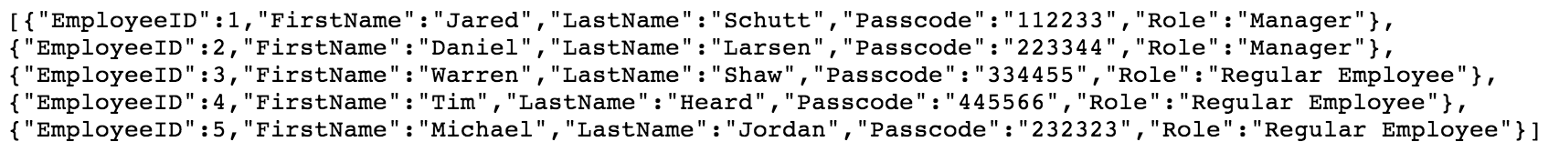

## GetEmployee

**Purpose:**

To retrieve a specific employee record from the database

**Type: GET**

**URL:**

http://deli-cious.se.rit.edu/DeliServer/SystemController.svc/GetEmployee?id={id}

**Parameters:**

|  |  |  |
| --- | --- | --- |
| **Name** | **Type** | **Explanation** |
| id | int | the id of the employee you want to retrieve from the database |

**Response:**



**Single structure containing information of one employee**

|  |  |  |
| --- | --- | --- |
| **Paramter Name** | **Type** | **Description** |
| EmployeeID | int | ID of employee |
| FirstName | String | First Name of Employee |
| LastName | String | Last Name of Employee |
| Passcode | string | Pass code of Employee |
| Role | String | “manager” or “employee” |

**Example(s):**

request: http://deli-cious.se.rit.edu/DeliServer/SystemController.svc/GetEmployee?id=1

response:



## GetKiosks

**Purpose:**

To retrieve all of the information for the kiosks in the database.

**Type : GET**

**URL:**

http://deli-cious.se.rit.edu/DeliServer/SystemController.svc/GetKiosks/

**Parameters:**

|  |  |  |
| --- | --- | --- |
| **Name** | **Type** | **Explanation** |
| N/A | N/A | N/A |

**Response:**

|  |  |  |
| --- | --- | --- |
| **Type** | **Structure** | **Example** |
| JSON | {  “createdOn”,  “kioskID”,  “lastUpdate”,  “printerID”,  “status”,  “storeID”,  “type”  } | {  "createdOn":"\/Date(1386738000000-0500)\/",  "kioskID":1,  "lastUpdate":"\/Date(1386738000000-0500)\/",  "printerID":1,  "status":"Active",  "storeID":1,  "type":"Customer"  } |

**Example(s):**

request: <http://deli-cious.se.rit.edu/DeliServer/SystemController.svc/GetKiosks/>

response:





## GetAllPrinters

**Purpose:**

To retrieve all of the information about the printers from the database.

**Type : GET**

**URL:**

http://deli-cious.se.rit.edu/DeliServer/SystemController.svc/GetAllPrinters/

**Parameters:**

|  |  |  |
| --- | --- | --- |
| **Name** | **Type** | **Explanation** |
| N/A | N/A | N/A |

**Response:**

|  |  |  |
| --- | --- | --- |
| **Type** | **Structure** | **Example** |
| JSON | {  ipAddress,  printerID,  status  } | {  "ipAddress":"192.168.1.120",  "printerID":1,  "status":"Active"  } |

**Example(s):**

request: <http://deli-cious.se.rit.edu/DeliServer/SystemController.svc/GetAllPrinters/>

response:



## GetAllStores

**Purpose:**

To retrieve all of the information about the stores in the database.

**Type: GET**

**URL:**

http://deli-cious.se.rit.edu/DeliServer/SystemController.svc/GetAllStores/

**Parameters:**

|  |  |  |
| --- | --- | --- |
| **Name** | **Type** | **Explanation** |
| N/A | N/A | N/A |

**Response:**

|  |  |  |
| --- | --- | --- |
| **Type** | **Structure** | **Example** |
| JSON | {  branchName,  city,  state,  storeID  } | {  "branchName":"Pittsford",  "city":"Pittsford",  "state":"NY",  "storeID":1  } |

**Example(s):**

request: <http://deli-cious.se.rit.edu/DeliServer/SystemController.svc/GetAllStores/>

response:



## GetAllWorkFlows

**Purpose:**

To retrieve all information from the database pertaining to the workflows stored there.

**Type: GET**

**URL:**

http://deli-cious.se.rit.edu/DeliServer/SystemController.svc/GetAllWorkFlows/

**Parameters:**

|  |  |  |
| --- | --- | --- |
| **Name** | **Type** | **Explanation** |
| N/A | N/A | N/A |

**Response:**

**Array of Workflow items:**

|  |  |  |
| --- | --- | --- |
| **Parameter Name** | **Type** | **Description** |
| type | String | String name of the workflow |
| workFLowID | int | ID of Workflow. |

**Example(s):**

request: <http://deli-cious.se.rit.edu/DeliServer/SystemController.svc/GetAllWorkFlows/>

response:



## GetAllOrderItems

**Purpose:**

To retrieve every order item from the database.

**Type: GET**

**URL:**

http://deli-cious.se.rit.edu/DeliServer/SystemController.svc/GetAllOrderItems/

**Parameters:**

|  |  |  |
| --- | --- | --- |
| **Name** | **Type** | **Explanation** |
| N/A | N/A | N/A |

**Response:**

Array of Order Items

See “Order Item” structure.



**Example(s):**

request: <http://deli-cious.se.rit.edu/DeliServer/SystemController.svc/GetAllOrderItems/>

response:



## LoadDeliCatalogAsJSON

**Purpose:**

To load the item catalog from the server as a json object

**Type: GET**

**URL:** http://deli-cious.se.rit.edu/DeliServer/SystemController.svc/LoadDeliCatalogAsJSON?workflow={workflow}

**Parameters:**

|  |  |  |
| --- | --- | --- |
| **Name** | **Type** | **Explanation** |
| workflow | String | the name of the workflow. For example, “DELI”. |

**Response:**

A N-Deep tree representing an item structure. Can be many levels deep, each level representing a category of items. In the case of Deli, this takes the form of Deli Category -> Item Category -> Specific Item

**Root Catalog JSON Object**

|  |  |  |
| --- | --- | --- |
| **Parameter Name** | **Type** | **Description** |
| name | string | name of the catalog (“Deli”) |
| isLeaf | boolean | identifier if this level is a leaf or not. True if Leaf. False if has children |
| children | array of Categories | Array of Categories (children) **(See “Category” object below)** |

**Category JSON Object:**

|  |  |  |
| --- | --- | --- |
| **Parameter Name** | **Type** | **Description** |
| name | string | category name |
| isLeaf | Boolean | identifier if this level is a leaf or not. True if Leaf. False if has children |
| type | string | Type identifying this level. In the case of Category, will = “Product Category” |
| children | array of Individual Items | Array of Individual Items(children)  **(See “Individual Item” below)** |

**Individual Item JSON Object**

|  |  |  |
| --- | --- | --- |
| **Parameter Name** | **Type** | **Description** |
| name | String | Name of the Item |
| id | int | DeliKiosk ID (used for all calls) |
| wegmansId | int | Wegmans ID (used for search) |
| description | string | Description of the item |
| price | Decimal | Price of the item |
| onSpecial | Boolean | True if item is on special. False if regular |
| isAvailable | Boolean | True if available  False if not available |
| isLeaf | Boolean | True if it is a leaf (product)  False if there is another set of children |
| nextNavigation | **????** | **???** |
| children | Array of Children Items | Because these are products, children are null |
| customAttributes | **Custom Attribute Array** | Array of custom attributes for an item. |

**Example(s):**

request: [http://deli-cious.se.rit.edu/DeliServer/SystemController.svc/LoadDeliCatalogAsJSON](http://deli-cious.se.rit.edu/DeliServer/SystemController.svc/LoadDeliCatalogAsJSON/)?workflow=DELI

response:

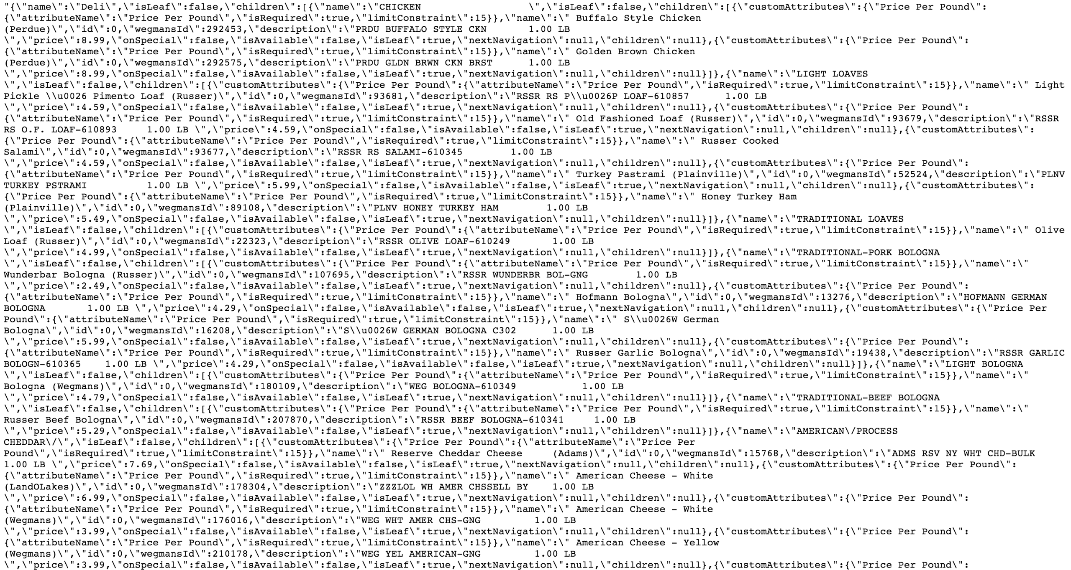

## GetOrdersFrom (FORMALLY GET ORDRDETAILS)

**Purpose:**

Get an order from a specific DateTime to the present time.

**Type: GET**

**URL:** http://deli-cious.se.rit.edu/DeliServer/SystemController.svc/GetOrdersFrom?date={DateTime}

**Parameters:**

|  |  |  |
| --- | --- | --- |
| **Name** | **Type** | **Explanation** |
| id | string | the id of the order you want to get the details from. |

**Response:**

One Order Object corresponding to the ID provided.

See “Order Object”











**Example(s):**

request: http://deli-cious.se.rit.edu/DeliServer/SystemController.svc/GetOrdersFrom?date=DateTime

response:



## GetAllOrders

**Purpose:**

To retrieve all of the orders from the database.

**Type: GET**

**URL: http://deli-cious.se.rit.edu/DeliServer/SystemController.svc/GetAllOrders/**

**Parameters:**

|  |  |  |
| --- | --- | --- |
| **Name** | **Type** | **Explanation** |
| N/A | N/A | N/A |

**Response:**

Array of Order Objects

See “Order Object”



**Example(s):**

request: http://deli-cious.se.rit.edu/DeliServer/SystemController.svc/GetAllOrders/

response:



## GetOrder

**Purpose:**

To retrieve a specific order from the database.

**Type: GET**

**URL: http://deli-cious.se.rit.edu/DeliServer/SystemController.svc/GetOrder?id={id}**

**Parameters:**

|  |  |  |
| --- | --- | --- |
| **Name** | **Type** | **Explanation** |
| id | string | the id of the order you want to get from the database. |

**Response:**

One Order Object corresponding to the ID sent

See “Order Object”

**Order Items will be NULL**



**Example(s):**

request: http://deli-cious.se.rit.edu/DeliServer/SystemController.svc/GetOrder?id=1

response:



## GetNewOrders

**Purpose:**

To get any orders newer than a given order.

**Type: GET**

**URL:** http://deli-cious.se.rit.edu/DeliServer/SystemController.svc/GetNewOrders?lastOrderID={lastOrderID}

**Parameters:**

|  |  |  |
| --- | --- | --- |
| **Name** | **Type** | **Explanation** |
| lastOrderID | string | ID of the last order that the employee kiosk has. |

**Response:**

Array of Order Objects

See “Order Object”

Order Objects contain order items.



**Example(s):**

**request:** http://deli-cious.se.rit.edu/DeliServer/SystemController.svc/GetNewOrders?lastOrderID=1

**response:**



## ProcessOrder

**Purpose:**

To complete an order on the server.

**Type: POST**

**URL:** http://deli-cious.se.rit.edu/DeliServer/SystemController.svc/ProcessOrder

**Parameters:**

|  |  |  |
| --- | --- | --- |
| **Parameter Name** | **Type** | **Description** |
| KioskID | int | ID of the kiosk submitting the order |
| TotalPrice | Decimal | Total calculated price of the order |
| EmployeeID | NOT USED - Need to Deprecate | --------- |
| items | Array of Items objects | All items that are submitted with the order. See **Item** below. |

**Item:**

|  |  |  |
| --- | --- | --- |
| **Parameter Name** | **Type** | **Description** |
| KioskID | int | ID of the kiosk submitting the order |
| QuantityType | string | “slices” or “pounds” depending on the type ordered. |
| QuantityOrdered | Double | Quantity Ordered. May be whole numbers for slices, or a double for pounds |
| QuotedPrice | Decimal | Quoted price for the item - based off quantity and base item price |
| SliceType | string | String used to denote slice type. May change - Currently “Thin” “Thick “Regular” |

**Response:**

**Response is a Dictionary of potential error messages**

|  |  |  |
| --- | --- | --- |
| **Name** | **Type** | **Description** |
| EmployeePrinter | string | “Success” or “Fail” |
| CustomerPrinter | string | “Success” or “Fail” |
| GeneralError |  |  |

**Example(s):**

request:

http://deli-cious.se.rit.edu/DeliServer/SystemController.svc/ProcessOrder/

** Note : must be a POST, and was tested using a Stream of data.

response:

1

## ReprintOrder

**Purpose:**

To re-print the deli ticket for a particular order.

**Type: GET**

**URL:** http://deli-cious.se.rit.edu/DeliServer/SystemController.svc/ReprintOrder?orderID={id}

**Parameters:**

|  |  |  |
| --- | --- | --- |
| **Parameter Name** | **Type** | **Description** |
| orderID | int | The ID of the order to reprint the order ticker for. |

**Response:**

**A Dictionary of potential error messages**

|  |  |  |
| --- | --- | --- |
| **Name** | **Type** | **Description** |
| EmployeePrinter | string | “Success” or “Fail” |
| CustomerPrinter | string | “Success” or “Fail” |
| GeneralError |  |  |
| Success |  |  |

**Example(s):**

request:

http://deli-cious.se.rit.edu/DeliServer/SystemController.svc/ReprintOrder?orderID=346

response:

## InitializePrinter

**Purpose:**

To setup a printer for the use in the system.

**Type : POST**

**URL:** http://deli-cious.se.rit.edu/DeliServer/SystemController.svc/InitializePrinter/

**Parameters:**

|  |  |  |
| --- | --- | --- |
| **Name** | **Type** | **Explanation** |
| location | String | The Location of the networked printer  ex: 192.168.1.1. Eventually may be printserver names |
| workflow | String | the type of workflow : “DELI”, “PIZZA”, “CHEESE” |
| kioskType | String | the type of kiosk : “EMPLOYEE”, “CUSTOMER”. |

**Response:**

|  |  |  |
| --- | --- | --- |
| **Type** | **Structure** | **Example** |
| PrinterID | int | ID of the printer |
| location | string | Location of the printer |
| status | string | Status of the printer |

**Example(s):**

request:

http://deli-cious.se.rit.edu/DeliServer/SystemController.svc/InitializePrinter/

response:

"{\"printerID\":6,\"ipAddress\":\"192.168.1.149\",\"status\":\"Active\"}"

## InitializeKiosk

**Purpose:**

To setup a kiosk for the use in the system.

**Type: PUT**

**URL:** http://deli-cious.se.rit.edu/DeliServer/SystemController.svc/InitializeKiosk/

**Parameters:**

|  |  |  |
| --- | --- | --- |
| **Name** | **Type** | **Explanation** |
| kioskDetails | Kiosk  Must set values for :  type = DELI_CUSTOMER, DELI_EMPLOYEE  printerID  workID = 1  storeID = 1 | The kiosk to initialize |

**Response:**

|  |  |  |
| --- | --- | --- |
| **Type** | **Structure** | **Example** |
| JSON | A kiosk object with the following format:  {  kioskID,  printerID,  storeID,  createdOn,  lastUpdate,  status,  workID  } | "{\"kioskID\":9,  \"printerID\":2,  \"storeID\":1,  \"createdOn\":\"\\\/Date(1393207743548)\\\/\",  \"lastUpdate\":\"\\\/Date(1393207743548)\\\/\",  \"status\":\"Active\",  \"type\":\"DELI\",  \"workID\":1}" |

**Example(s):**

request:

http://deli-cious.se.rit.edu/DeliServer/SystemController.svc/InitializeKiosk/

response:

"{\"kioskID\":9,

\"printerID\":2,

\"storeID\":1,

\"createdOn\":\"\\\/Date(1393207743548)\\\/\",

\"lastUpdate\":\"\\\/Date(1393207743548)\\\/\",

\"status\":\"Active\",

\"type\":\"DELI\",

\"workID\":1}"

## GetItemImage

**Purpose:**

To retrieve an image for a specific item.

**Type: GET**

**URL:** http://deli-cious.se.rit.edu/DeliServer/SystemController.svc/GetItemImage?itemID={itemID}

**Parameters:**

|  |  |  |
| --- | --- | --- |
| **Name** | **Type** | **Explanation** |
| itemID | int | The id of the item |

**Response:**

|  |  |  |
| --- | --- | --- |
| **Type** | **Structure** | **Example** |
| Image (jpg) | N/A | N/A |

**Example(s):**

request:

http://deli-cious.se.rit.edu/DeliServer/SystemController.svc/GetItemImage?itemID=19

response:

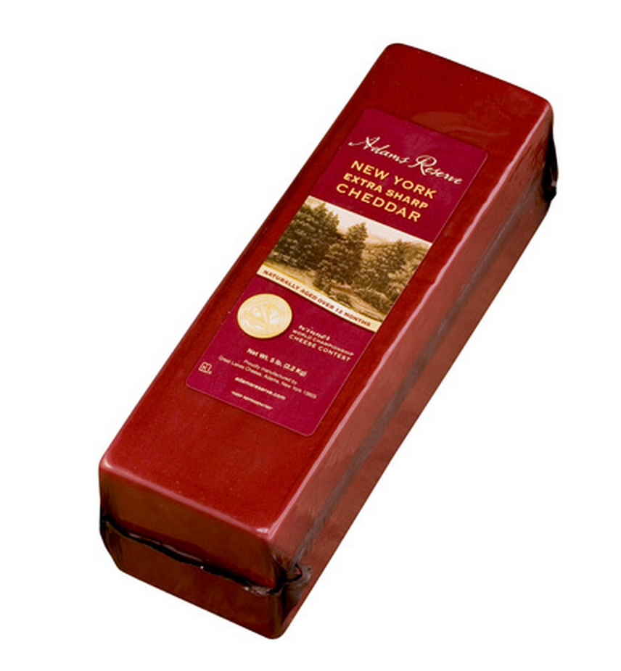

## LoginManager

**Purpose:**

To validate the credentials entered for a manager user.

**Type: POST**

**URL:** http://deli-cious.se.rit.edu/DeliServer/SystemController.svc/LoginManager/

**Parameters:**

|  |  |  |
| --- | --- | --- |
| **Name** | **Type** | **Explanation** |
| passcode | string | the passcode of the manager that is trying to login. |

**Response:**

|  |  |  |
| --- | --- | --- |
| **Type** | **Structure** | **Example** |
| boolean | true or false, depending on if the login was successful or not. | true or false |
| string | userID | employee ID |

**Example(s):**

request: [http://deli-cious.se.rit.edu/DeliServer/SystemController.svc/LoginManager](http://deli-cious.se.rit.edu/DeliServer/SystemController.svc/LoginManager?passcode)/

response:

true

## LogoutManager

**Purpose:**

To logout a manager user and invalidate their session.

**Type: POST**

**URL:** http://deli-cious.se.rit.edu/DeliServer/SystemController.svc/LogoutManager/

**Parameters:**

|  |  |  |
| --- | --- | --- |
| **Name** | **Type** | **Explanation** |
| Passcode | Integer | The passcode of the manager that wants to logout. |

**Response:**

|  |  |  |
| --- | --- | --- |
| **Type** | **Structure** | **Example** |
| boolean | true or false, depending on if the logout was successful or not. | true or false |

**Example(s):**

request:http://deli-cious.se.rit.edu/DeliServer/SystemController.svc/LogoutManager?passcode=112233

response: true

## UpdateItem

**Purpose:**

To modify an item in the system.

**URL:** http://deli-cious.se.rit.edu/DeliServer/SystemController.svc/UpdateItem?item={item}

**Type: POST**

**Parameters:**

|  |  |  |
| --- | --- | --- |
| **Name** | **Type** | **Explanation** |
| item | Item | the item that needs to be updated in the database. |
| managerID | int | ID of the manager currently logged in |

**Response:**

|  |  |  |
| --- | --- | --- |
| **Type** | **Structure** | **Example** |
| boolean | true or false, depending on if the update was successful or not. | true |

**Example(s):**

request: http://deli-cious.se.rit.edu/DeliServer/SystemController.svc/UpdateItem

response: true

## GetSplashScreens

**Purpose:**

To get the ids of the splash screens for the kiosk.

**URL:** http://deli-cious.se.rit.edu/DeliServer/SystemController.svc/GetSplashScreens/

**Type: GET**

**Parameters:**

|  |  |  |
| --- | --- | --- |
| **Name** | **Type** | **Explanation** |
| N/A | N/A | N/A |

**Response:**

|  |  |  |
| --- | --- | --- |
| **Type** | **Structure** | **Example** |
| List | [ screenID1, screenID2, … ] | [1,2,3] |

**Example(s):**

**request:** <http://deli-cious.se.rit.edu/DeliServer/SystemController.svc/GetSplashScreens/>

response: [1,2]

## GetSplashScreenImage

**Purpose:**

To retrieve the splash screen image to display on the kiosk.

**URL:** deli-cious.se.rit.edu/DeliServer/SystemController.svc/GetSplashScreenImage?screenID={screenID}

**Type: GET**

**Parameters:**

|  |  |  |
| --- | --- | --- |
| **Name** | **Type** | **Explanation** |
| screenID | int | the id of the splashScreen you want to get the image for. |

**Response:**

|  |  |  |
| --- | --- | --- |
| **Type** | **Structure** | **Example** |
| image/jpeg | N/A | N/A |

**Example(s):**

request: deli-cious.se.rit.edu/DeliServer/SystemController.svc/GetSplashScreenImage?screenID=1

response:



## CheckSplashScreenUpdate

**Purpose:**

Check the timestamp of when the splash screens were last updated.

**URL:**

http://deli-cious.se.rit.edu/DeliServer/SystemController.svc/CheckSplashScreenUpdate?workflow={workflow

**Type: GET**

**Parameters:**

|  |  |  |
| --- | --- | --- |
| **Name** | **Type** | **Explanation** |
| workflow | string | The name of the workflow that you want to check the last splash screen update for. Example: “DELI” |

**Response:**

|  |  |  |
| --- | --- | --- |
| **Type** | **Structure** | **Example** |
| Dictionary<String,String> | { lastUpdate : “Timestamp”} | { lastUpdate : “*4/22/2014 8:03:57 PM*”} |

**Example(s):**

request:

http://deli-cious.se.rit.edu/DeliServer/SystemController.svc/CheckSplashScreenUpdate?workflow=DELI

response:

*Object {lastUpdate: "4/22/2014 8:03:57 PM"}*

## UpdatePrinterForKiosk

**Purpose:**

To update the printer that is associated with a particular kiosk, so that the proper print commands can be sent to the proper printer.

**URL:**

http://deli-cious.se.rit.edu/DeliServer/SystemController.svc/UpdatePrinterForKiosk/

**Type: POST**

**Parameters:**

|  |  |  |
| --- | --- | --- |
| **Name** | **Type** | **Explanation** |
| updateDetails | Dictionary<String,String>  {  kioskID : int,  printerID : int  } | This is a json object that contains the id of the kiosk we want to update the printer for and the id of the printer that we want to give to the kiosk. |

**Response:**

|  |  |  |
| --- | --- | --- |
| **Type** | **Structure** | **Example** |
| Dictionary<String,String> | {“result” : “boolean”} | { “result” : “true” } |

**Example(s):**

request:

<http://deli-cious.se.rit.edu/DeliServer/SystemController.svc/UpdatePrinterForKiosk/>

response:

Object{ "result" : "true" }

## UploadSplashScreenImage

**Purpose:**

Used to upload a new splash screen image file to the system.

**URL:**

<http://deli-cious.se.rit.edu/DeliServer/SystemController.svc/UploadSplashScreenImage/>

**Type: POST**

**Parameters:**

|  |  |  |
| --- | --- | --- |
| **Name** | **Type** | **Explanation** |
| screenImage | image file (jpg, png) | The splash screen image file you want to add to the system. |

**Response:**

|  |  |  |
| --- | --- | --- |
| **Type** | **Structure** | **Example** |
| Dictionary<String,String> | { “result” : “boolean” } | { “result” : “true” } |

**Example(s):**

request:

<http://deli-cious.se.rit.edu/DeliServer/SystemController.svc/UploadSplashScreenImage/>

response:

{ “result” : “true” }

## RemoveSplashScreen

**Purpose:**

Used to remove an existing splash screen from the system.

**URL:**

<http://deli-cious.se.rit.edu/DeliServer/SystemController.svc/RemoveSplashScreen/>

**Type: POST**

**Parameters:**

|  |  |  |
| --- | --- | --- |
| **Name** | **Type** | **Explanation** |
| screenID | int | id of the splash screen you want to remove |

**Response:**

|  |  |  |
| --- | --- | --- |
| **Type** | **Structure** | **Example** |
| string | boolean | “true” |

**Example(s):**

request:

<http://deli-cious.se.rit.edu/DeliServer/SystemController.svc/RemoveSplashScreen/>

response:

true

## UpdateSplashScreenSequence

**Purpose:**

Used to update the sequence of splash screens in the system and the order that they will be displayed on the client application.

**URL:** [http://deli-cious.se.rit.edu/DeliServer/SystemController.svc/UpdateSplashScreenSequence/](http://deli-cious.se.rit.edu/DeliServer/SystemController.svc/RemoveSplashScreen/)

**Type: POST**

**Parameters:**

|  |  |  |
| --- | --- | --- |
| **Name** | **Type** | **Explanation** |
| screens | List<int> | A list of ids of the splash screens, in order. |

**Response:**

|  |  |  |
| --- | --- | --- |
| **Type** | **Structure** | **Example** |
| Dictionary<String,String> | { “result” : “boolean” } | { “result” : “true” } |

**Example(s):**

request:

<http://deli-cious.se.rit.edu/DeliServer/SystemController.svc/UpdateSplashScreenSequence/>

response:

{ “result” : “true” }

## UpdateSplashScreen

**Purpose:**

Used to update an existing splash screen.

**URL:**

http://deli-cious.se.rit.edu/DeliServer/SystemController.svc/UpdateSplashScreen/

**Type: POST**

**Parameters:**

|  |  |  |
| --- | --- | --- |
| **Name** | **Type** | **Explanation** |
| splashScreen | SplashScreen | The splash screen you want to update, which has the following fields occupied:   * isActive * screenID |

**Response:**

|  |  |  |
| --- | --- | --- |
| **Type** | **Structure** | **Example** |
| string | true or false | “true” |

**Example(s):**

request:

<http://deli-cious.se.rit.edu/DeliServer/SystemController.svc/UpdateSplashScreen/>

response:

“true”

## AddSplashScreen

**Purpose:**

Used to add a new splash screen to the system.

**URL:**

<http://deli-cious.se.rit.edu/DeliServer/SystemController.svc/AddSplashScreen/>

**Type: POST**

**Parameters:**

|  |  |  |
| --- | --- | --- |
| **Name** | **Type** | **Explanation** |
| splashScreen | SplashScreen | A splash screen object with all of the values set except for screenID. |

**Response:**

|  |  |  |
| --- | --- | --- |
| **Type** | **Structure** | **Example** |
| string | true or false | “true” |

**Example(s):**

request:

<http://deli-cious.se.rit.edu/DeliServer/SystemController.svc/AddSplashScreen/>

response:

“true”

## RemoveCoupon

**Purpose:**

Used to remove an existing coupon from the system.

**URL:**

<http://deli-cious.se.rit.edu/DeliSever/SystemController.svc/RemoveCoupon/>

**Type: POST**

**Parameters:**

|  |  |  |
| --- | --- | --- |
| **Name** | **Type** | **Explanation** |
| couponID | int | id of the coupon you want to delete |

**Response:**

|  |  |  |
| --- | --- | --- |
| **Type** | **Structure** | **Example** |
| string | true or false | “true” |

**Example(s):**

request:

<http://deli-cious.se.rit.edu/DeliServer/SystemController.svc/RemoveCoupon/>

response:

“true”

## EditCoupon

**Purpose:**

Used to edit an existing coupon in the system.

**URL:**

<http://deli-cious.se.rit.edu/DeliServer/SystemController.svc/EditCoupon/>

**Type: POST**

**Parameters:**

|  |  |  |
| --- | --- | --- |
| **Name** | **Type** | **Explanation** |
| coupon | Coupon | A coupon object that you would like to update to the system. It must be populated with all of the values that you wish to update. |

**Response:**

|  |  |  |
| --- | --- | --- |
| **Type** | **Structure** | **Example** |
| String | true or false | “true” |

**Example(s):**

request:

<http://deli-cious.se.rit.edu/DeliServer/SystemController.svc/EditCoupon/>

response:

“true”

## AddCoupon

**Purpose:**

Used to add a new coupon to the system.

**URL:**

<http://deli-cious.se.rit.edu/DeliServer/SystemController.svc/AddCoupon/>

**Type: POST**

**Parameters:**

|  |  |  |
| --- | --- | --- |
| **Name** | **Type** | **Explanation** |
| coupon | Coupon | A coupon object that you would like to add to the system. It must be populated with values for every variable except for couponID. |

**Response:**

|  |  |  |
| --- | --- | --- |
| **Type** | **Structure** | **Example** |
| string | true or false | “true” |

**Example(s):**

request:

<http://deli-cious.se.rit.edu/DeliServer/SystemController.svc/AddCoupon/>

response:

“true”

## RemoveEmployee

**Purpose:**

Used to remove an existing employee from the system.

**URL:**

<http://deli-cious.se.rit.edu/DeliServer/SystemController.svc/RemoveEmployee/>

**Type: POST**

**Parameters:**

|  |  |  |
| --- | --- | --- |
| **Name** | **Type** | **Explanation** |
| employeeID | int | id of the employee to remove |

**Response:**

|  |  |  |
| --- | --- | --- |
| **Type** | **Structure** | **Example** |
| string | true or false | “true” |

**Example(s):**

request:

<http://deli-cious.se.rit.edu/DeliServer/SystemController.svc/RemoveEmployee/>

response:

“true”

## EditEmployee

**Purpose:**

Used to update an existing employees information.

**URL:**

<http://deli-cious.se.rit.edu/DeliServer/SystemController.svc/EditEmployee/>

**Type: POST**

**Parameters:**

|  |  |  |
| --- | --- | --- |
| **Name** | **Type** | **Explanation** |
| employee | Employee | The employee that you would like to update the data for. It should be populated with everything, including the employeeID. |

**Response:**

|  |  |  |
| --- | --- | --- |
| **Type** | **Structure** | **Example** |
| string | true or false | “true” |

**Example(s):**

request:

<http://deli-cious.se.rit.edu/DeliServer/SystemController.svc/EditEmployee/>

response:

“true”

## AddEmployee

**Purpose:**

Used to add a new employee to the system.

**URL:**

<http://deli-cious.se.rit.edu/DeliServer/SystemController.svc/AddEmployee/>

**Type: POST**

**Parameters:**

|  |  |  |
| --- | --- | --- |
| **Name** | **Type** | **Explanation** |
| employee | Employee | The employee that you want to add to the system. The employee object should have values entered for everything except for employeeID. |

**Response:**

|  |  |  |
| --- | --- | --- |
| **Type** | **Structure** | **Example** |
| string | true or false | “true” |

**Example(s):**

request:

<http://deli-cious.se.rit.edu/DeliServer/SystemController.svc/AddEmployee/>

response:

“true”

## RemoveKiosk

**Purpose:**

Used to remove an existing kiosk from the system.

**URL:**

[http://deli-cious.se.rit.edu/DeliServer/SystemController.svc/RemoveKiosk/](http://deli-cious.se.rit.edu/DeliServer/SystemController.svc/AddEmployee/)

**Type: POST**

**Parameters:**

|  |  |  |
| --- | --- | --- |
| **Name** | **Type** | **Explanation** |
| kioskID | int | id of the kiosk to remove |

**Response:**

|  |  |  |
| --- | --- | --- |
| **Type** | **Structure** | **Example** |
| string | true or false | “true” |

**Example(s):**

request:

[http://deli-cious.se.rit.edu/DeliServer/SystemController.svc/RemoveKiosk/](http://deli-cious.se.rit.edu/DeliServer/SystemController.svc/AddEmployee/)

response:

“true”

## EditKiosk

**Purpose:**

Used to edit an existing kiosk in the system.

**URL:**

[http://deli-cious.se.rit.edu/DeliServer/SystemController.svc/EditKiosk/](http://deli-cious.se.rit.edu/DeliServer/SystemController.svc/AddEmployee/)

**Type: POST**

**Parameters:**

|  |  |  |
| --- | --- | --- |
| **Name** | **Type** | **Explanation** |
| kiosk | Kiosk | The kiosk that you want to update in the system. Should have values for every variable. |

**Response:**

|  |  |  |
| --- | --- | --- |
| **Type** | **Structure** | **Example** |
| string | true or false | “true” |

**Example(s):**

request:

[http://deli-cious.se.rit.edu/DeliServer/SystemController.svc/EditKiosk/](http://deli-cious.se.rit.edu/DeliServer/SystemController.svc/AddEmployee/)

response:

“true”

## RemovePrinter

**Purpose:**

Used to remove an existing printer from the system.

**URL:**

<http://deli-cious.se.rit.edu/DeliServer/SystemController.svc/RemovePrinter/>

**Type: POST**

**Parameters:**

|  |  |  |
| --- | --- | --- |
| **Name** | **Type** | **Explanation** |
| printerID | int | id of the printer to remove |

**Response:**

|  |  |  |
| --- | --- | --- |
| **Type** | **Structure** | **Example** |
| string | true or false | “true” |

**Example(s):**

request:

<http://deli-cious.se.rit.edu/DeliServer/SystemController.svc/RemovePrinter/>

response:

“true”

## EditPrinter

**Purpose:**

Used to update an existing printer in the system.

**URL:**

<http://deli-cious.se.rit.edu/DeliServer/SystemController.svc/EditPrinter/>

**Type: POST**

**Parameters:**

|  |  |  |
| --- | --- | --- |
| **Name** | **Type** | **Explanation** |
| printer | Printer | The printer that you want to update in the system. Should have values set for every variable in the printer. |

**Response:**

|  |  |  |
| --- | --- | --- |
| **Type** | **Structure** | **Example** |
| string | true or false | “true” |

**Example(s):**

request:

<http://deli-cious.se.rit.edu/DeliServer/SystemController.svc/EditPrinter/>

response:

“true”

## AddPrinter

**Purpose:**

Used to add a new printer to the system.

**URL:**

<http://deli-cious.se.rit.edu/DeliServer/SystemController.svc/AddPrinter/>

**Type: POST**

**Parameters:**

|  |  |  |
| --- | --- | --- |
| **Name** | **Type** | **Explanation** |
| printer | Printer | The printer that you want to add to the system. It should have variables set for the entire object except for printerID. |

**Response:**

|  |  |  |
| --- | --- | --- |
| **Type** | **Structure** | **Example** |
| string | true or false | “true” |

**Example(s):**

request:

<http://deli-cious.se.rit.edu/DeliServer/SystemController.svc/AddPrinter/>

response:

“true”

## CheckLastUpdate

**Purpose:**

Used to check for when the last time that the item catalog was updated.

**URL:**

[http://deli-cious.se.rit.edu/DeliServer/SystemController.svc/CheckLastUpdate?workflow={workflow](http://deli-cious.se.rit.edu/DeliServer/SystemController.svc/CheckLastUpdate?workflow=%7Bworkflow)}

**Type: GET**

**Parameters:**

|  |  |  |
| --- | --- | --- |
| **Name** | **Type** | **Explanation** |
| workflow | String | name of the workflow to update : “DELI”, “PIZZA”, etc. |

**Response:**

|  |  |  |
| --- | --- | --- |
| **Type** | **Structure** | **Example** |
| DateTime | “\/Date()\/” | "\/Date(1399584987000-0400)\/" |

**Example(s):**

request:

<http://deli-cious.se.rit.edu/DeliServer/SystemController.svc/CheckLastUpdate?workflow=DELI>

response:

"\/Date(1399584987000-0400)\/"

## GetAllItems

**Purpose:**

Used to get a list of all of the items in the system.

**URL:**

<http://deli-cious.se.rit.edu/DeliServer/SystemController.svc/GetAllItems/>

**Type: GET**

**Parameters:**

|  |  |  |
| --- | --- | --- |
| **Name** | **Type** | **Explanation** |
| N/A | N/A | N/A |

**Response:**

|  |  |  |
| --- | --- | --- |
| **Type** | **Structure** | **Example** |
| List<Item> | List of item objects | List of item objects |

**Example(s):**

request:

<http://deli-cious.se.rit.edu/DeliServer/SystemController.svc/GetAllItems/>

response:

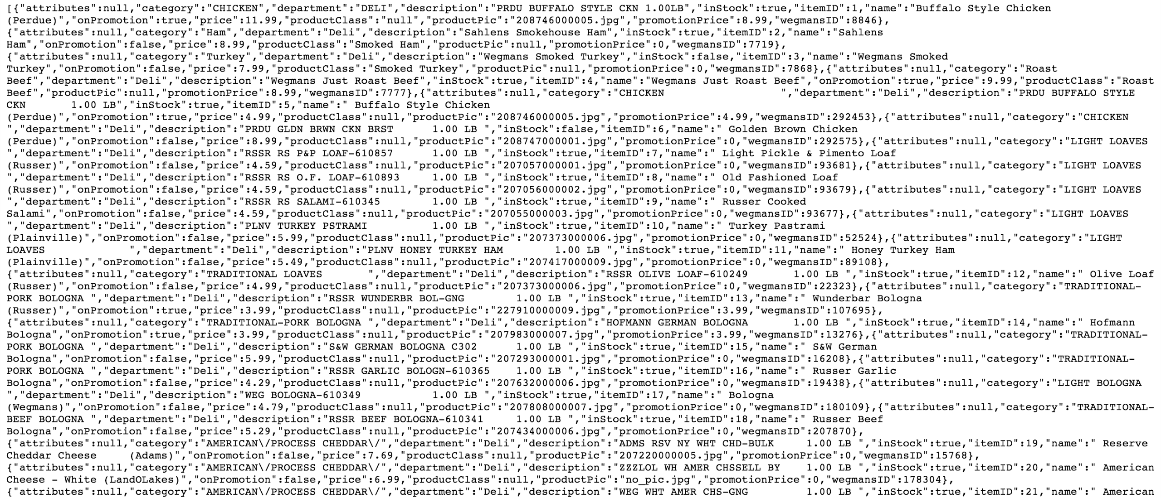

## GetKiosk

**Purpose:**

Used to get a specific kiosk from the system.

**URL:**

[http://deli-cious.se.rit.edu/DeliServer/SystemController.svc/GetKiosk?kioskID={kioskID](http://deli-cious.se.rit.edu/DeliServer/SystemController.svc/GetKiosk?kioskID=%7BkioskID)}

**Type: GET**

**Parameters:**

|  |  |  |
| --- | --- | --- |
| **Name** | **Type** | **Explanation** |
| kioskID | int | id of the kiosk you want to get from the system. |

**Response:**

|  |  |  |
| --- | --- | --- |
| **Type** | **Structure** | **Example** |
| Kiosk | Kiosk object | {"BackColor":"#ff00ff",  "BorderColor":"#ff00ff",  "ThemeColor":"#ff08ff",  "kioskID":1,  "printerID":1,  "status":"Active",  "storeID":1,  "type":"DELI_CUSTOMER",  "workID":1} |

**Example(s):**

request:

<http://deli-cious.se.rit.edu/DeliServer/SystemController.svc/GetKiosk?kioskID=1>

response:

{"BackColor":"#ff00ff","BorderColor":"#ff00ff","ThemeColor":"#ff08ff","kioskID":1,"printerID":1,"status":"Active","storeID":1,"type":"DELI_CUSTOMER","workID":1}

## UpdateItem

**Purpose:**

Used to update an existing item in the system.

**URL:**

<http://deli-cious.se.rit.edu/DeliServer/SystemController.svc/UpdateItem/>

**Type: POST**

**Parameters:**

|  |  |  |
| --- | --- | --- |
| **Name** | **Type** | **Explanation** |
| details | Dictionary<String,String> | Dictionary object with all variables set to the variables of the Item object. |

**Response:**

|  |  |  |
| --- | --- | --- |
| **Type** | **Structure** | **Example** |
| boolean | true or false | true |

**Example(s):**

request:

<http://deli-cious.se.rit.edu/DeliServer/SystemController.svc/UpdateItem/>

response:

true

## SalesPerKioskReport

**Purpose:**

Used to get generate a report of the number of sales per kiosk for a particular week.

**URL:**

[http://deli-cious.se.rit.edu/DeliServer/SystemController.svc/SalesPerKioskReport?from={from](http://deli-cious.se.rit.edu/DeliServer/SystemController.svc/SalesPerKioskReport?from=%7Bfrom)}

**Type: GET**

**Parameters:**

|  |  |  |
| --- | --- | --- |
| **Name** | **Type** | **Explanation** |
| from | DateTime | the date to start the report from. Will always be a sunday and be in the format:   * “MM/dd/yyyy” |

**Response:**

|  |  |  |
| --- | --- | --- |
| **Type** | **Structure** | **Example** |
| json object | Contains a collection of kiosk sales data in the following format:  { “Kiosk” :  “KioskID” : “int”,  “Date1” : “sales string”,  “Date2” : “sales string”,  “Date3” : “sales string”,  “Date4” : “sales string”,  “Date5” : “sales string”,  “Date6” : “sales string”,  “Date7” : “sales string”} | {"Kiosk1":  {"Kiosk":  "KioskID:1",  "5/12/2014":"$0",  "5/13/2014":"$0",  "5/14/2014":"$0",  "5/15/2014":"$0",  "5/16/2014":"$0",  "5/17/2014":"$0",  "5/18/2014":"$0"} |

**Example(s):**

request:

<http://deli-cious.se.rit.edu/DeliServer/SystemController.svc/SalesPerKioskReport?from=05/12/2014>

response:

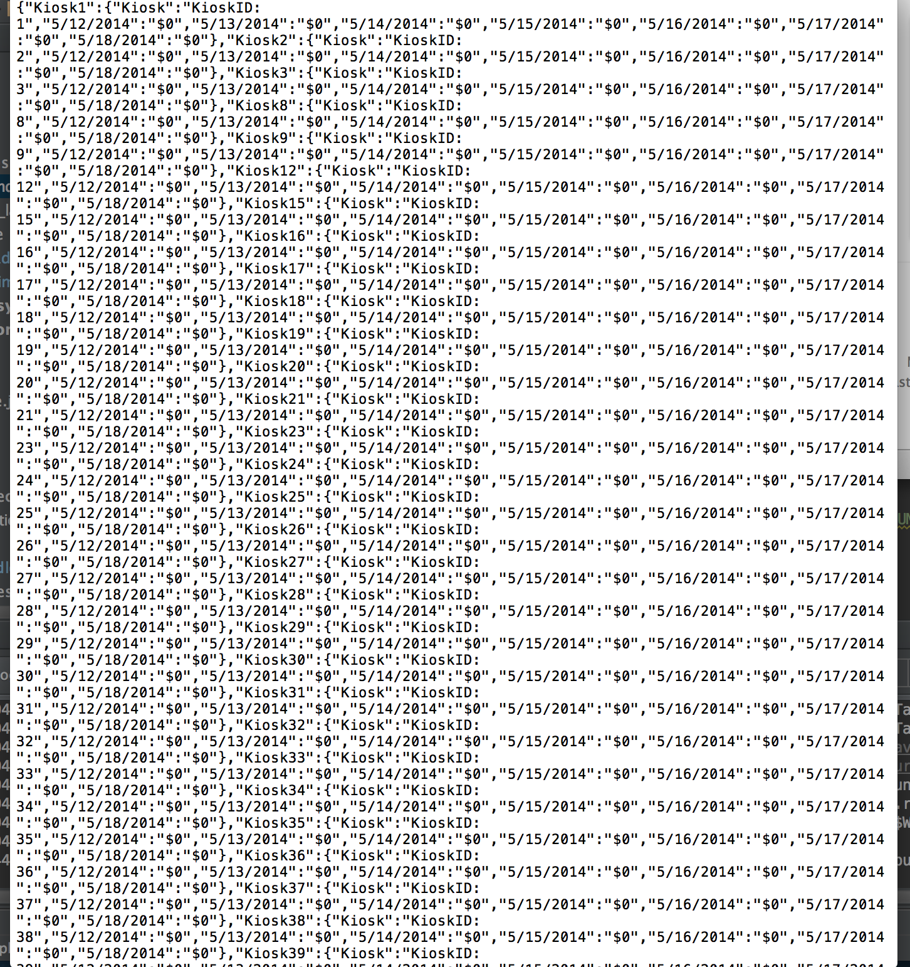

## OrdersPerHourReport

**Purpose:**

Used to generate a report of the number of orders per hour.

**URL:**

[http://deli-cious.se.rit.edu/DeliServer/SystemController.svc/OrdersPerHourReport?from{from](http://deli-cious.se.rit.edu/DeliServer/SystemController.svc/OrdersPerHourReport?from%7Bfrom)}

**Type: GET**

**Parameters:**

|  |  |  |
| --- | --- | --- |
| **Name** | **Type** | **Explanation** |
| from | DateTime | the date to start the report from. Will always be a sunday and be in the format:   * “MM/dd/yyyy” |

**Response:**

|  |  |  |
| --- | --- | --- |
| **Type** | **Structure** | **Example** |
| json object | Contains a collection of the number of orders per hour in the following format:  rowIndex:  {"Day":"Monday"  ,"09:00:00 - 10:00:00":"0",  "10:00:00 -11:00:00":"0",  "11:00:00 - 12:00:00":"8",  "12:00:00 - 13:00:00":"0",  "13:00:00 - 14:00:00":"0",  "14:00:00 - 15:00:00":"0",  "15:00:00 - 16:00:00":"0",  "16:00:00 - 17:00:00":"0",  "17:00:00 - 18:00:00":"0",  "18:00:00 - 19:00:00":"2",  "19:00:00 - 20:00:00":"1",  "20:00:00 - 21:00:00":"0"} | "0":{"Day":"Monday","09:00:00 - 10:00:00":"0","10:00:00 - 11:00:00":"0","11:00:00 - 12:00:00":"8","12:00:00 - 13:00:00":"0","13:00:00 - 14:00:00":"0","14:00:00 - 15:00:00":"0","15:00:00 - 16:00:00":"0","16:00:00 - 17:00:00":"0","17:00:00 - 18:00:00":"0","18:00:00 - 19:00:00":"2","19:00:00 - 20:00:00":"1","20:00:00 - 21:00:00":"0"} |

**Example(s):**

request:

<http://deli-cious.se.rit.edu/DeliServer/SystemController.svc/OrdersPerHourReport?from=05/12/2014>

response:

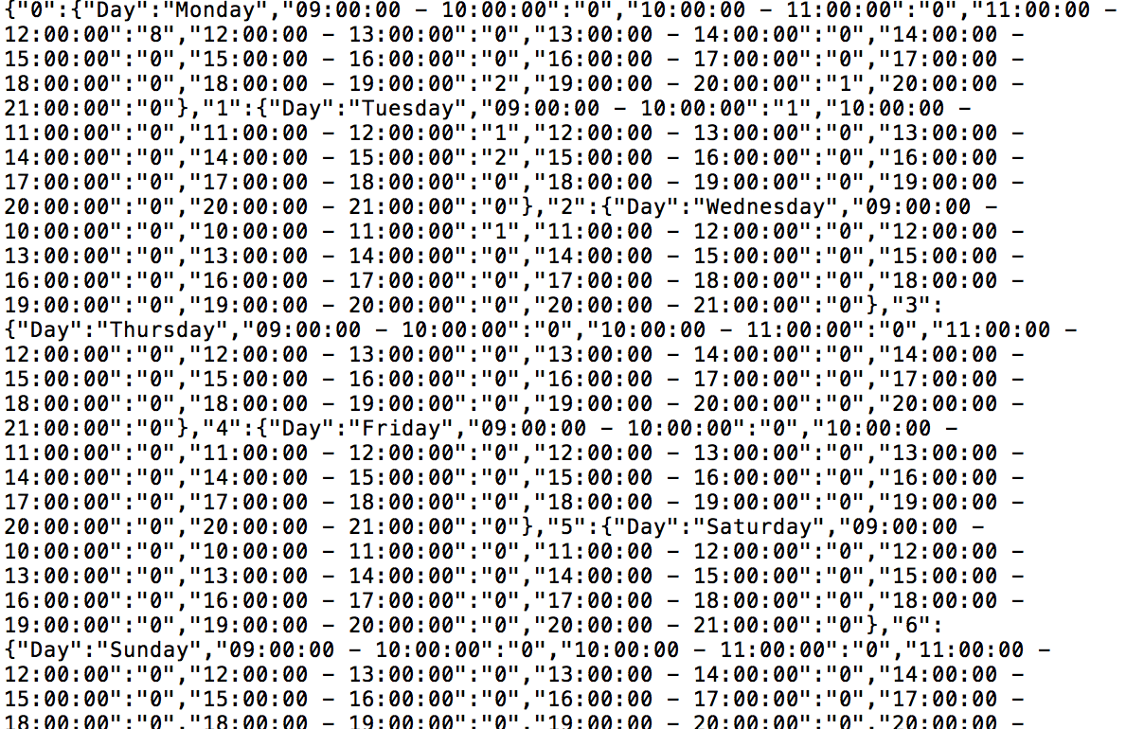

## OrdersPerItemReport

**Purpose:**

Used to generate a report of number of orders per item.

**URL:**

[http://deli-cious.se.rit.edu/DeliServer/SystemController.svc/OrdersPerItemReport?from={from](http://deli-cious.se.rit.edu/DeliServer/SystemController.svc/OrdersPerItemReport?from=%7Bfrom)}

**Type: GET**

**Parameters:**

|  |  |  |
| --- | --- | --- |
| **Name** | **Type** | **Explanation** |
| from | DateTime | the date to start the report from. Will always be a sunday and be in the format:   * “MM/dd/yyyy” |

**Response:**

|  |  |  |
| --- | --- | --- |
| **Type** | **Structure** | **Example** |
| json object | "itemNumber":  {"ItemNumber":"int",  "ProductName":"string",  "Date1":numOrders,  Date2:numOrders,  Date3:numOrders,  Date4:numOrders,  Date5:numOrders,  Date6:numOrders,  Date7:numOrders  "} | "item1"  :{"ItemNumber":"8846",  "ProductName":"Buffalo Style Chicken (Perdue)",  "5/12/2014":"0",  "5/13/2014":"0",  "5/14/2014":"0",  "5/15/2014":"0",  "5/16/2014":"0",  "5/17/2014":"0",  "5/18/2014":"0"} |

**Example(s):**

request:

<http://deli-cious.se.rit.edu/DeliServer/SystemController.svc/OrdersPerItemReport?from=05/12/2014>

response:

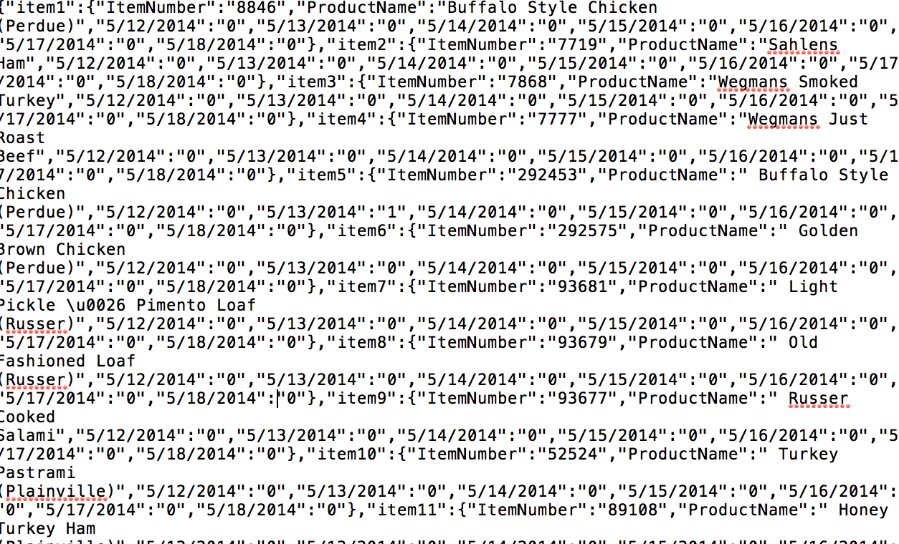

## OrdersPerKioskReport

**Purpose:**

Used to generate a report of the number of order per kiosk for a specified week.

**URL:**

[http://deli-cious.se.rit.edu/DeliServer/SystemController.svc/OrdersPerKioskReport?from={from](http://deli-cious.se.rit.edu/DeliServer/SystemController.svc/OrdersPerKioskReport?from=%7Bfrom)}

**Type: GET**

**Parameters:**

|  |  |  |
| --- | --- | --- |
| **Name** | **Type** | **Explanation** |
| from | DateTime | the date to start the report from. Will always be a sunday and be in the format:   * “MM/dd/yyyy” |

**Response:**

|  |  |  |
| --- | --- | --- |
| **Type** | **Structure** | **Example** |
| json object | Kiosk orders report with the following format:  {"Kiosk1":  {"Kiosk":"KioskID: 1",  "5/12/2014":"0",  "5/13/2014":"0",  "5/14/2014":"0",  "5/15/2014":"0"  ,"5/16/2014":"0",  "5/17/2014":"0",  "5/18/2014":"0"} | {"Kiosk1":  {"Kiosk":  "KioskID:1",  "5/12/2014":"0",  "5/13/2014":"0",  "5/14/2014":"0",  "5/15/2014":"0",  "5/16/2014":"0",  "5/17/2014":"0",  "5/18/2014":"0"} |

**Example(s):**

request:

<http://deli-cious.se.rit.edu/DeliServer/SystemController.svc/OrdersPerKioskReport?from=05/12/2014>

response:

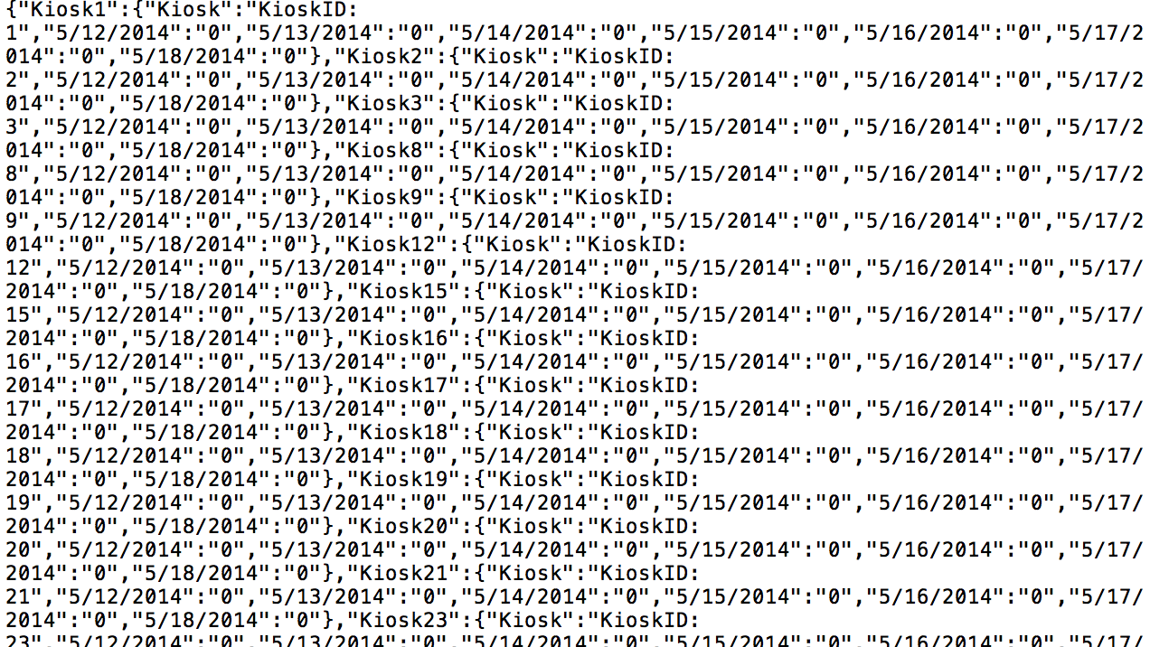

## GetNewOrders

**Purpose:**

Used to get a list of all of the new orders in the system from a specific time and to the present.

**URL:**

[http://deli-cious.se.rit.edu/DeliServer/SystemController.svc/GetNewOrders?lastOrderID={lastOrderID](http://deli-cious.se.rit.edu/DeliServer/SystemController.svc/GetNewOrders?lastOrderID=%7BlastOrderID)}

**Type: GET**

**Parameters:**

|  |  |  |
| --- | --- | --- |
| **Name** | **Type** | **Explanation** |
| lastOrderID | int | id of the last order that client application already has. |

**Response:**

|  |  |  |
| --- | --- | --- |
| **Type** | **Structure** | **Example** |
| List<Order> | List of order objects | [{"OrderID":11,  "KioskID":1,  "EmployeeID":1  ,"Timestamp":"\/Date(1393201637000)\/",  "TotalPrice":"22.5",  "Items":[  {"OrderItemID":4,  "OrderID":11,  "ItemID":1,  "QuantityType":"0"  ,"QuantityOrdered":4,  "QuotedPrice":"9.99",  "customAttributes":[]},  {"OrderItemID":5,  "OrderID":11,  "ItemID":2,"  QuantityType":"0"  ,"QuantityOrdered":3,  "QuotedPrice":"10",  "customAttributes":[]}],  "DisplayID":1} |

**Example(s):**

request:

<http://deli-cious.se.rit.edu/DeliServer/SystemController.svc/GetNewOrders?lastOrderID=1>

response:

