FIRE

DragonSoft
Greg Giacovelli | Nick Mancuso | Shaun Newsum
Jean-Paul Pietraru | Nick Stroh

Rochester Institute of Technology
James Heliotis

Faculty Mentor
Fernando Naveda
1. Project Overview

Automated assignment submission programs have gained widespread popularity in universities across the nation. These tools are especially popular in dealing with assignments whose deliverables consist of electronic originals. Some advantages to using automated programs are customizable organization, logging, and archiving.
The Computer Science (CS) department at Rochester Institute of Technology (RIT) currently uses several such systems that enable students to submit their programming assignments electronically. The tool used to handle the bulk of these assignments, called try, also has the ability to compile and test the student’s submitted code. try was developed by Professor Kenneth Reek with the last major release being in the early 1990’s. Students are required to run try from a computer in the Computer Science department that is running the Solaris™ operating system and shares the same file system with the computer system from which the grader of the assignment will be working. Each submitter’s work is archived and saved in the grader’s account along with the results of tests implemented with customized scripts.
While the try system serves its purpose well, it is not without shortcomings. There is very little functionality to the core of the system; it essentially moves files and then executes standardized scripts on those files. The rest of the functionality that developed around the core was done via the script files developed by various faculty members, either to add a feature for the entire department, or to tailor try to their individual liking. The result of this development process is try has become a complicated collection of script files, so expandability or integration are very limited and require an intimate knowledge of these incongruous scripts. Another shortcoming of the system is portability; students need to be using a Solaris™ machine on a specific file system to submit their assignments. These two major limitations caused RIT’s CS department to seek out a replacement for try.
Our replacement for try is called FIRE. FIRE has four main actors: a student, a grader, a professor, and an administrator. A student’s function in the system is to submit files to be assessed. These files are then tested by the system and the results are displayed for the student and stored for the grader. Graders look at the test results, then determine and record grades. Professors are mainly responsible for creating the assignments that students will submit. The final role is administrator, whose main function is to manage all users of the FIRE system. Implementing these roles in our system satisfied the core functionality of the original try system.
With the FIRE system, we aimed to overcome try’s shortcomings and also to expand on its core functionality. In order to address try’s haphazard architecture, we spent months developing a cohesive design for FIRE. Our architectural framework for FIRE was built with scalability and expandability in mind. To overcome try’s severe portability and accessibility limitations, we made FIRE a web-based solution. FIRE is a J2EE application tied to a pure Java back-end, making it portable to any operating system and accessible by any system with a web browser. In addition, the main features of FIRE are exposed as Web Services, allowing them to be accessed from custom clients. This allows anyone using FIRE to write their own client if they prefer a different interface than is offered in our J2EE application. To expand on the functionality of the try system, some of the new features we decided to implement are: a grade book for students to view, a detailed submission history, a portal-style navigation screen for all users, and wizard-style assignment creation. We see these changes to the original system as adding significant value for all users.

2. Basic Requirements

2.1 Overall System requirements

The system shall:
- Have four user groups: administrator, professor, grader, and student.
- Allow a user to be part of more than one group.

An administrator shall:
- Have the ability to manage users of the system.
- Be able to perform any action that a professor or a grader can perform.

A professor shall:
- Have access to activity management, test management, and assignment management.
- Be able to perform any action that a grader can perform.
- Have the ability to add users to the grader user group (and then assign those users assignments to grade).

A grader shall:
- Have the ability to view and assign grades to student submissions (for activities part of assignments that the grader has been assigned to grade).

A student shall:
- Be able to submit files for any active activity part of an assignment in one of the student’s classes (this action may be performed multiple times for an activity).

2.2 Activity Management Requirements

An activity is a distinct part of an assignment. Each activity consists of one or more file names that can be later submitted by students as solutions. Optional properties of an activity are: any number of file names that will be ignored if submitted; any number of compile statements; and any number of tests. An activity part of an assignment also has the following properties: a number of points, a starting time, and a submission deadline.

The system shall:
- Ensure that the modification or removal of an activity or activity template shall have no effect on activities already created from it.
- Record a change history for each activity.

A professor shall:
- Be able to create, delete, edit, and save activities.

A student shall:
- Be able to download the “student download files” associated with an activity one at a time or as an archive.

2.3 Test Management Requirements

To verify that the numerous solutions submitted for a given activity have certain characteristics, tests may be created and automatically run against each set of submitted files. A test is associated with an activity, but the testing process is fairly involved and warrants its own feature section.

A professor shall have the ability to:
- Create, delete, and edit a test for an activity.
- Upload input files and/or expected output files for a test from the professor’s computer.
- Select a group of tests, and then update a test property for all those tests at once.

2.4 Assignment Management Requirements

An assignment is a set of one or more activities assigned to a group of students. On its own, an activity cannot be assigned – it must be part of an assignment. Once assigned as part of an assignment, an activity has a number of points, a starting time, a submission deadline, and an optional late submission deadline. Adding the number of points of each activity part of an assignment will determine the total number of points of that assignment.

The system shall:
- Record a change history for each assignment.

A professor shall be able to:
- Create, delete, and edit assignments.
- Compose a group of students by adding individual students, the students in a class, and/or the students in a course.
- Offer one or more students a submission extension for an activity (part of an assignment).
- Copy an assignment, change any of its properties, and reuse it for another group of students.

A student shall be able to:
- See activities whose starting time has passed.

2.5 Submission Requirements

Students can provide solutions for activities (part of assignments) they are assigned by submitting one or more files. The system also provides mechanisms to automatically compile and test such files.

The system shall:
- Store the submitted files, and the results of any processing done on the submitted files, for the most recent submission by each student.
- Notify a student at the time of submission if the files he or she submitted were accepted or ignored.
- Reject any submission if a student submission does not contain all required submission files.
- Display to a student, at the time of submission, the “pass” or “fail” status of each test as well as output from that test
- Keep a log of all student submissions, containing the following information: the time stamp of the submission, and any test results.

A student shall be able to:
- Submit one or more files as a solution to an active activity that is part of an assignment given to the student.

2.6 Grade Book Requirements

The grade book feature allows graders to view student submissions and assign grades to each of them. It also allows a student to view the grades assigned to any of his or her past submissions.

The system shall:
- Allow graders to modify the grade of individual students.

A professor shall be able to:
- To select which (if any) data exportation modules to use for a given course.

A grader shall be able to:
- View and/or download any of the files a student submitted for an activity (part of an assignment that the grader is assigned to grade).
- Assign grades and comments to each student submission for an activity (part of an assignment that the grader is assigned to grade).
- Download an archive of the files a given student submitted for an activity (part of an assignment that the grader is assigned to grade).
- Obtain a “grading lock” for an activity (part of an assignment that the grader is assigned to grade), if a “grading lock” for that activity does not already exist.

A student shall be able to:
- Retrieve any of his or her past grades or comments.

2.7 Course Management Requirements

The system shall:
- Allow for past courses to be archived, and then later retrieved.

An administrator shall be able to:
- Create and delete courses.
- Assign professors to a course.

A student shall be able to:
- Register for a course.

A professor shall be able to:
- Assign students and a grader to a course.

2.8 Authentication Requirements

The system shall authenticate users against a local database over a secure connection. User creation and course registration will be done via a script students must run from a registered account on the CS machines. This registration script will need to be run once for each course the student is in to register for the course.

- The system shall include a registration script which may only be run on the CS machines, either locally or over a secure SSH terminal connection.
- The system shall authenticate users against a local database over a secure SSL connection.

3. Constraints

3.1 Time Constraints
The most severe constraint DragonSoft faced was our available time; this proved to be a constraint we underestimated from the beginning. We had two quarters (6 months) worth of time to complete all phases of the project. This initially sounded sufficient to complete the task at hand, but we soon realized that 6 months of time with full course loads is much less productive than 6 months of dedicated work time. Our time devoted to FIRE was further reduced by deliverables separate from our software system (poster, papers, etc.) that we failed to allot adequate time for.

3.2 Personnel Constraints
Our personnel constraints further confounded our time issue. We were limited in personnel to the five members of our group, thus eliminating the possibility of outsourcing components of the system. We were permitted to bring in outside help for our poster, but since the poster isn’t a part of the software system, this only reduced our time lost on FIRE.

3.3 Software Constraints
We faced implied constraints on the web platform we used to build FIRE. Though not explicitly stated, it was made clear to us that it would be easier on all parties to use the existing CS server equipment to host our application, rather than to purchase new systems. Since this equipment is UNIX based, we were left with Java 2 Enterprise Edition (J2EE) as our only viable solution (as opposed to .NET). Using J2EE also satisfied the CS department’s desire for the system to be fully portable.

3.4 Monetary Constraints
We had a monetary constraint in that we had $1000 for project-related expenses. However this didn’t end up being a factor in our project since we chose to use free technologies for all aspects of FIRE. We were also told that should it be necessary for the CS department to purchase new computer equipment, though not the ideal situation, we could be accommodated.

4. Development Process

DragonSoft was permitted to propose the development process we felt best suited the project after basic requirements had been collected. We chose a modified spiral development process for the FIRE project. We added a large requirements phase to the beginning of our project, due to our lack of knowledge about the system we were replacing. After the initial requirements phase, our development process was iterative with five phases producing deliverables. The first phase was primarily for investigation, with the major deliverable being a prototype. The second, third, and fourth iterations were planned to add pieces of functionality while maintaining FIRE in a state that could be deployed at the conclusion of any iteration. The final phase was the finished product; a fully functional, documented and ready to deploy system.
This development model was approved by our sponsor and faculty coach, we all agreed it would be a good fit for the system. The main aspect we all liked about the system was the rapid prototyping. Developing prototypes of the user interfaces early in the process facilitated communication with our sponsor with regards to the direction of the project. These prototypes also allowed us to painlessly modify the design and finalize any ambiguous requirements.
We identified the role of team leader early in the development process; other roles were informally filled later as work was delegated. Greg Giacovelli was named team leader. His primary responsibilities were to keep work evenly delegated and ensure everyone was progressing smoothly with their tasks. As technologies were utilized in the development process, we made it well known within the team who was the ‘expert’ on each tool. This enabled us to concurrently develop across a range of technologies without each having to research them in depth. We didn’t feel further formal role designation was necessary on such a small team.

5. Project Schedule: Planned and Actual

Our project schedule was developed in the first month of our effort, after we decided on our development process. We based our schedule and milestones on the concept that at the end of any iteration, we would have a deliverable system, with progressively more functionality. This original schedule is showed in Figure 1.

Due Date | Name | Description
12-26-04 | Project Plan | This document
01-06-05 | SRS | Defines the system requirements
01-25-05 | Design | Describes the system design
01-20-05 | Test Plan | Defines the testing approach and requirements
01-29-05 | M1 | Milestone #1 – The Framework
02-17-05 | Progress report | Midpoint project presentation
02-28-05 | M2 | Milestone #2 – Submit and grade
03-31-05 | M3 | Milestone #3 – Compile and Test
04-28-05 | Project poster | Product presentation poster for display
04-30-05 | M4 | Milestone #4 – Code complete
05-16-05 | Conference Paper | This document
05-20-05 | M5 | Milestone #5 – Gold
Figure 1 – Original FIRE Schedule

From the beginning of the project we realized that we would need some up-front requirements elicitation time, so we set aside the first month for that. Once the design and coding iterations began, we tried to allot a month of development time for each milestone. We left an additional month between M4 – Code Complete and M5 – Gold as padding to the schedule. Other deliverables such as papers and the poster we planned on being developed concurrently with code, and not pushing back our development schedule.
Figure 2 shows the deliverables as they were actually delivered, and highlights discrepancies.

Due Date | Delivered | Name | Description
12-26-04 | 12-26-04 | Project Plan | This document
01-06-05 | 01-26-05 | SRS | Defines the system requirements
01-25-05 | 02-18-05 | Design | Describes the system design
01-20-05 | 01-20-05 | Test Plan | Defines the testing approach
01-29-05 | 02-18-05 | M1 | Milestone #1 – The Framework
02-17-05 | 02-17-05 | Progress report | Midpoint project presentation
02-28-05 | 03-24-05 | M2 | Milestone #2 – Submit
03-31-05 | 05-02-05 | M3 | Milestone #3 – Compile and Test
04-28-05 | 04-28-05 | Project poster | Product presentation poster for display
04-30-05 | N/A | M4 | Milestone #4 – Code complete
05-16-05 | 05-16-05 | Conference Paper | This document
05-20-05 | N/A | M5 | Milestone #5 – Gold
Figure 2 – Actual FIRE Schedule

As is evident from Figure 2, our project fell significantly behind schedule. The first major slip was in the requirements elicitation, which took us 20 days longer to complete than we planned for. This was due to the fact that the system our customer wanted was deeper and more complex than we originally thought. This 20 day delay then pushed back all subsequent milestones by about a month. Throughout the process, we encountered problems with jBoss, our application server. Every time we went to deploy or integrate components, we had major configuration issues that cost us about a week to fix on average. This constant problem kept us from catching up to our planned schedule and in the end pushed us back about another 2 weeks.
As a result of both of these problems, milestones 4 and 5 were cut due to time. Milestone 2 also had to be modified to omit the grading functionality. When we realized how far the project was falling behind schedule, we prioritized all aspects of the system. We decided that submit, compile, and test were the core of the system, so those are the features we focused on delivering.

6. System Design

6.1 Language and Platform
FIRE is written purely in Java and uses the Java 2 Enterprise Edition (J2EE) application framework. It was clear from the beginning that we needed this to be a web-based enterprise application. Since the student base will be accessing the system from a heterogeneous operating system base, we either needed a rich client solution or a web based solution. A rich client solution led to problems in the area of updating the software, as well as the issue of defining our own interface for the students to become familiar with. A web-based solution affords the ability to access the system from any machine, even if they haven’t installed any of our software. Additionally, any time they access the web page, they will be using the latest version of the software.
This left us with two major options: J2EE or .NET. We chose to use J2EE because the major server and execution hardware is UNIX-based, and .NET can only run in a Windows environment. Even if we were to purchase adequate Windows hardware, if that hardware failed, there wouldn’t be backup hardware to re-deploy the system on. There is an additional concern with running in a Windows environment, it may be hard to ensure the student code, which is almost always targeted at UNIX environments, would compile and execute in an identical fashion on a Windows machine.

6.2 Architecture
Once we had decided on using J2EE, making our high level system architecture was just a matter of mapping functional components of our system to the J2EE framework (Figure 3).
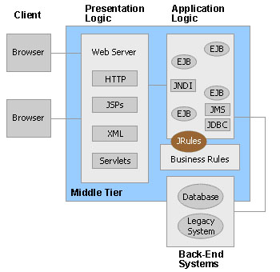
Figure 3 – J2EE Framework

6.2.1 Web Tier
The web tier is the “top level” in the J2EE paradigm as it is the tier that the clients interact with via web browsers. It provides a visual interface to the system that can be accessed anywhere by administrators, professors, graders, and students. In FIRE, this component consists mainly of JavaServer Pages (JSPs) build on the Apache Struts framework. We chose to use Struts mainly for its efficient way of dealing with web page forms. The JSP pages communicate with Servlets which act as an interface to the rest of the system. The Web Tier resides on the web server, inside of the JBoss container. The web tier can be seen in Figure 4.
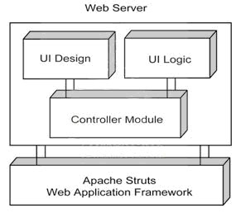
Figure 4 – Web Tier

6.2.2 Business Tier
The Business Tier consists of three distinct modules, as shown in figure 5. This tier resides on the web server, inside of JBoss, with the exception of and client written to utilize the web services.
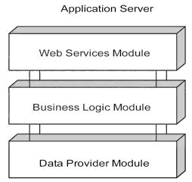
Figure 5 – Business Tier

The Web Services module provides an alternate interface to the FIRE system; these services expose the main business methods. Users can then access these methods without a web browser, and even write their own client interfaces to use the system. We chose to implement Web Services because it became apparent to us during requirements elicitation that many CS professors prefer to use their own scripts to automate using the try system. With web services, the interface to the system is completely customizable for students and faculty.
The Business Logic module of the Business Tier is composed of session Enterprise Java Beans (EJBs). This is the part of the web application that processes all of the requests sent by the Web Tier or Web Services component. The session beans are responsible for deciding what resources need to be accessed or instantiated to carry out the request and send the response back to the client.
The Data Provider module is composed of entity EJBs. This component provides all of the necessary functionality to retrieve and represent persistent business entities from the underlying relational database. In addition, it is the base layer for the business tier architecture of the FIRE web application.

6.2.3 Middle Tier
The Middle Tier in FIRE contains our compile and testing software built from the MantaRay middleware package. MantaRay uses multicasting to discover clients, allowing new machines to be added (or removed) to collection of available clients for testing without requiring any changes to the server. This component will queue student’s submissions as they arrive. The submissions are forwarded to the first available distributed client. This allows the server to transfer the burden of compiling and testing submissions to other machines on the same network. The Middle Tier resides partially in the JBoss web container and partially on the CS UNIX machines. Figure 6 shows the Middle Tier.

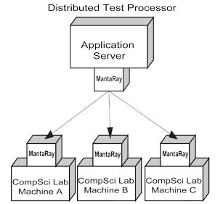
Figure 6 – Middle Tier

6.2.4 Data Tier
The Data Tier contains both our relational database and our file structure. The bulk of the data (student files, test scripts, test output, instructor files) are stored and maintained by the file structure. The database mainly stores user roles and authentication information, and has some ties to the file system. The Data Tier resides on our file server. Figure 7 shows the Data Tier.
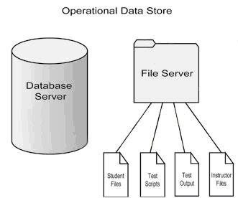
Figure 7 – Data Tier

6.3 System Communication
Since we are using J2EE, communication protocols between system components are well defined for us. All communication to or from the Business Tier uses Java Naming and Directory Interface (JNDI) and Remote Method Invocation (RMI) to access the EJBs. The exception to this is the Web Service messages, which use Simple Object Access Protocol (SOAP). Access to our database is provided by Java Database Connectivity (JDBC).
Figure 8 shows the main components of the system and main communication pathways between them during a student submission. This high level diagram gives a good overview of the system components and how they communicate.

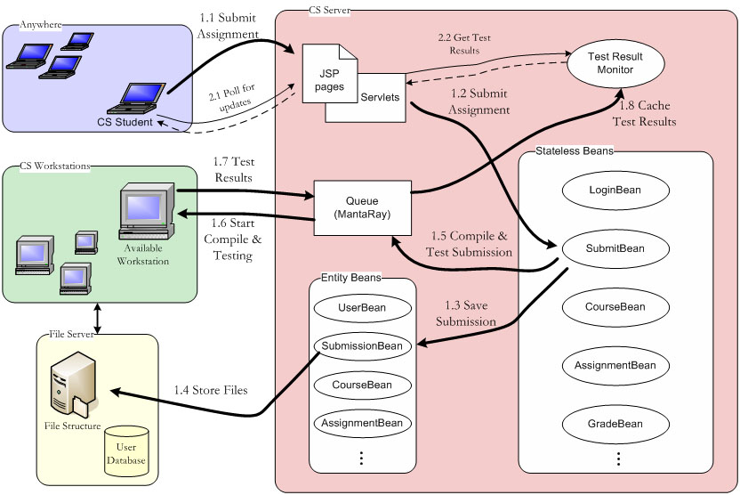
Figure 8 – Architectural Flow

7. Process and Product Metrics

We chose to track three different metrics: lines of code (LOC), LOC per man hour, and defects per component. The LOC metric provides us with the size of the overall product, as well as each component. The man hours metric approximates how much time we spent in development, and along with the LOC metric gives us a measure of our overall productivity. Our defects metric give us an idea of the complexity of the components relative to each other.

7.1 Lines of Code
The following are the results for the LOC metric:
Component | Lines of Code
Common package | 1660
Web Tier | 2104
Business Tier | 10764
Middle Tier | 2204
Web Services | 612
Test Suite | 1672
Prototypes | 4534
Total | 23550
Figure 9 – LOC Metric Results

The only surprising aspect of this metric was how large our prototypes ended up being. We expected the bulk of the code to be in the business logic, which it was.

7.2 LOC per Man Hour
To estimate man hours spent on the project, we assumed an average of 6 hours per team member per week. This results in 30 hours per week over 22 weeks, for a total of 660 man hours. The following are the results for the man hours metric:
Man Hours (Est.) | 660
LOC | 23550
LOC / Man Hour | 35.6
The results of this metric are higher than we expected. Given the fact that we didn’t code at all for the first month, along with the amount of meetings and documentation, we produced an impressive amount of code.

7.3 Defects per Component
We used Bugzilla, an open source bug tracking program, to manage our defect repository. Figure 10 shows defects by the component they were found in.
Figure 10 – Defects per Component
The defect results were not too surprising when severity of defects is taken into consideration. The bulk of the defects against the docs and web tier were minor severity, requiring small changes. The Business Tier had the majority of the high severity defects, which is consistent with the higher level of complexity found in that tier.

8. Product State at Time of Delivery
As can be seen in Section 5, we had significant slippage from our planned schedule and we did not deliver a completed system. Both our customer and coach didn’t believe we would complete the project from the outset, in fact this was even stated in the project proposal. What the CS department wanted was a solid framework on which to build, rather than a rushed “complete” system.
When we realized that finishing the system would be impossible in the given time frame, we decided to focus on the core functionality of the system. We prioritized Submit, Compile, and Test as the three most important aspects of the system. These three features are functional in the system we are delivering. Much of the rest of the system has been defined in proof-of-concept code. The highest priority toward the end of the project became thorough and complete documentation; so we left the project in a state it could be continued from. We provided full documentation on all components of the system, along with specific instructions on how to complete them, architecture diagrams, and deployment instructions. We are confident that another team will be able to pick up and complete this project.

9. Project Reflection
Overall, the FIRE project went well. The members of the team had very few disagreements during the development process, and we all contributed about the same amount of work. Our decision to only have one defined role (team leader) worked out well, any disputes were settled quickly. Jim Heliotis, our customer, seemed happy with our progress throughout the project. The spiral development model we chose was well suited for the project, and allowed us to get some higher priority pieces of the system functional before others were started.
Some elements of the project did not go smoothly. Requirements gathering took much longer than expected, and pushed the whole project back a substantial amount. Looking back, we should have asked to see the try manuals from the beginning; this would have given us a good up-front idea of the project’s full scope. We also ran into a great deal of configuration issues, mainly having to do with our chosen application server: JBoss. JBoss is open source, however they sell their best manuals and tutorials. Had we known this ahead of time, or how complex configuring JBoss was, we would most likely have chosen a different application server.
This project was a valuable exercise in taking a project from beginning to end, something that is unique to Senior Project. We all learned valuable lessons about overestimating how much work we could do, and underestimating the likelihood of problems.

10. References

1. Try User Manuals, Rochester Institute of Technology Computer Science Department, 2001.

2. Struts User Guide, Apache Software Foundation
http://struts.apache.org/userGuide/index.html.

3. MantaRay User Guide, Cordian Inc. http://sourceforge.net/docman/display_doc.php?docid=24128&group_id=112623.

4. JBoss Application Server 4.0 User Guide, JBoss Inc. http://www.jboss.org/index.html?module=downloads&op=download&downloadId=29.

5. J2EE Specification, Sun Microsystems
http://java.sun.com/j2ee/1.4/docs/index.html.

