FIRE
by Dragonsoft

Architecture
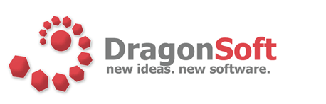
1. Introduction
This document is meant to give a broad overview of the FIRE system as a whole. Each of the tiers described in section 3 has its own detailed design and implementation document.

2. Language and Platform
FIRE is written purely in Java and uses the Java 2 Enterprise Edition (J2EE) application framework. It was clear from the beginning that we needed this to be a web-based enterprise application. Since the student base will be accessing the system from a heterogeneous operating system base, we either needed a rich client solution or a web based solution. A rich client solution led to problems in the area of updating the software, as well as the issue of defining our own interface for the students to become familiar with. A web-based solution affords the ability to access the system from any machine, even if they haven’t installed any of our software. Additionally, any time they access the web page, they will be using the latest version of the software.
This left us with two major options: J2EE or .NET. We chose to use J2EE because the major server and execution hardware is UNIX-based, and .NET can only run in a Windows environment. Even if we were to purchase adequate Windows hardware, if that hardware failed, there wouldn’t be backup hardware to re-deploy the system on. There is an additional concern with running in a Windows environment, it may be hard to ensure the student code, which is almost always targeted at UNIX environments, would compile and execute in an identical fashion on a Windows machine.

3. System Design
Once we had decided on using J2EE, making our high level system architecture was just a matter of mapping functional components of our system to the J2EE framework (Figure 1).
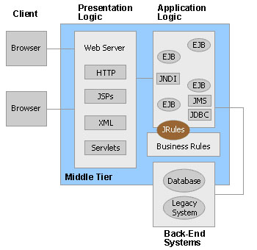
Figure 1 – J2EE Framework

3.1. Web Tier
The web tier is the “top level” in the J2EE paradigm as it is the tier that the clients interact with via web browsers. It provides a visual interface to the system that can be accessed anywhere by administrators, professors, graders, and students. In FIRE, this component consists mainly of JavaServer Pages (JSPs) build on the Apache Struts framework. We chose to use Struts mainly for its efficient way of dealing with web page forms. The JSP pages communicate with Servlets which act as an interface to the rest of the system. The Web Tier resides on the web server, inside of the JBoss container. The web tier can be seen in Figure 2.
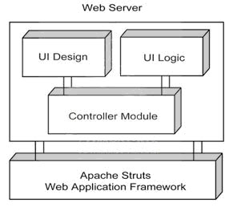
Figure 2 – Web Tier

3.2. Business Tier
The Business Tier consists of three distinct modules, as shown in figure 3. This tier resides on the web server, inside of JBoss, with the exception of and client written to utilize the web services.
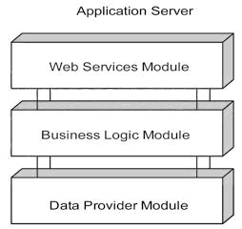
Figure 3 – Business Tier

The Web Services module provides an alternate interface to the FIRE system; these services expose the main business methods. Users can then access these methods without a web browser, and even write their own client interfaces to use the system. We chose to implement Web Services because it became apparent to us during requirements elicitation that many CS professors prefer to use their own scripts to automate using the try system. With web services, the interface to the system is completely customizable for students and faculty.
The Business Logic module of the Business Tier is composed of session Enterprise Java Beans (EJBs). This is the part of the web application that processes all of the requests sent by the Web Tier or Web Services component. The session beans are responsible for deciding what resources need to be accessed or instantiated to carry out the request and send the response back to the client.
The Data Provider module is composed of entity EJBs. This component provides all of the necessary functionality to retrieve and represent persistent business entities from the underlying relational database. In addition, it is the base layer for the business tier architecture of the FIRE web application.

3.3. Middle Tier
The Middle Tier in FIRE contains our compile and testing software built from the MantaRay middleware package. MantaRay uses multicasting to discover clients, allowing new machines to be added (or removed) to collection of available clients for testing without requiring any changes to the server. This component will queue student’s submissions as they arrive. The submissions are forwarded to the first available distributed client. This allows the server to transfer the burden of compiling and testing submissions to other machines on the same network. The Middle Tier resides partially in the JBoss web container and partially on the CS UNIX machines. Figure 4 shows the Middle Tier.

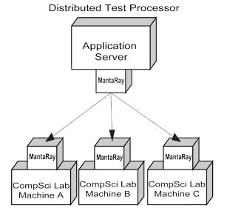
Figure 4 – Middle Tier

3.4. Data Tier
The Data Tier contains both our relational database and our file structure. The bulk of the data (student files, test scripts, test output, instructor files) are stored and maintained by the file structure. The database mainly stores user roles and authentication information, and has some ties to the file system. The Data Tier resides on our file server. Figure 5 shows the Data Tier.
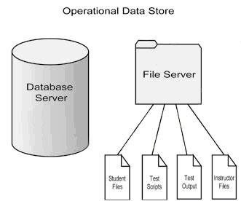
Figure 5 – Data Tier

4. System Communication
Since we are using J2EE, communication protocols between system components are well defined for us. All communication to or from the Business Tier uses Java Naming and Directory Interface (JNDI) and Remote Method Invocation (RMI) to access the EJBs. The exception to this is the Web Service messages, which use Simple Object Access Protocol (SOAP). Access to our database is provided by Java Database Connectivity (JDBC).
Figure 6 shows the main components of the system and main communication pathways between them during a student submission. This high level diagram gives a good overview of the system components and how they communicate.

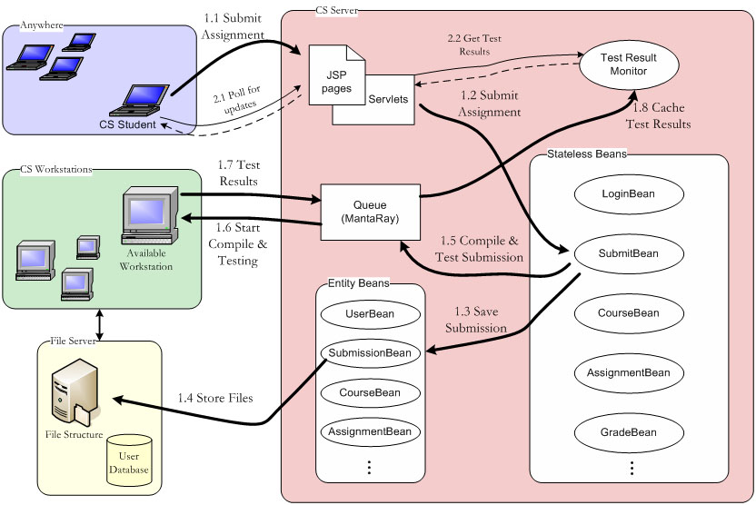
Figure 6 – Architectural Flow

