Scrum Management System

Intelcrum
Nick Dziedzic | Dustin Keller | Michael Starukhin
 | Chad Ver Dow

Intel Corporation

John Delos Reyes

Faculty Mentor
Professor Ken Martinez

Project Overview
Scrum Management System is a web-based software system which is designed to help software developers who are using the scrum development process, to manage their software requirements and project activities. The project was proposed by Intel as a replacement for the management system that they are currently using. The current system is not a web-based solution and has some usability issues which the sponsor requested be upgraded in the new system. Since a system is already in existence, the sponsor also provided the team with a current database structure which was used for the new system to ease the transition between systems. In addition, no data migrations were required by the sponsor.
The main goal of the project team was to realize the functional requirements and set up a base system which Intel could continue development on. Due to this, no administrative operations were required to be included in the system. All of the technology choices were left up to the project team.

Basic Requirements
The basic requirements for the system were already well planned by the project sponsor since the proposed system was an upgrade to an already existing system. This meant that the project team’s primary responsibility was to understand and clarify the requirements as well as propose some upgrades to the current system.
The two largest requirement areas which the sponsor was requesting were the drag and drop functionality as well as the windowing functionality. Drag and drop was implemented for both table rows as well as individual elements within the Document Object Model (DOM). The windowing functionality which was requested was maximize, minimize, pin, restore, and close. Each of these functions was implemented on each window section within the main browser window.
Following is a list of the project requirements which were completed for the project. These are taken from the project backlog which was the process document used to manage development tasks.
  - Create initial view for the hierarchy of Product/Project/backlog/sprint
  - Connect the database to the explorer view to enable the selection of products from the view
  - Connect the database to the explorer view to enable the selection of projects from the view
  - Connect the database to the explorer view to enable the selection of sprints from the view
  - Create inital view to display user stories and associated details
  - Create a link between user stories displayed in a sprint and their user-story page.
  - Implement client side sorting of user stories based on user story details using ajax.
  - Implement single click editing of user story details in the story list view (L5).
  - Update L1 view to meet feedback provided by project sponsor.
  - Update L5 view to meet feedback provided by project sponsor.
  - Populate storylist with data from the database when landing page is loaded.
  - Display percent completed for user stories.
  - Implement a 3 link column in the story list to move user stories to 3 specified sprints.
  - Calculate the current sprint based on the current date.
  - Update User story view when new sprint is selected
  - Create initial interface to display the list of User stories
  - Implement links so user story names open the User Story Page
  - All available statuses which a task can fall under are visible in the User story grid
  - Initial layout provided of each task visually associated with its User story
  - Implement the dragging a dropping feature to update the status of the task in the database.
  - Create required statuses: Not Started, Impeded, WIP, Done
  - Create an interface element to create a new user story
  - Add Story Name input element to new user story window
  - Set up intermediate window to link to new User Story page
  - Update S4 view to meet feedback provided by project sponsor.
  - Update S9 layout to meet feedback provided by project sponsor.
  - Implement the interface for dragging and dropping of tasks between statuses in storyboard partial
  - Add Owner input element to new user story window
  - Alter the storyboard interface to load values from the database.
  - Restrict dropping a draggable task to only its droppable target.
  - Maintain borders of table when tasks are dragged and dropped.
  - Fix dropping of task when mouse leaves droppable area.
  - Visually separate tasks in the storyboard.
  - Load user stories in the display when a sprint is selected on the explorer page
  - Create initial view for the user stories that contains a list of tasks based on the story selected, the list is ordered.
  - Create a add buttton that will insert a new row into the task list.
  - Create a delete button that will remove the task from the task list.
  - Create an edit button that will pop up a dialog box with the editable fields of the task.
  - Create a checkbox inside the done column of the task list
  - Create initial text boxes for Acceptance criteria and Description on U1 view.
  - Implement drag and drop sorting of tasks in the task list.
  - Create a hidden field that will keep the track of the order upon drag and drop.
  - Access the database to Display the following information on the page: Story Name, Story ID, Stakeholder, Story Owner, Business Value, Priority, Size and Description
  - Create a save button that will save story and task information to the database
  - Revert - If items have been changed the revert button will changed everything back to original place.
Should read refresh until a change is made, then it should read revert.
  - Update U1 view to meet feedback provided by project sponsor.
  - Update U6 text boxes to meet feedback provided by project sponsor.
  - Inline editing of table rows for Userstory partial
  - Create a unique page for each user story.
  - Implement a drag and drop link in the leftmost column of the task list portion of the user story window.
  - Enable drag and drop on new task rows when they are created by the user.
  - Restructure layout of the user story page.
  - Create popup window for task editting from the user story page.
  - Create Login controller for Username and Password
  - Create Storyboard controller and view
  - Create User Story controller and view
  - Create Landing controller and view
  - Create initial interface element to contain all views within the system.
  - Update O8 interface to meet feedback provided by the project sponsor.
  - Implement Minimize function in dialog.js
  - Implement Maximize function in dialog.js
  - Implement Restore function in dialog.js
  - Implement Pin function in dialog.js
  - Add pin button to dialog.js
  - Implementing layout for windows
  - Create functional prototype for table row drag and drop
  - Add min button to dialog.js
  - Add max button to dialog.js
  - Add restore button to dialog.js
  - Explorer Window is located in left portion of the screen when landing page is loaded.
  - User Story Window is located in the right top portion of the screen when the window is displayed.
  - Story Board is located in the bottom right portion of the screen when the window is displayed.
  - Story List is located in the right portion of the screen when the landing page is loaded.
  - Fix Z-Ordering of Explorer Window, User Story Page, Story Board, and Story List
  - Implement position for multiple minimized windows
  - Create a session object to keep track of who is logged on
  - Make storylist same height as explorer window when application loads.
  - Implement loading status display during loading.
  - Rearrange edit task window to go horizontal.
  - Setup intial size of edit task window.
  - Implement popup of user story window when add new story button has been pressed.
  - Restrict size of move sprint in storylist
  - Implement age instead of modified date in storylist
  - Restrict size of age field in storylist
  - Implement scrollbar for overflow in storylist and storyboard.

Constraints
The main constraint for our project was on the database structure. Since the customer is currently using their system they already have a lot of data in a database. In order to ease the transition of moving that data between the systems, we developed the structure based on a diagram which the sponsor provided.
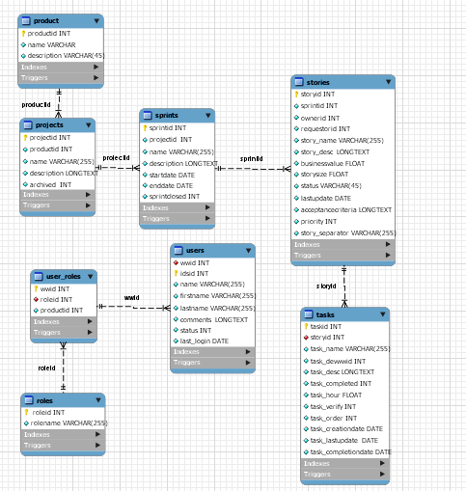

Development Process
Our project sponsor requested that we use the Scrum development process in order to gain some experience and knowledge in the problem domain for our product. This also allowed us to increase the usefulness of the software by solving some of the process problems which we were running into throughout development. None of the team members had any experience using this development process so research was conducted on the subject to help mitigate the risk that the process would not be followed correctly. After some research a project schedule was developed which consisted of several sprints of varying lengths to address the changing needs of the project/product.
There are several areas where the project team learned critical lessons about the development process implemented. First and foremost, the most difficult issue which had to be overcome is the amount of scheduling which is required for the scrum process to be completed. Since frequent meetings are used to track progress and ensure that everything is getting completed, if team members have differing schedules it becomes more difficult to arrange regular meetings. This was a major problem for our group because the college environment is not as regulated as that of a general work day and individual group members had other commitments which made the task of scheduling difficult. The second major lesson we learned was that the scrum process was not designed to be implemented until after the initial design and documentation set-up has been completed. This is because the process centers on task progress and completion, where as much of the initial work on a project leads up to the creation of the project tasks.
Each of the team members was assigned at least one role to ensure that tasks were completed correctly and on time. The project team agreed from the start that these roles were not connected with any particular project tasks but simply responsibilities which each individual was in charge of making sure got completed.
Dustin – Project Leader, Sponsor Communication
Chad – Process Updater
Nick – Server Technician
Mike –Metrics, Ruby Guru

Project Schedule: Planned and Actual
As stated in the previous section, the project schedule was broken down into a series of sprints which varied in length between two and three weeks. The first sprints were three weeks in length because they consisted mainly of planning and initial development tasks. As the project progressed we made the sprints shorter to increase the amount of feedback we received from our sponsor and better handle changing priorities as the amount of time we had remaining to finish up our tasks was running short. This ensured that those items which contained the most business value to the customer were completed within the project schedule. The full project schedule along with dates is listed below for reference.

First sprint starts Week 4 and ends Week 7
- Requirements, Design
- Prioritize features
- Investigate Technology
- Database planned, set up and links set up
- Server setup

Second sprint starts Week 7 and ends Week 10
- Release 1
  - Initial views completed

Third sprint starts Week 10 and ends Week 13
- Release 2
  - High propriety features to be addressed
    - Drag and drop
    - Minimize, maximize, restore
    - Pinning and unpinning
    - Connecting and saving to the database

Fourth sprint starts Week 13 and ends Week 15
- Release 3
  - Full connection to the database
  - User story page completed
    - Save, refresh and revert
    - Add, edit, and delete
  - Explorer is functional
  - Story list is functional
  - Story board functional

Fifth sprint starts Week 15 and ends Week 17
- Release 4
- All features implemented
- Clean up GUI
- Test
  - Stress testing
  - Acceptance testing
  - HTA User Testing
  - Regression testing
  - Validate product

Sixth sprint starts Week 17 and ends Week 19
- Release 5
- Fix any bugs found
- Clean up GUI
- Start user manual

System Design
The major part of the system design was decided up front by the technology choices that the team made. The major decision which needed to be made was to whether to go with an ASP.net product or a Ruby on Rails product. The team decided on Ruby on Rails which meant that a lot of the design was set up through Active Record and other utilities which Ruby on Rails provides.
The overall design of the system followed the Model View Controller pattern. The model was set up using Active record generators to create the desired tables, along with the CRUD operations (Create, Read, Update, Delete). The controller for our system was heavily dependant upon the design of the views and the architecture of ruby on rails. Since each section of the project was its own “window” inside of the browser, partials were used to render each individual section so that they could be manipulated individually. This created limitations on the flexibility with which the controllers could be designed. The overall design of the system is included below in a series of diagrams outlining the different sections of the design.

Process and Product Metrics
The team selected two metrics along with the required time and effort metrics. Slippage was chosen because the team wanted to know whether or not they were not they were on schedule. HTA was used because the project sponsor was worried about the performance of the application.
The team completed 37.4% more work then was estimated in the progress reports. Overall slippage of the implementation portion of the project was about 12.5% with 15 planned tasks cancelled out of the original 120 tasks. The team also under estimated the worked required for tasks by 3934 minutes of implementation time. A major reason for such an underestimate was because of the new technology and the limited experience with web user interface implementation. This is really evident in sprint three where the team underestimated by 1837 minutes.
HTA results showed a 1.875 to 4.75 times decrease in the amount of operations it took to perform similar effective tasks. The data is only really based off four features of a previous version of the program. Since the major concern of the team was the UI functionality, many of the features that can be used for HTA could not be tested.
Overall the metrics show that the project was a little behind schedule then planned, but the HTA does point to the tasks becoming more efficient.

Product State at Time of Delivery
At the time of delivery our product was functioning with all of the major requirements completed. The only high priority requirement which was not met by the team was the compatibility with both IE and Firefox browsers. This was missed because many problems were being encountered with the use of Javascript and CSS style sheets. Usability was one of our two primary nonfunctional requirements and many of the problems we were facing with IE were affecting the usability of the system. It was decided this was the best course of action by the project sponsor who was informed of the problems and gave permission to remove the requirement due to lower business value.
There were also some smaller features which did not make it into the final system. The first of which is special handling of the backlog inside of the system. Each of the sprints contains a list of the user stories which are being completed during that time interval. On the other hand the backlog is a special case which contains a list of all of the user stories, even if they are on another sprint. Its purpose is to provide the user with a way of viewing overall progress through the project.
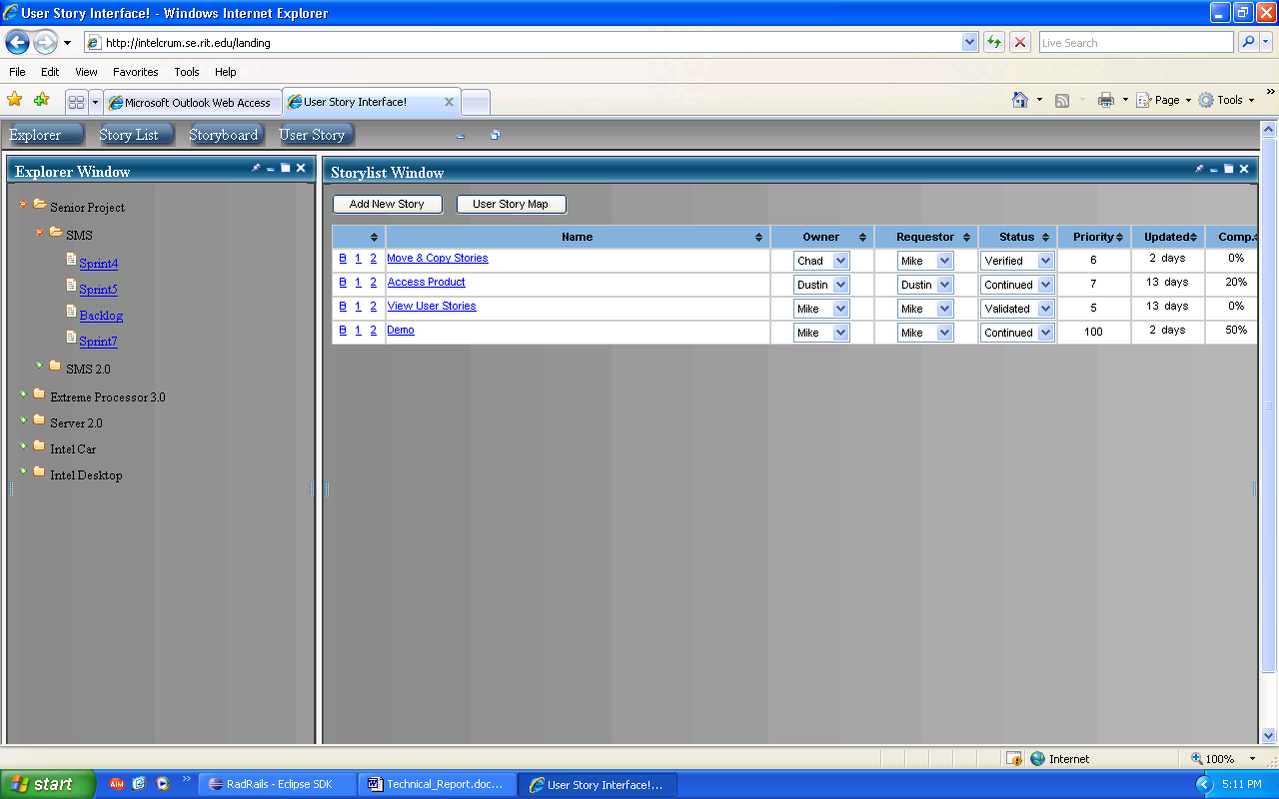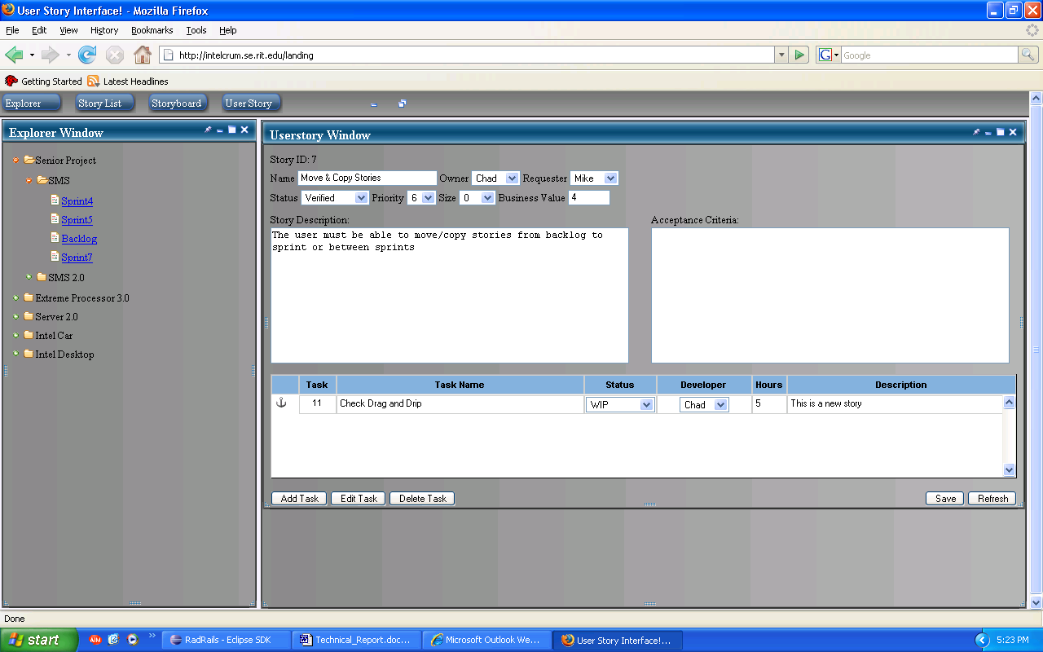

Project Reflection
Overall the project went very well, and we feel like the entire project was a success. The scrum methodology was the correct process to employ and we feel that this played a large part in the success of the product. Our team enjoyed completing the project and felt that we learned a lot about web based development as well as several new technologies. Most of the group was not familiar with a majority of the technologies which we used, so the learning process took up a lot of time especially in the first quarter of the project.
After the project was complete we discussed how we felt the overall experience in senior project went. Many of the group members felt that while it was a valuable experience, it felt more like having to do work while at school than an actual class. This made it more difficult to rate progress and accurately evaluate how the team overall was performing. It was generally accepted that a successful project with high customer satisfaction would result in a successful senior project experience.

