Excellus jTIGRESS and Portlet Project

Phase II Requirement Findings
Prototype Iteration II

  - Portlet capabilities
2.2.1 Interface design
General concern: to what extent can portlet interfaces emulate the look and feel of popular PC interfaces?
2.2.1.1 Capabilities and limitations
2.2.1.2 Look and feel; customization
2.2.2 Application design
General concern: to what extent can a portlet-based application be designed without concern for limitations imposed by inter-portlet communications?
2.2.2.1 Inter-portlet communication – Click here
    - Portlet families
General concern: to what extent can families of portlets be created from foundation portlets
      - Limitations/constraints – Click here
      - Effort to develop

    - Websphere/Portal capabilities and limitations
General concern: is it feasible to base an enterprise-wide authentication strategy on Websphere/Portal?
      - Single sign on capability

Other concerns include:
- External LDAP

General questions for next iteration are:
- Are there any other application design or portlet family objective areas you would like us to explore?
- Other questions are outlined in the Obstacles Encountered section below.

The next iteration will address the following:
- Interface design capabilities and limitations
- Single Sign-On capabilities and limitations
- External LDAP functionality

Obstacles Encountered

1. Database Connectivity: We are currently working to connect with the DB2 database on our server (we’ve encountered issues with driver and namespace configurations). This will allow us to use Enterprise JAVA Beans (EJBs) functionality with the portlets. Currently, the portlets rely on a data object for member and claims information. Though this does not replicate what the actual version of jTIGRESS might look like (Portlets talking to EJBs) it does offer us the functionality we need to address the key objectives outlined above.

Our question is: Should we add connecting to the data source as an objective for phase 2? Or should we disregard it and focus our efforts on the objectives outlined above?

2. Interface, Single Sign-On, and External LDAP Research: We have also been working on documenting the portlet interface capabilities and limitations, single sign-on capabilities, and external LDAP capabilities. Due to limited resources on this holiday weekend, our concentration for this iteration was directed toward the inter-portlet communication and family of portlets objectives. This documentation is nearing completion and will be sent out as soon as it is finished (which will be before the submission of iteration three). Our goal is to have this documentation to you by the end of this week so that we can receive feedback next Monday and incorporate the feedback into iteration 3.

Inter-portlet Communication

1–way communication – Member page

The members page allows CSR users to login to the system and view information about BlueCross BlueShield subscribers. To operate this functionality, 1-way communication between portlets must be capable. Below we see a view of the Members page with 2 portlets: Member ID, which accepts a nine digit ID (‘123456789’ or ‘111111111’ for our testing), and Member Info, which displays the member information.

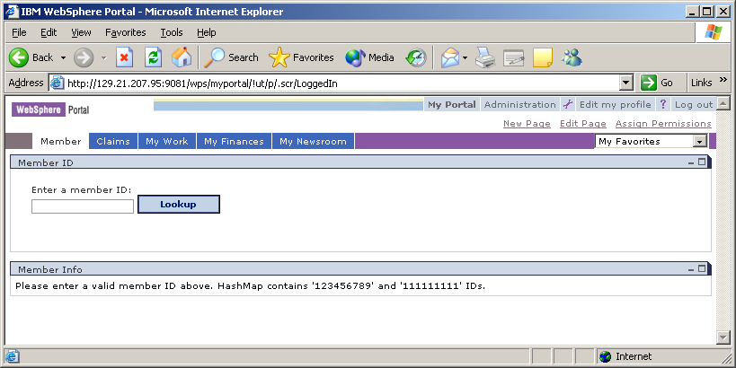

By typing in a member ID in the Member Info portlet and pressing the ‘Lookup’ button, the Member Info portlet is automatically updated to display the information:

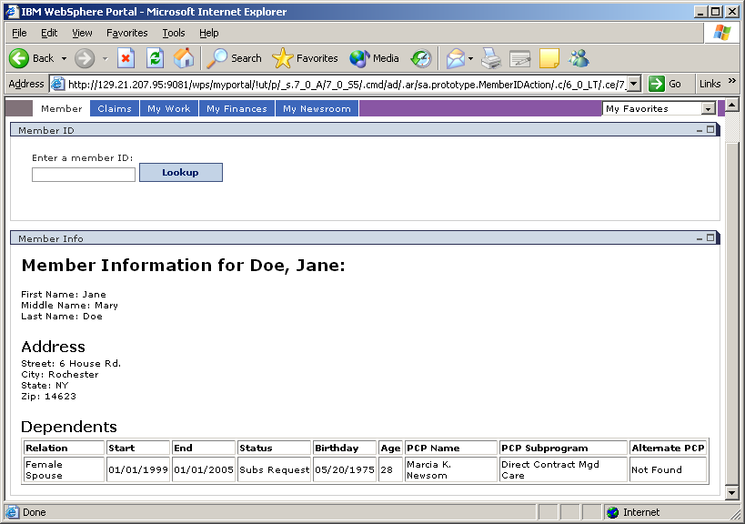

This occurs through the use of portlet message passing and storing to the session’s user object. Portlet message passing works by allowing one portlet to listen for events on the page, here the Member ID portlet listens for the ‘Lookup’ button to be pressed. Once an event occurs, information about the event is sent to the portlet’s actionPerformed() method. In this method, logic can be done to process the information before a message is sent via the send() method.

Sending of the data can be done to all portlets as a broadcast or to a specific portlet. In this case we wish to send the information to the Member Info portlet on the same page. The Member Info portlet is set up as a MessageListener, so when the Member ID portlet calls the sent() command, Member Info portlet will receive the data. Here when a member ID is entered and ‘Lookup’ is pressed, the ID is sent to the Member Info portlet retrieves information from a data source about the ID and displays it on screen.

To display data from the portlet (a JAVA class file) to the webpage (a JSP file), the session’s User object is used. This object stores data about the specific user that is logged into the system. For the Member page, the Member ID is stored in the User object and can be retrieved at any point from JAVA or JSP files. This data is only stored for the life of the session. So, when a user logs off of the system, the information stored in the User object is destroyed.

Most of the time developing inter-portlet communication was spent figuring out how to deliver information for the portlet to the jsp. There are several different objects encoded into the PortletRequest object. The objects have different lifetimes, however, and it is the User object which offers the longest lifetime (alive while a user is logged into the system). This lifetime allows data to persist between pages and portlets which offers significant functionality for data passing.

2–way communication – Claims page
1-way communication between portlets only addresses some of the concerns of a Portal based software solution. In a portal environment where there are vast amounts of dependant information, such as the jTIGRESS application, it must be possible to portlets to offer 2-way communication back-and-forth and to multiple portlets. To display such functionality, we have chosen a simple claims processing system. After entering a member ID in the Member page, a CSR can click on the Claims tab to display claim information about the user. This page appears as follows:

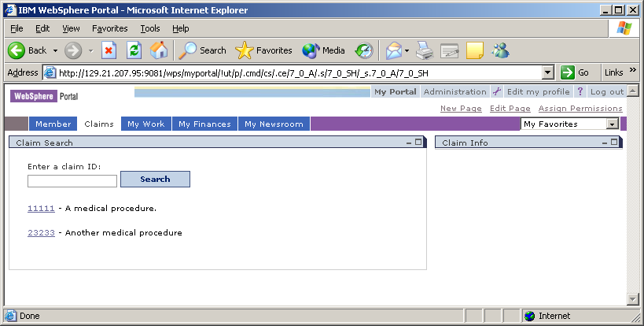

We have chosen to display a search style page, since this is what is currently in TIGRESS. The functionality of this search in our prototype is very limited, however, and it’s best to use the default results that are given when entering the page.

In this scenario we wish to update the Claim Info portlet on the right with information about the claim that is clicked on in Claim Search. To do this, the same functionality as explained in the 1-way communication section above is used. After clicking on a claim in Claim Search, the id of the claim is sent to Claim Info:

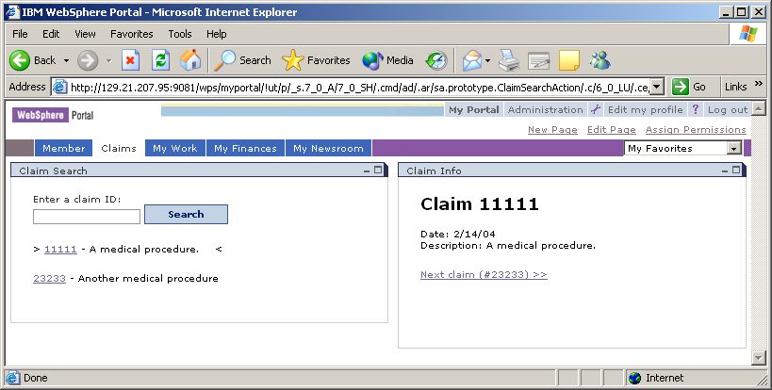

Notice that a link to the next claim is show at the bottom of the Claim Info page and a marker for the current claim (‘11111’) is used on the Claim Search page. To display communication between the portlets, we wish for Claim Search to update the marker when the ‘Next claim’ link on Claim Info is clicked. This involves 2-way communication between portlets. Claim Search must be configured both as an ActionListener (to send data to Claim Info) and as a MessageListener (to receive information from Claim Info). Claim Info will be configured the same way. Now information will be sent from the Claim Info to the Claim search to update the current claim market when the ‘Next claim’ is clicked:

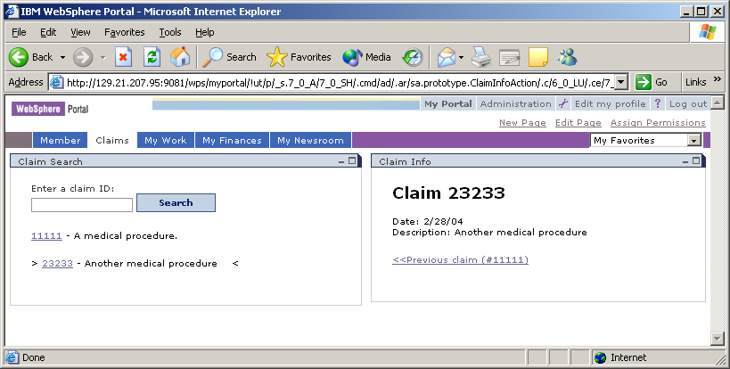

The following diagram describes 2-way communication between the Claim page portlets:

Implementing a Family of Portlets

One of the benefits of a portal based application solution is the ability to reuse functionality across users and portlets. For example, two users of the jTIGRESS system, a CSR and a BlueCross BlueShield subscriber logging in from the web, are very different. The CSR will be able to view a wealth of information about the subscriber such as benefits information, claims information, a history of their calls, etc. while a web user will be able to view a limited amount of information about only their account, perhaps only their information or claim history. Instead of creating one set of portlets for the CSR and a completely different set for the web user, the portlets can be combined to leverage reuse.

This works by doing a simple check on who is currently logged into the system and what kind of authorization they have to view information. For testing purposes we have a CSR (which is logged in by using the proto/proto1 account) and a web user (which uses no account information). The CSR will see the following information after entering an ID (notice the dependant information is displayed):

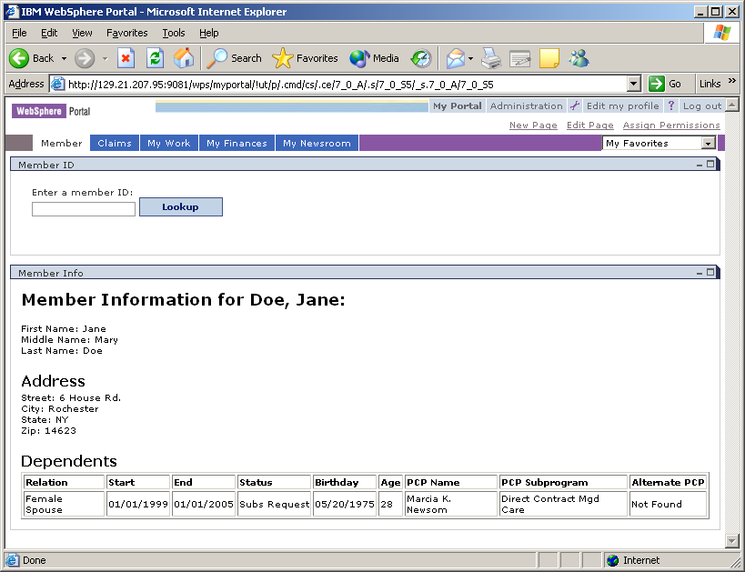

In our system, a web user will not be able to view information about other people on the subscriber’s plan:

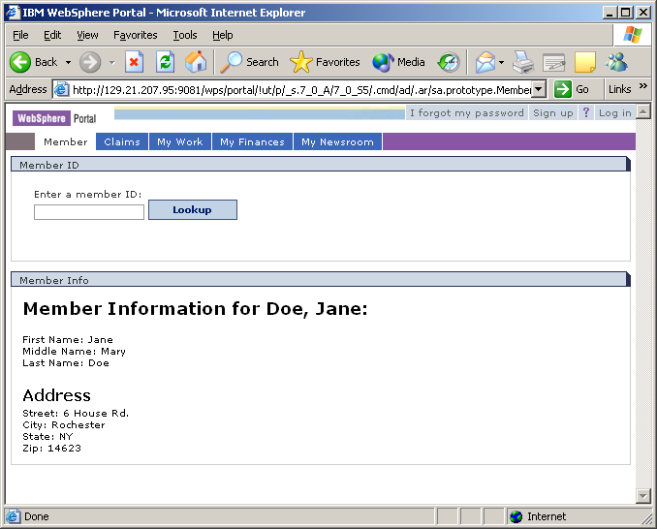

Both users, the CSR and the web user, are using the same portlets to display the information (Member ID and Member Info). The difference between the two users is the presentation (JSP) layer of the applications. The CSR is authorized to view the complete member information JSP while the web user is authorized to view the restricted member information JSP. This is accomplished by checking what type of user is logged into the system and then sending them to the appropriate page. In our case, a logged in user (CSR) will view the regular member information page while a user that is not logged in will view restricted information:

Here common logic for both users will be placed in the portlets themselves while user dependent information will be handled by the JSP. This relieves the developer of having to maintain separated common components to applications (such as TIGRESS and excellus.com applications).

