Excellus jTIGRESS and Portlet Project

Phase II Requirement Findings
Prototype Iteration III

  - Portlet capabilities
2.2.1 Interface design
General concern: to what extent can portlet interfaces emulate the look and feel of popular PC interfaces?
2.2.1.1 Capabilities and limitations
2.2.1.2 Look and feel; customization
2.2.2 Application design
General concern: to what extent can a portlet-based application be designed without concern for limitations imposed by inter-portlet communications?
2.2.2.1 Inter-portlet communication – Click here (Updated for iteration 3 with more clarification of persistent data and session objects and how 3-way portlet communication is accomplished)
    - Portlet families
General concern: to what extent can families of portlets be created from foundation portlets
      - Limitations/constraints – Click here (Awaiting example from Dr. Lasky)
      - Effort to develop

    - Websphere/Portal capabilities and limitations
General concern: is it feasible to base an enterprise-wide authentication strategy on Websphere/Portal?
      - Single sign on capability

Other concerns include:
- External LDAP

Obstacles Encountered

1. Database Connectivity: We are currently working to connect with the DB2 database on our server (we’ve encountered issues with driver and namespace configurations). This will allow us to use Enterprise JAVA Beans (EJBs) functionality with the portlets. Currently, the portlets rely on a data object for member and claims information. Though this does not replicate what the actual version of jTIGRESS might look like (Portlets talking to EJBs) it does offer us the functionality we need to address the key objectives outlined above.

Our question is: Should we add connecting to the data source as an objective for phase 2? Or should we disregard it and focus our efforts on the objectives outlined above?

UPDATE: It is not necessary to research this functionality in Phase 2 of R&D any further.

Inter-portlet Communication

1–way communication – Member page

The members page allows CSR users to login to the system and view information about BlueCross BlueShield subscribers. To operate this functionality, 1-way communication between portlets must be capable. Below we see a view of the Members page with 2 portlets: Member ID, which accepts a nine digit ID (‘123456789’ or ‘111111111’ for our testing), and Member Info, which displays the member information.

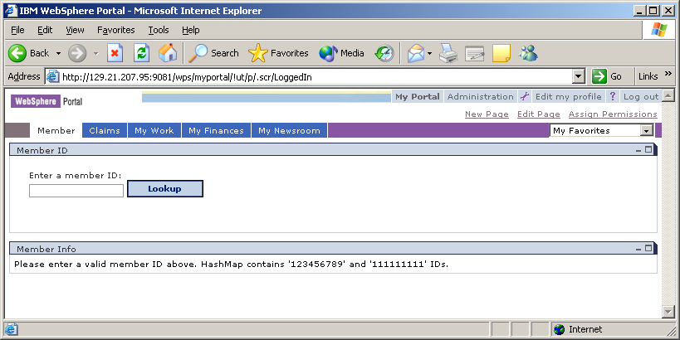

By typing in a member ID in the Member Info portlet and pressing the ‘Lookup’ button, the Member Info portlet is automatically updated to display the information:

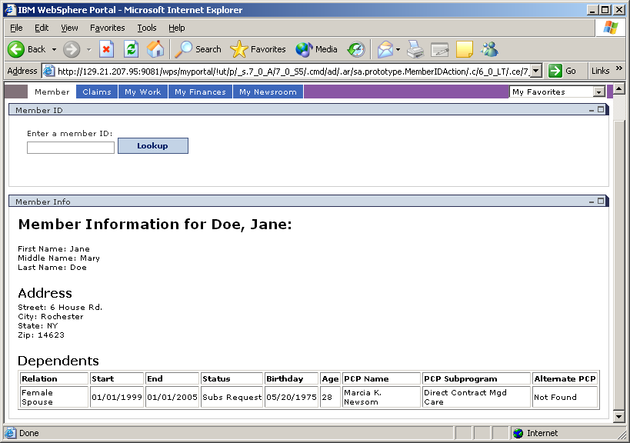

This occurs through the use of portlet message passing and storing to the session’s user object. Portlet message passing works by allowing one portlet to listen for events on the page, here the Member ID portlet listens for the ‘Lookup’ button to be pressed. Once an event occurs, information about the event is sent to the portlet’s actionPerformed() method. In this method, logic can be done to process the information before a message is sent via the send() method.

Sending of the data can be done to all portlets as a broadcast or to a specific portlet. In this case we wish to send the information to the Member Info portlet on the same page. The Member Info portlet is set up as a MessageListener, so when the Member ID portlet calls the sent() command, Member Info portlet will receive the data. Here when a member ID is entered and ‘Lookup’ is pressed, the ID is sent to the Member Info portlet retrieves information from a data source about the ID and displays it on screen.

To display data from the portlet (a JAVA class file) to the webpage (a JSP file), the session’s User object is used. This object stores data about the specific user that is logged into the system. For the Member page, the Member ID is stored in the User object and can be retrieved at any point from JAVA or JSP files. This data is only stored for the life of the session. So, when a user logs off of the system, the information stored in the User object is destroyed.

Most of the time developing inter-portlet communication was spent figuring out how to deliver information for the portlet to the jsp. There are several different objects encoded into the PortletRequest object. The objects have different lifetimes, however, and it is the User object which offers the longest lifetime (alive while a user is logged into the system). This lifetime allows data to persist between pages and portlets which offer significant functionality for data passing.

The original object that we began trying to pass data through was the PortletSession object. Our initial assumption was that this portlet session acted as a session object, carrying data between portlets. It was discovered, however, that the lifetime of this object was the same as the lifetime of the portlet. So, when the portlet was no longer being show in the current webpage, the data would expire. We then discovered the user object which functions as explained above, carrying data from portlet to portlet for the life of the user logged in. One caveat of this approach, however, is that if there is no user logged in, the User object does not exist. This mean that to pass data from portlet to portlet, a standard HTTP session must be used like on any other non-portal based web application.

2–way communication – Claims page

1-way communication between portlets only addresses some of the concerns of a Portal based software solution. In a portal environment where there are vast amounts of dependant information, such as the jTIGRESS application, it must be possible to portlets to offer 2-way communication back-and-forth and to multiple portlets. To display such functionality, we have chosen a simple claims processing system. After entering a member ID in the Member page, a CSR can click on the Claims tab to display claim information about the user. This page appears as follows:

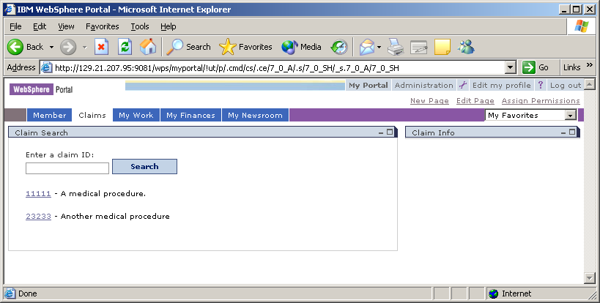

We have chosen to display a search style page, since this is what is currently in TIGRESS. The functionality of this search in our prototype is very limited, however, and it’s best to use the default results that are given when entering the page.

In this scenario we wish to update the Claim Info portlet on the right with information about the claim that is clicked on in Claim Search. To do this, the same functionality as explained in the 1-way communication section above is used. After clicking on a claim in Claim Search, the id of the claim is sent to Claim Info:

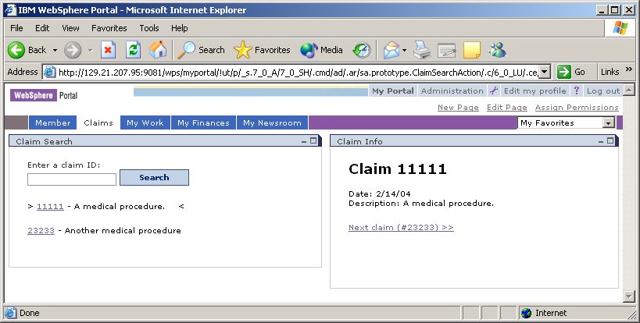

Notice that a link to the next claim is show at the bottom of the Claim Info page and a marker for the current claim (‘11111’) is used on the Claim Search page. To display communication between the portlets, we wish for Claim Search to update the marker when the ‘Next claim’ link on Claim Info is clicked. This involves 2-way communication between portlets. Claim Search must be configured both as an ActionListener (to send data to Claim Info) and as a MessageListener (to receive information from Claim Info). Claim Info will be configured the same way. Now information will be sent from the Claim Info to the Claim search to update the current claim market when the ‘Next claim’ is clicked:

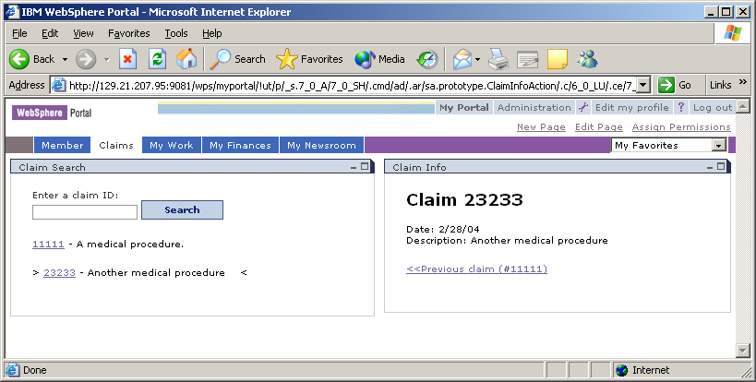

The following diagram describes 2-way communication between the Claim page portlets:

3-way communication – Claims page (Iteration 3)

The claims page has been updated in iteration three to exhibit the communication of three portlets passing data to each other. Using the functionality that we had in iteration two, we’ve added a third portlet to detail claim check (payment) information. The results of which can be seen below.
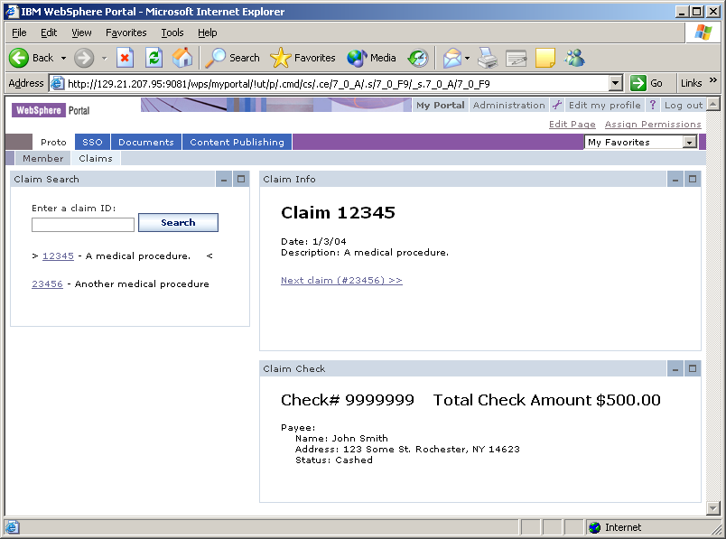

Here we see that by clicking on a claim in the Claim Search portlet, both the Claim Info and Claim Check portlet are updated. This functionality can be accomplished through two methods. The first involves sending a message to each portlet separately. The second method involves broadcast a message to all portlets on the page. Either can be used in this case but it is probably better to start a habit of separately sending message to each portlet. This is because in a much larger application, such as jTIGRESS, many portlets will be used on a page and only some of the will need to be updated when an action occurs (as opposed to all of the getting updated via the broadcast message method).

As mentioned befpre, when an action occurs in the Claim Search portlet, both the Claim Info and Claim Check portlet are updated. This is because the Claim Search portlet sends the claim number to the Claim Info portlet and the Claim Check portlet. Each portlet receives this message and looks up the claim in our data source, displaying its information on screen. Now, when the “Next Claim” is clicked on in the Claim Info portlet, a message is sent to both the Claim Search and Claim Check portlets telling them to update with a new claim number.

Summary of inter-portlet communication

The functionality and methodology behind three way portlets can be extended to n-way portlets. Essentially there are four different types of portlets:
- Ones that do not communicate with others at all.
- Source portlets - Portlets that only send information to other portlets (explicitly or by broadcast).
- Target portlets – Portlets that only receive information and update themselves based on other portlets.
- Source and Target portlets – Portlets that both send and receive data.

Arranging these in a portal application allows data transfer capabilities between portlets. In the end, the data transfer capabilities offered by Portal based applications are very similar to that of any other software application with one main concern.
This concern is server power. The messages and data sent between portlets are done through the application server. This application server must be powerful enough to handle many of these transfers by several different end users. Developers must also be concerned with this limitation as it affects how their applications are written. Developers must try to store the least amount of information as they can in the User object that was talked about above so as to not “clog” the server with data. If this consideration is not addressed, meaning the server hardware infrastructure and software applications are not efficiently designed, intercommunication between portlets will be greatly affected.

Implementing a Family of Portlets

One of the benefits of a portal based application solution is the ability to reuse functionality across users and portlets. For example, two users of the jTIGRESS system, a CSR and a BlueCross BlueShield subscriber logging in from the web, are very different. The CSR will be able to view information about the subscriber such as benefits information, claims information, a history of their calls, etc. while a web user will be able to view a limited amount of information about only their account, perhaps only their information or claim history. Instead of creating one set of portlets for the CSR and a completely different set for the web user, the portlets can be combined to leverage reuse.

This works by doing a simple check on who is currently logged into the system and what kind of authorization they have to view information. For testing purposes we have a CSR (which is logged in by using the proto/proto1 account) and a web user (which uses no account information). The CSR will see the following information after entering an ID (notice the dependant information is displayed):

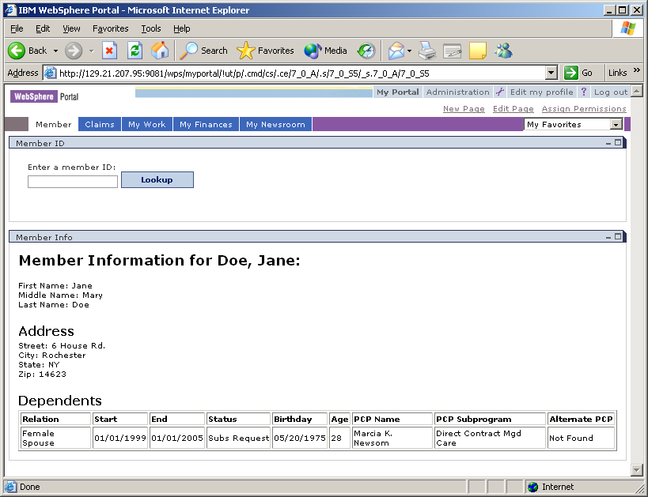

In our system, a web user will not be able to view information about other people on the subscriber’s plan:

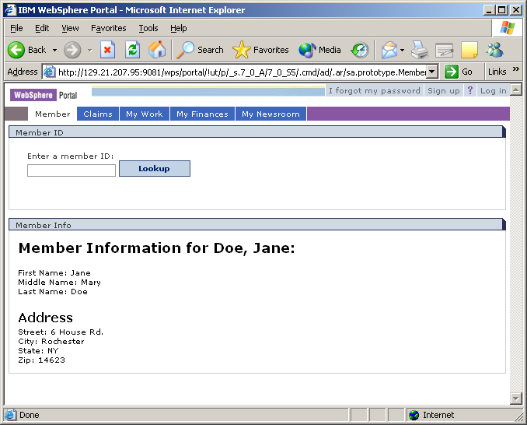

Both users, the CSR and the web user, are using the same portlets to display the information (Member ID and Member Info). The difference between the two users is the presentation (JSP) layer of the applications. The CSR is authorized to view the complete member information JSP while the web user is authorized to view the restricted member information JSP. This is accomplished by checking what type of user is logged into the system and then sending them to the appropriate page. In our case, a logged in user (CSR) will view the regular member information page while a user that is not logged in will view restricted information:

Here common logic for both users will be placed in the portlets themselves while user dependent information will be handled by the JSP. This relieves the developer of having to maintain separated common components to applications (such as TIGRESS and excellus.com applications).

For more information on other inheritance and user role passed customization, see the Look and Feel section which explains how to change the user view based on rules.

