U of R eXtensible Library

MetaCat
Rob Busack, Anthony Lyo, Matthew Horoszowski, Ben Greenwood, Dean Rzonca

Project Sponsor
Nathan Sarr

Faculty Mentor
Robert Bubacz

Overview :
Currently, the University of Rochester uses an aging proprietary system to hold digital information on material in the library collection. This system, while functional, has limited features and a non-intuitive interface. They would like to extend the functionality of the system with custom-written software.
Our project will comprise the first stage of extending the existing proprietary software system. Our task is to take the existing MARC and Dublin Core metadata from the existing system, parse it, create relations between bibliographic records and author records, and then provide an easy mechanism for other systems to search and interact with this data. This is complicated by the fact that not all the data in the existing database is correct. When creating relations between records, our system will have to be able to identify and correctly match records that have alternate forms of the authority name, or create authority records if none exist in the system. There are a variety of rules for matching these records, and it must be easy to modify the matching rules in our system. Additionally, the system must allow librarians to check and confirm or reject matches that the system is uncertain about.
We will be releasing the system in four phases. The system is naturally broken up into four major functional blocks. This also allows us to use the iterative and incremental development process, which is well-suited to the size of the team and the project. The first phase functionality will consist primarily of being able to parse MARC records and create relations between records that match exactly, and provide an API that allows external systems to interact with the database easily. The second stage will extend support to Dublin Core records, allow matching of alternate forms of authority names, and reporting on this matching. The third stage will allow configuration files to specify how the matching strategy operates, and provide additional rules for alternate name matching. Finally, the fourth stage will utilize external web resources when the system is unable to match records based on the existing rules.
The system will be built using Java 1.5 and MySQL. In addition to the API, there will also be a simple GUI provided with the system to demonstrate the system's functionality and perform some basic tasks such as importing data to the database.
Use Cases
No. | Description
1. | Import a Record
1.1 | Import an Authority Record
1.2 | Import a Bibliographic Record
1.3 | Batch Import Records
2.0 | Match Names in a Record
2.1 | Match Names in All Unprocessed Records
3. | Generate Usage Report
4. | Review Possible Name Matches

See Use Case Descriptions.doc for more details
Scope Limitations
The system will import bibliographic records and identify the correct, authorized form of the names of authors and subjects attached to the record. The functionality of the system is limited to processing of bibliographic records and generating usage statistics associated with this processing. The primary goal of the system is to work as a larger part of the eXtensible Catalog, so an API will be provided to access these features. Additionally, a simple UI will be offered to process records, obtain results, accept or reject a questionable result, or generate usage reports. This UI is not intended to work as part of the larger XC system, so it will not be as robust as other user-facing component. No capability for retrieval will be built in.
Functional Release Schedule
See Name Access Control Module Project Schedule.mpp
Task List Scheduling And Time Management : Release planning and time management, the splitting up of work and assigning estimated hours to it - Matthew
Risk Management - See Meta.cat - Risk Management.xls
Technical Process
Iterative and incremental process is used for this project. This process allows the development team to implement incrementally and learn from the earlier deliverables of the system. It also gives customers a chance to give feedback on the deliverables.
The process consists of initialization step, and iteration step.
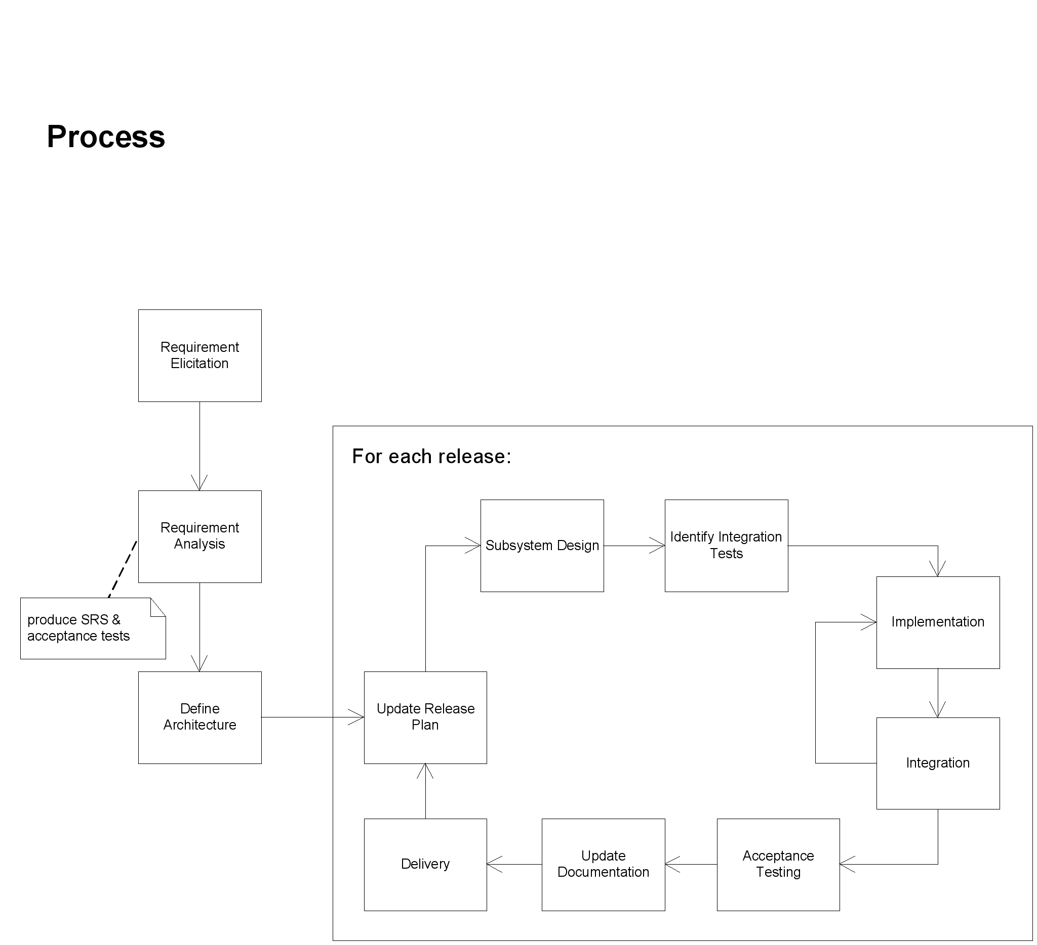
Figure: Iterative and incremental process flow
The initialization step consists of domain analysis, scope analysis, and planning. During this stage, the development team discusses the details of the project with the customers regarding the key aspects of the problem. The team then creates an initial project plan, a draft requirements and specifications (SRS). Using SRS, an initial architecture for the system is created so that the team can start working on implementation.
The initialization step sets the motion for the first iteration of the project. Each project’s iteration involves updating release plan, subsystem design, integration test plan, implementation, integration, acceptance testing, documentation revision, and, finally, deliverables for review. At the end of iteration, the customers get a chance to review the deliverables and give feedback to the team. The next iteration takes account of the customers’ feedback and makes adjustments accordingly.
Project Metrics
The following metrics are used to measure the progress and status of the project.
Effort by type of activity
Record the amount of time the team spends on different activities such as requirements, design, implementation, documentation, and others. It shows how much time the team is spending on each activity, and attempts to improve efficiency if possible.
Test metrics
Analyze code coverage, # of test cases per requirement (use case, user story etc), % of tests passed successfully.
Defects by types
Record the number of defects found in different stages of the project such as requirements, design, implementation, documentation, and others.

