Kodak Bluetooth Stack Architecture

Document Overview

This document describes the high level design of the Bluetooth Protocol Stack. It shows system layers, component interactions and threads. This document also present design alternatives that were considered and discarded along with the pros and cons of each design alternative. For a synopsis of the project see the Project Synopsis.

Requirements and Qualities

Users must be able to upload pictures to the kiosk through any of the three protocols BPP, OPP, and FTP. The Kodak implementation must support all the mandatory functions specified in the Bluetooth profile specifications for BPP, OPP, and FTP. The Protocol Stack implementation will provide an API to interface with the application that runs in the Picture Maker Kiosk.

The quality that is most important to the protocol stack is availability. The stack must be constantly available to the kiosk application and must recover from any fault without crashing the system.

The Architecture

The layered diagram below shows how the Kodak Bluetooth Protocol Stack fits in with the Picture Maker Kiosk Application and it’s relation to the other technology layers. The portions shaded in blue are the layers that will be addressed in the Protocol Stack implementation.

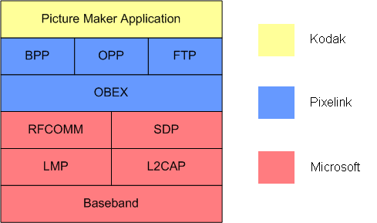

Selected Design:

The selected design can be characterized as Event-Driven, with Top-Down deployment. It was selected because it possesses most of the benefits of each of the alternatives, while exhibiting no significant drawbacks.

Key Features:

- Profiles are instantiated and maintained by the Kiosk Application, with which they have a bidirectional relationship (the Kiosk Application may call methods on the Profiles, and the Profiles may call methods on the Kiosk Application, as indicated in Kodak’s API).
- Profiles are responsible for registering with the Service Discovery subsystem and instantiating the OBEX layer of the system.
- SDP is a singleton class that is responsible for communicating Service Discovery registrations to the Microsoft Bluetooth Stack, and maintaining awareness of registered services and used channels.
- Messages are communicated using an event model. They are assembled at the OBEX layer and delivered via method call to the appropriate profile for handling. A reply to the message is determined via a response to the method call.

Benefits:

- Provides PictureMaker Kiosk application with references to Profile instances easily, aiding compliance with Kodak API.
- Event-Driven structure is easy to model and familiar to implementers.

Drawbacks:

- An additional layer of the system requires bidirectional associations, which increases coupling.

Class Diagram:

Sequence Diagram: Deployment

Sequence Diagram: Message Delivery

- Design Alternative #1:

This design is characterized by a socket-style call structure that resembles the general architecture of network socket systems.

Key Features:

- Profiles receive OBEX Messages by monitoring and reading from a queue in an OBEX object.
- Replies to OBEX Messages are delivered from Profiles via method call to the OBEX layer.

Benefits:

- Provides PictureMaker Kiosk application with references to Profile instances easily, aiding compliance with Kodak API.
- Unidirectional associations between Profiles and OBEX reduce coupling.

Drawbacks:

- Architecture is unfamiliar to implementers.
- The call structure leaves some ambiguity about the intended recipient of responses, and may prevent future support for concurrent communication with devices.

Design Alternative #2:

This design is characterized by an event-driven call structure, with bottom-up deployment.

Key Features:

- Profiles are only responsible for handling messages and communicating with Kiosk,
- Messages are delivered to Profiles via method call.
- OBEX Subsystem is the entry to threads.

Benefits:

- Event-Driven structure is easy to model and familiar to implementers.

Drawbacks:

- Design is tightly coupled.
- Does not easily provide PictureMaker Kiosk application with references to Profile instances as is specified in the customer provided API.

