
Content Management & Generation System II
Administrator User Guide

Team SHARP
Samuel Goshen
Leo Torbochkin
Dan Edenhofer
Nicholas Sabocheck
Dominic Holt

Last Update:
2/15/2009
Table of Contents

1. Administrator Capabilities 2
2. Capability Instructions 2
2.1. Login: 2
2.2. Edit Profile: 3
2.3. Submit Document: 3
2.4. Download Document: 3
2.5. Update Document Metadata: 3
2.6. Send Notification: 3
2.7. Change Issue for Document: 3
2.8. Sort Document List: 4
2.9. Filter Document List: 4
2.10. Issue Creation 4
2.11. Remove User Accounts from System 4
2.12. Edit info of User Accounts in the system 4

1. Introduction

The administrator is the highest role one can obtain within the newsletter generation tool. If you don’t have a separate account you’ve created that has administrative access, you will need to perform administrative features using the default administrator account. To do so, merely login with the username: admin and password: admin. It is recommended that once you create your own account and set that account as an administrator account, you should delete the default administrator account for security purposes.

1. Administrator Capabilities
- Login
- Edit Profile
- View submitted documents
- Submit Document
- Change Document metadata
- Send notifications
- Download documents
- Change issue for document
- Approval/Rejection of document
- Issue Creation
- Remove User Accounts from System
- Edit info of User Accounts in the system
  - Email
  - Name
  - Affiliation
  - Role
  - Reset Password

2. Capability Instructions

2.1. Login:

When you are attempting to log into the system, you must go to http://sharp.se.rit.edu/ACM_Sigsoft/ and enter your username (this is your email address). After your username is entered you need to correctly match your password with that username and click log in.

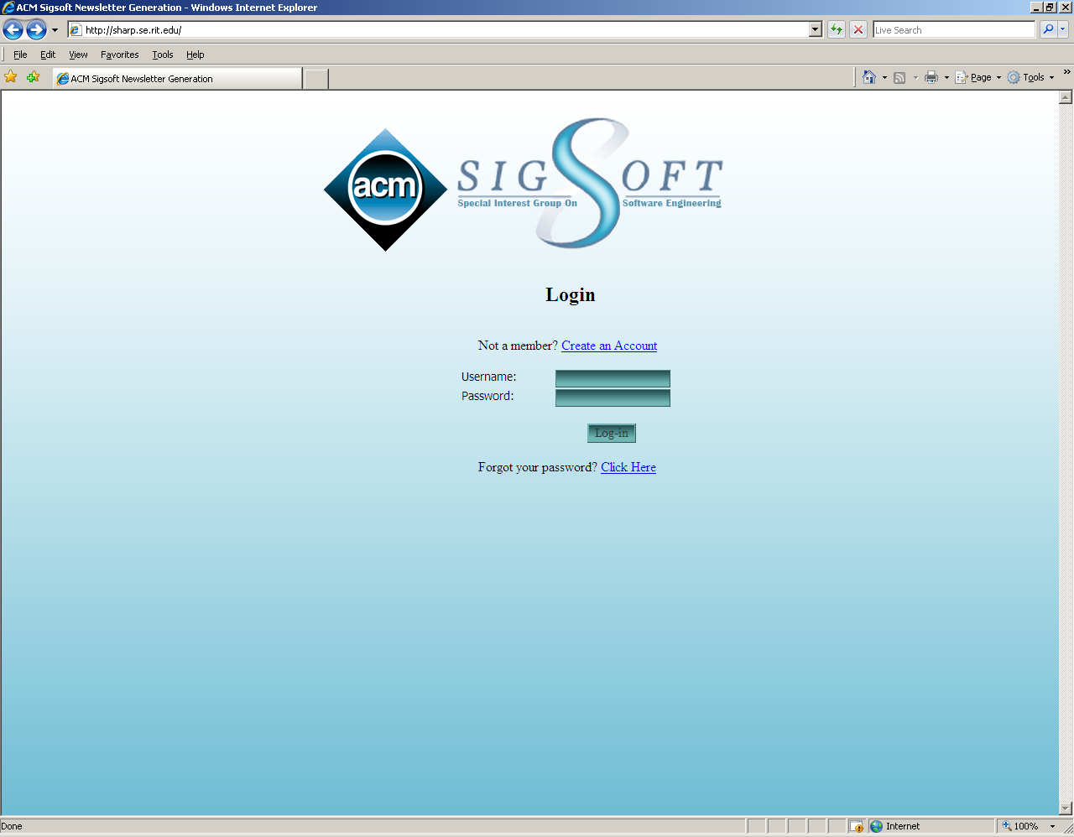

2.2. Edit Profile:

When you want to edit a profile you first must log into the system itself. Once logged in, you need to click on the edit profile tab from the main screen. After you are taken to the edit profile page you can update the desired fields and then once finished you must click on the update user button.

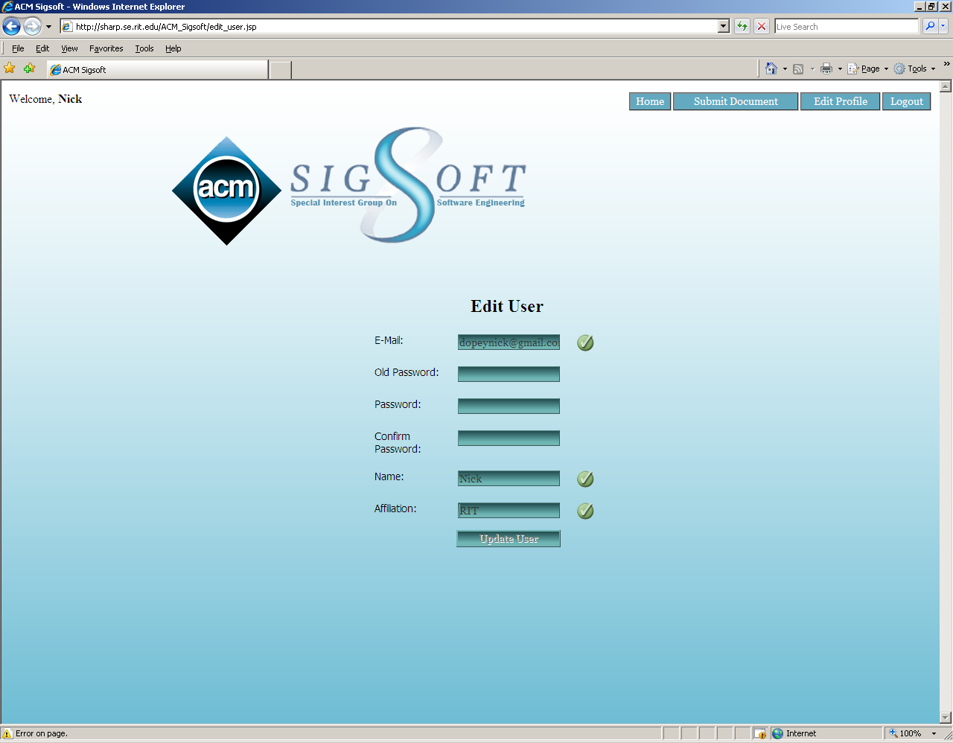

2.3. Submit Document:

When you desire to submit a document to the system, you first must log into the system. Once on the main screen you then click onto the Submit Document tab. After you are transferred to the submit document page you need to enter the document title and the document authors. Once the fields are filled in, you must select the type of document that you are putting into the system then you need to select the document from your file system. After everything is finished you just click the submit file button.

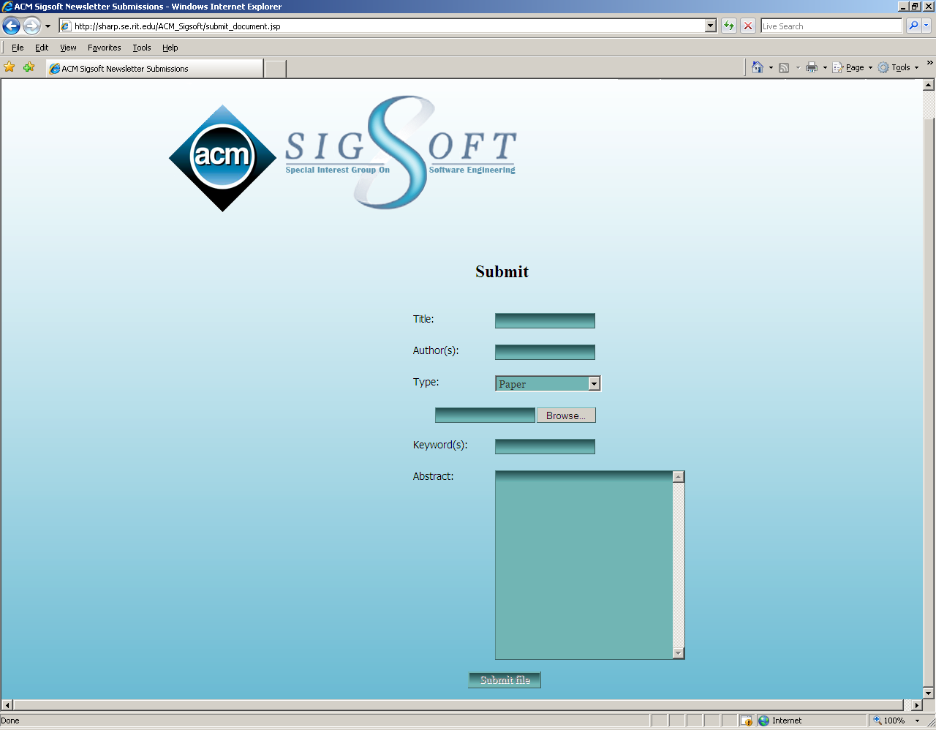

2.4. Download Document:
If you are trying to download a document from the system, you must be logged into the system. After successfully logging in, you can find the desired document in the document list at the main screen. Then all you have to do is click the Download button (Down facing arrow).

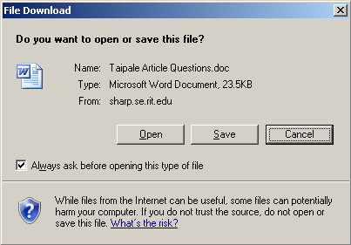

2.5. Update Document Metadata:

In order to update your document metadata, you need to be logged into the system. Then you need to locate the desired document that you want to update. After the document is located, you click on the view/edit metadata button. Next you would update the desired fields after you are taking to the correct page. Finally, you must click on the update button.

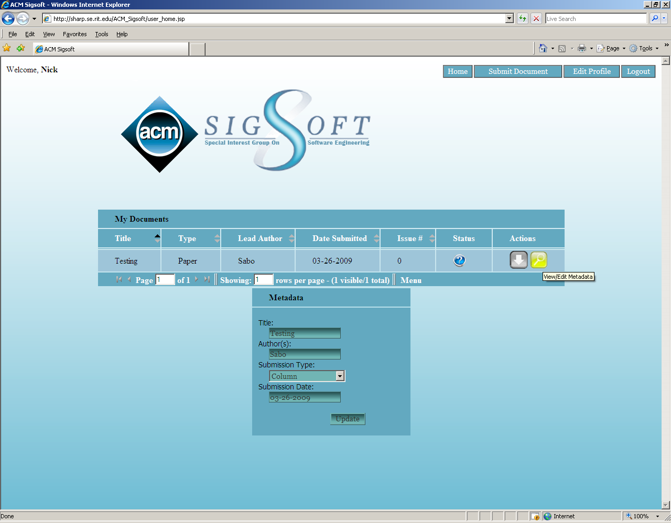

2.6. Send Notification:

If a notification is wished to be sent, you must be logged into the system as an admin/editor. Then from the main screen you must click on the user list button. Once you are taken to the user list, you can check any users in which you wish to send the notification. Then you must enter a title to the email and the body of the email and once finished you just click the send notification button.

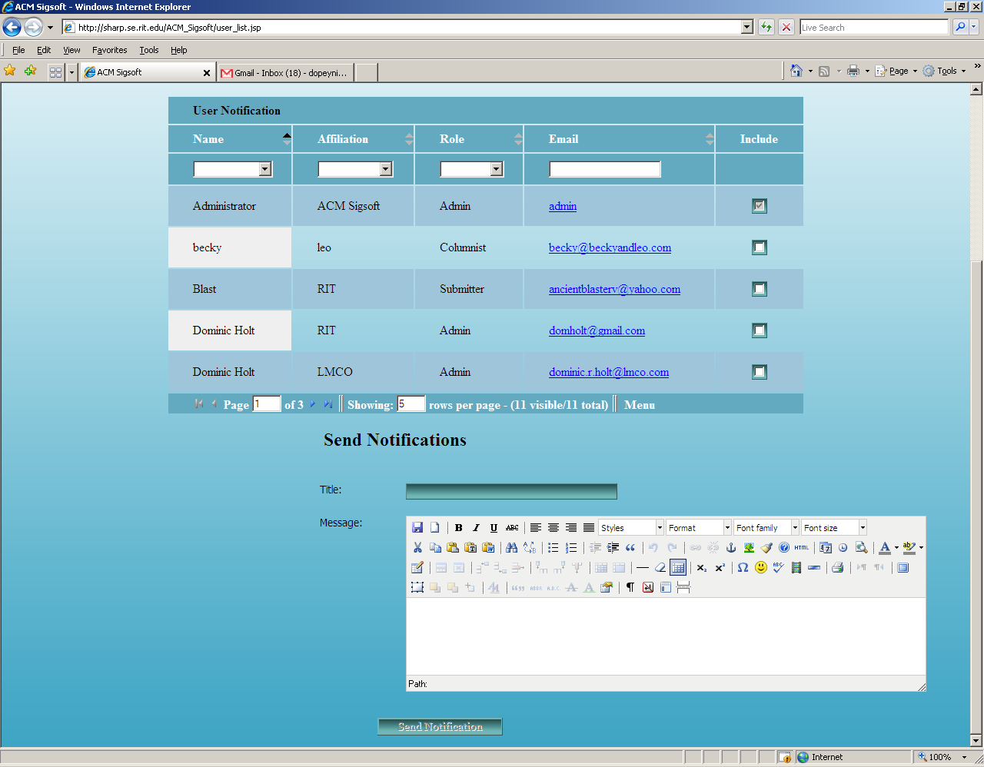

2.7. Change Issue for Document:

In order for you to change an issue for a document you must be logged into the system as an Admin/Editor. Then you just have to find the document in which you wish to update. Once located you click on the move to a different issue button and then you select the issue number you wish it to be. Finally you click on the update button.

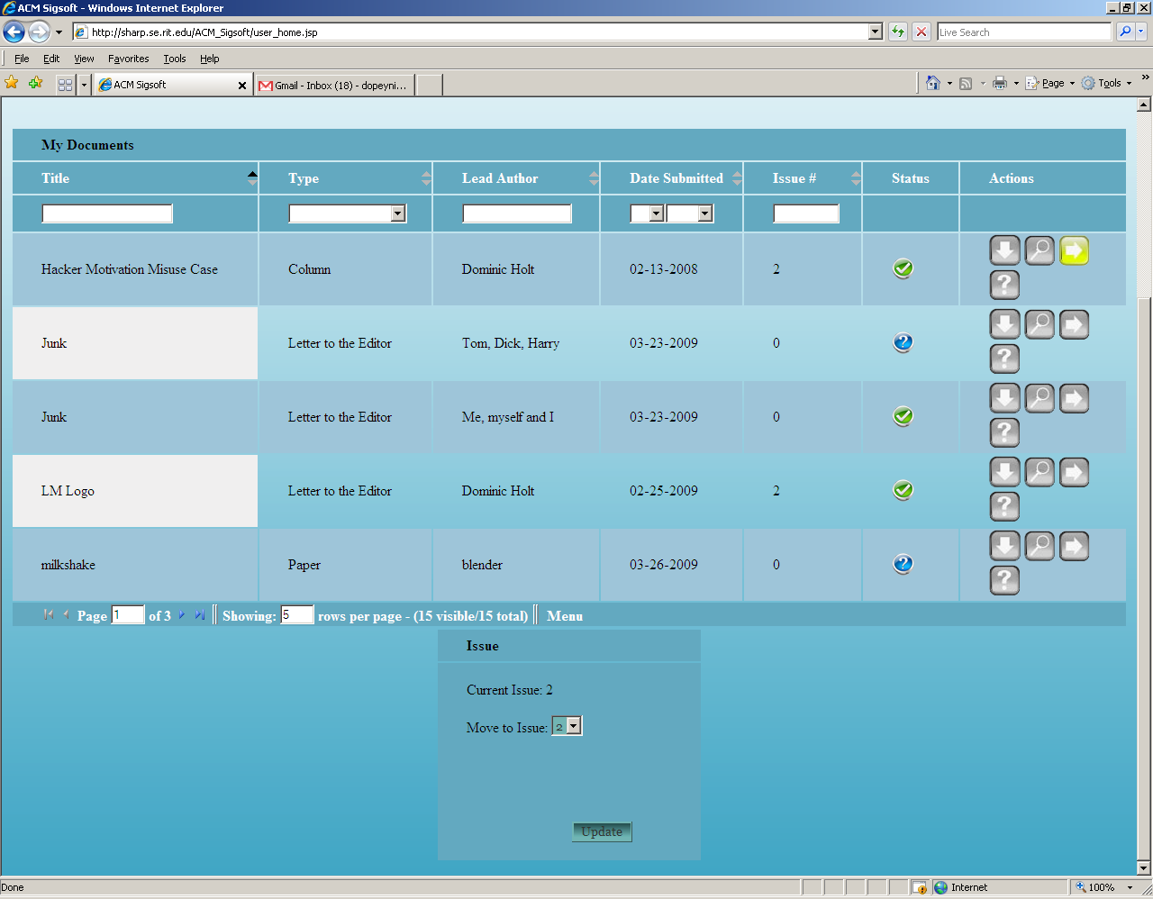

2.8. Sort Document List:

In order to sort the document list you must be logged into the system. Then you identify the column in wish you want to sort by. After it is found, you can click on the up or the down arrow to sort and if you wish to sort multiple columns you can just hold control and click the arrows.

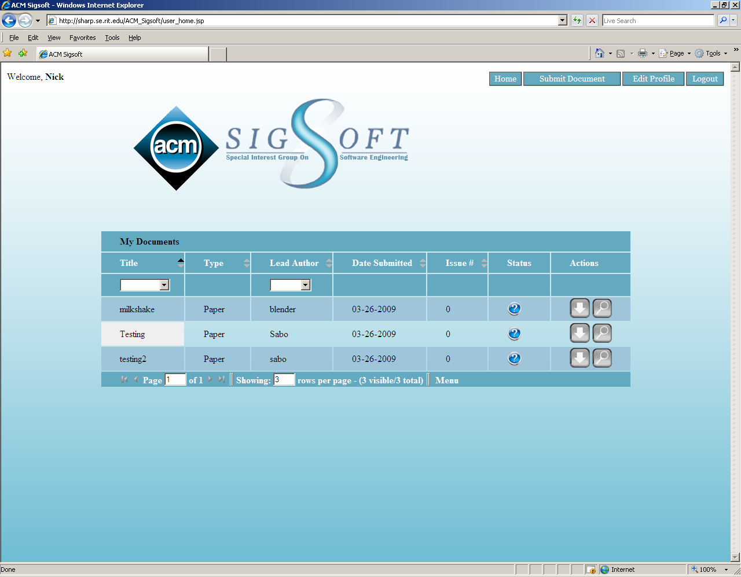

2.9. Filter Document List:

If you wish to filter a document, you have to be logged into the system. Then you can find the column in which you wish to filter. In order to filter you must select an item to filter by from the drop-down list provided.

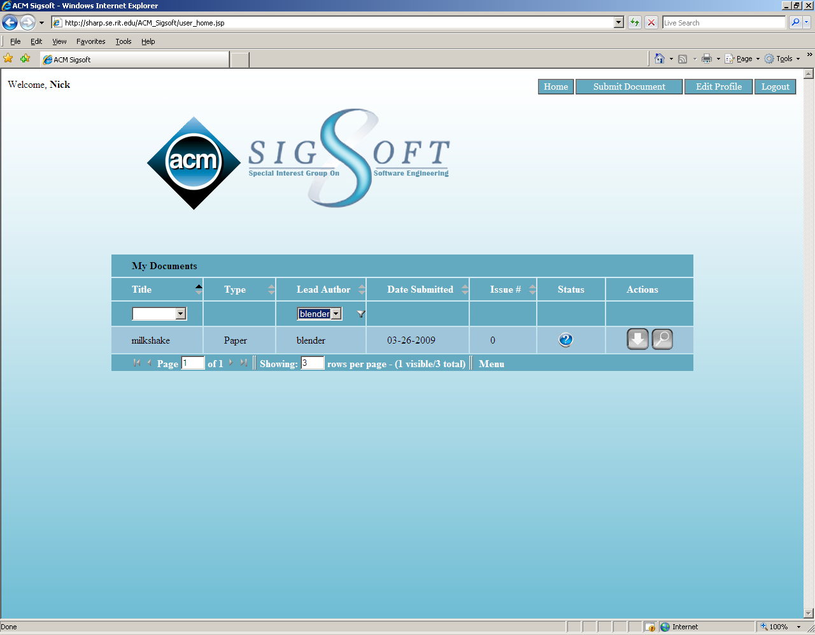

2.10. Issue Creation

Click the “Issue Creation” button in the menu in the top right hand corner. Select an issue number to generate an issue for. All accepted documents listed as a part of that issue will be included in generating the tables for that issue. A word document will be returned to the user to open or save on their file system.

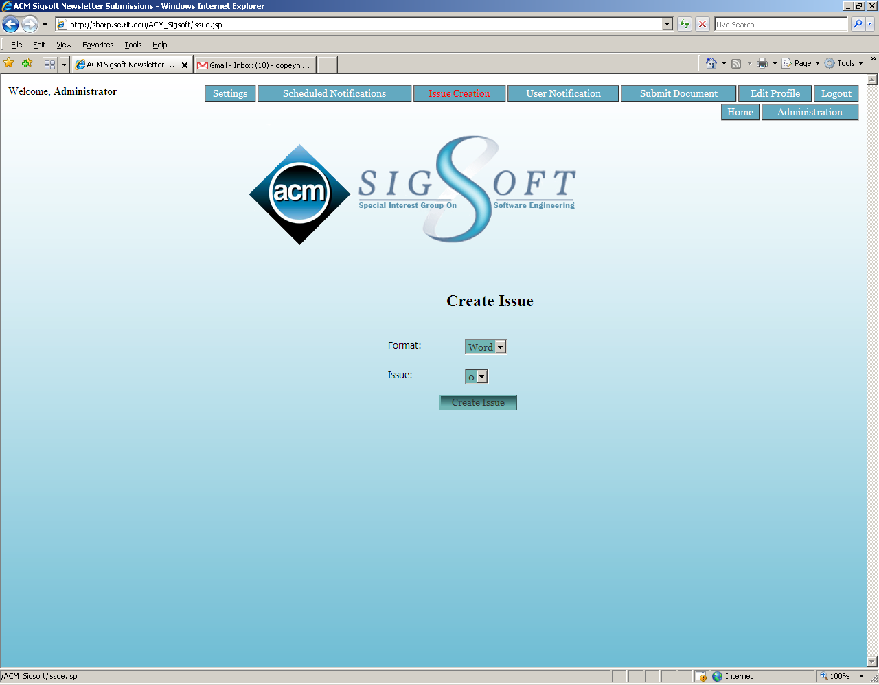

2.11. Remove User Accounts from System

Click the “Administration” button in the menu in the top right hand corner. Select the magnifying glass button next to a user you want to remove. Click the “Remove User” button in the right hand side of the screen.

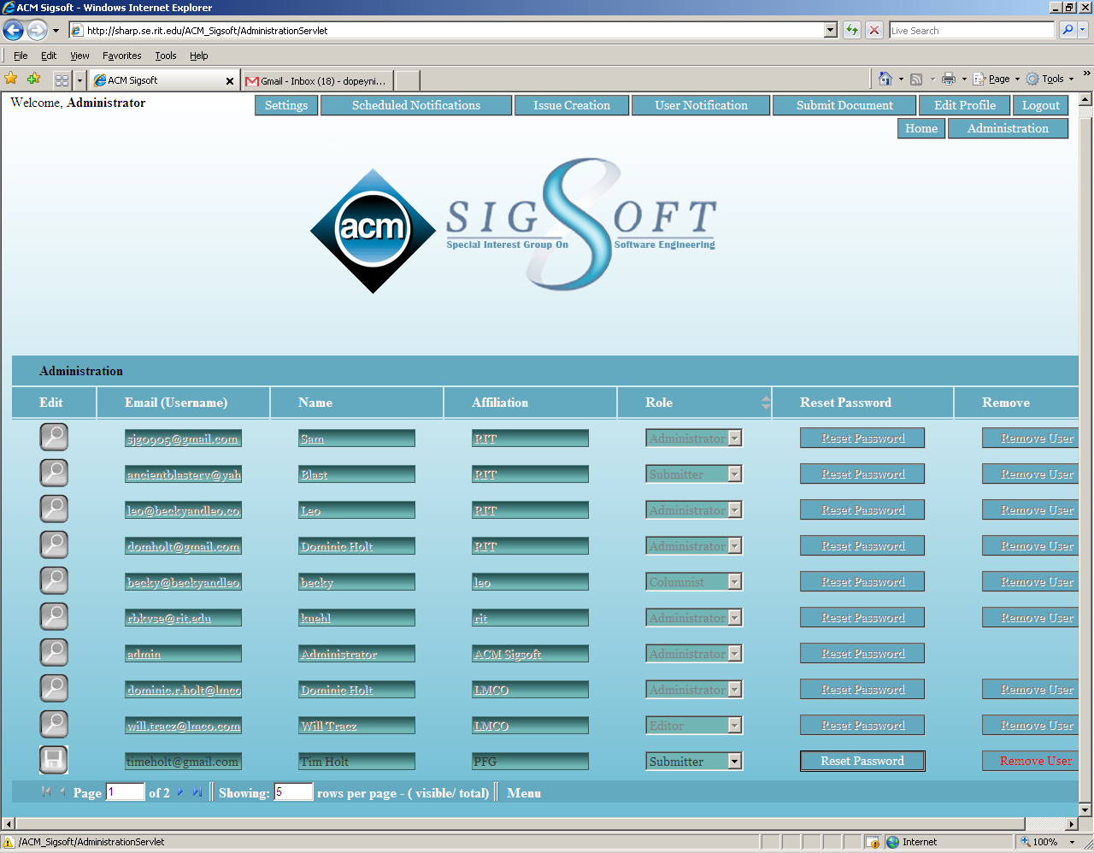

2.12. Edit info of User Accounts in the system

Click the “Administration” button in the menu in the top right hand corner. Select the magnifying glass button next to a user whose account information you would like to modify. You’ll notice the magnifying glass icon will change to a “save” icon. You can modify the Email, Name, Affiliation, and Role fields. You can also reset a user’s password. When you are finished modifying user information, click the “save” icon, which will turn back into the magnifying glass icon.

