Detail Design Document
For Session Management and Brainstorming in FACETs Mobile Toolset
Document Control

Document Information
Document | Information
Document Owner | Team6g
Issue Date | 06/23/2010
Last Saved Date | 11/13/2010
File Name | Detail Design Document

Document History
Version | Issue Date | Changes | Responsible
1.0 | 06/23/2010 | Initial document creation | Arnold King
1.1 | 06/30/2010 | Added Screens and filled out sections 1-3 | Ryan Chadwick
1.2 | 7/10/2010 | Finished filling out section 4, 7 | Ryan Chadwick
1.3 | 7/14/2010 | Filled out section 5, 6 | Ryan Chadwick

Table of Contents
1. Summary 4
2. Hardware Requirements 4
3. Software Requirements 5
4. Presentation Layer 5
4.1 Screens 6
5. Business Layer 24
6. Database Layer 24
7. Detailed Design to Functional Requirement Cross Reference Matrix 24

1. Summary
This document describes the detailed architectural design for the system. It specifies all known components needed to deliver a complete system.
The Brainstorming Mobile Tool will be broken down into 3 sub systems with a separate system being implemented that will be used in all other Facets mobile tools to handle Session Management.
The Session Management sub system is used to create, edit, and control the sessions. This sub system is the base launching point for any of the facets. It will have several generic properties and functions that will be needed for every Facet Mobile Tool. It will also include specific properties and functions for each Facet Mobile Tool that requires it.
The Brainstorming Facet Mobile Tool’s three sub systems include, Idea Generation, Grouping, and Voting/Results. Each of these sub systems will include a unique manner in which the user will view, interact with, and generate data. These will be controlled by a state based architecture in which as the moderator moves the session forward only one type of view/interaction will be available. This will occur in a specific order and will allow for moving forward and backward in this chain (shown below):
Idea Generation Grouping Voting/Results

2. Hardware Requirements
There will be a minimum of 2 hardware requirements for system usage.
The first requirement is a web server hosting the current Facets database and its support software. This web server should be capable of handling a moderate amount of transactional throughput on the order of several hundred (100-300) read and write requests per second maximum. The collaborative nature of this application as well as its possible growth requires that it be given enough resources to successfully handle a large numbers of transactions.
The second requirement is an Android smart phone or smart device. The device should have some form of wireless connection to a wireless provider for connection to the Facets server.

3. Software Requirements
The development environment is based around the Android SDK. We have chosen to use Eclipse as our IDE because the Android SDK includes an Eclipse plug-in to ease development. The android SDK is based in the Java language so the most recent Java SDK is also required for development.
Operation of the system requires SQL server for the Facets database. The Android app will not require any extra software to operate, besides actually downloading the app itself to the phone.

4. Presentation Layer
This section describes all the screens and reports needed to deliver all the functional requirements. Include screen descriptions, screen shots, report descriptions and report shots. The client should understand that the final product may not be exactly as listed here but the functionality will stay the same. During coding, we may merge or separate screens to achieve a nicer user interface and to promote reusability of components.

4.1 Screens

4.1.1 Create/Edit Session

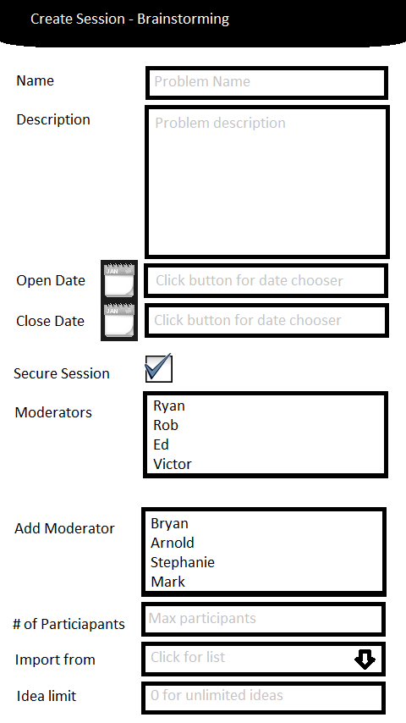
Description | This screen is meant for the creation of new Facets sessions as well as editing already created Facets sessions.
Security Group | Moderators
Data | - Name: This field is the name that the session will be referred to as by the database and users  - Description: This field is a simple description of what is trying to be achieved in the session  - Open Date: This is the date that the session will open to user interaction  - Close Date: This is the date the session will close to user interaction  - Secure Session: This toggles whether anonymous users can gain access to and contribute to the session  - Moderators: This is a list of all the moderators currently in control of the session  - Add Moderator: This is a list of all the available moderators to add to the session  - # of Participants: This will put a limit on the maximum number of people allowed to access the session  - Import: This option allows for selection of a previous session of the same type for importation of all data  - Idea Limit: This option puts a maximum limit on how many ideas can be generated in the session between all users or on a per user basis
Actions | This screen will have two popup menu options.  - Apply changes: This will create a new session if the screen is reached from a create session link or it will update a previously created session if it is reached from an edit link  - Cancel changes: All changes will be discarded

4.1.2 Session List

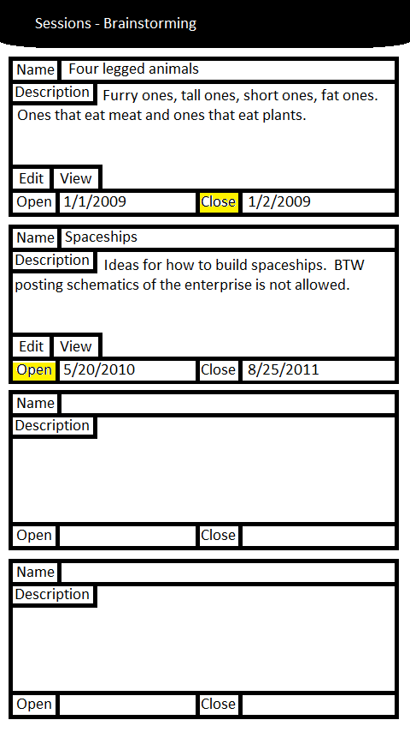
Description | This screen is an outline of all created sessions and their most important properties
Security Group | Moderators, Users
Data | Per each entry:  - Name: This is the name for this session  - Description: This is the description of the objectives for this session  - Open: This is the date that the session will open to user interaction  - Close: This is the date that the session will close to user interaction
Actions | This screen will have four action options on each entry.  - Clicking Edit: as a moderator will take you to a session screen 4.1.1 where changes can be made. Nothing will happen as a User.  - Clicking View: as a moderator and user will take you to screen 4.1.4, 4.1.6, or 4.1.9 depending on the state of the session  - Clicking Open: this will immediately open the session to user interaction and replace the open date with the current time as of clicking the button  - Clicking Close: this will immediately close the session to user interaction and replace the close date with the current time as of clicking the button

4.1.3 Teaser List

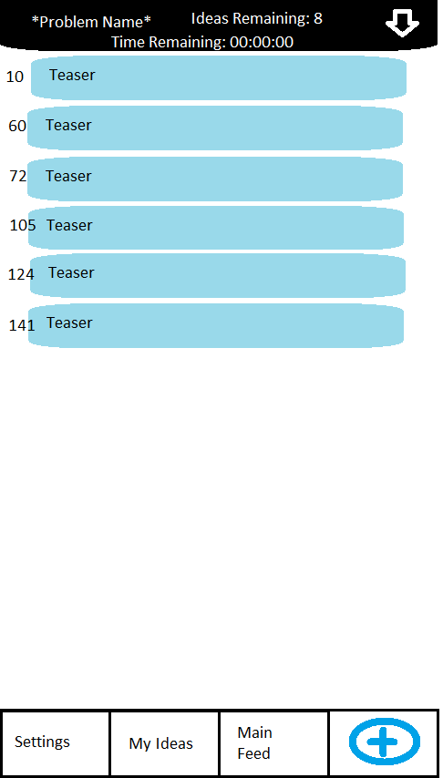
Description | This screen lists all the teasers created by moderators for users to view.
Security Group | Moderators, Users
Data | - Problem Name: The name of this session  - Time Remaining: The time remaining before this session closes  - Ideas Remaining: The ideas remaining before this session closes, or ideas remaining for the user to generate  - Teaser Entries: All of these entries are special teaser data entries, not ideas, they are created by moderators for users to view
Actions | There are four menu options for this screen.  - Settings: This will open a dialog for the user to select simple setting options like font size  - My Ideas: This will take the user to screen 4.1.5  - Main Feed: This will take the user to screen 4.1.4  - Add a Teaser: This will only be available to moderators and will allow seeding new teasers

4.1.4 Main Idea List

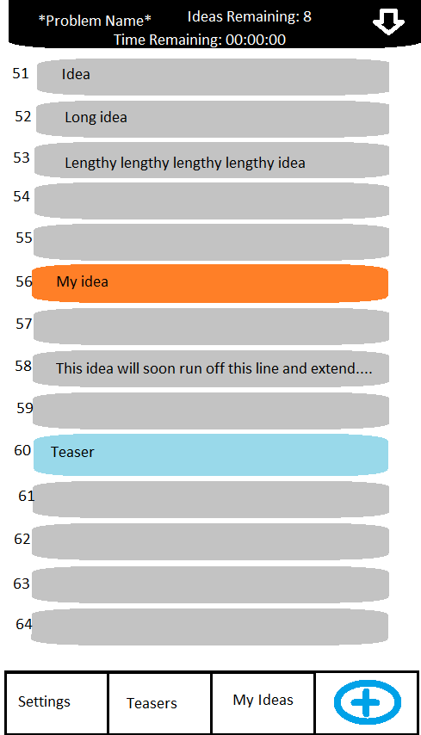
Description | This screen shows all ideas and teasers in chronological order
Security Group | Moderator, User
Data | - Problem Name: The name of this session  - Time Remaining: The time remaining before this session closes  - Ideas Remaining: The ideas remaining before this session closes, or ideas remaining for the user to generate  - Data Entries: These entries are either ideas or teasers. Teasers will show up blue and ideas grey. Ideas generated by the user will show up orange.
Actions | There are four menu options for this screen.  - Settings: This will open a dialog for the user to select simple setting options like font size  - My Ideas: This will take the user to screen 4.1.5  - Teasers: This will take the user to screen 4.1.3  - Add an Idea: This will open a dialog for adding a new idea

4.1.5 My Ideas List

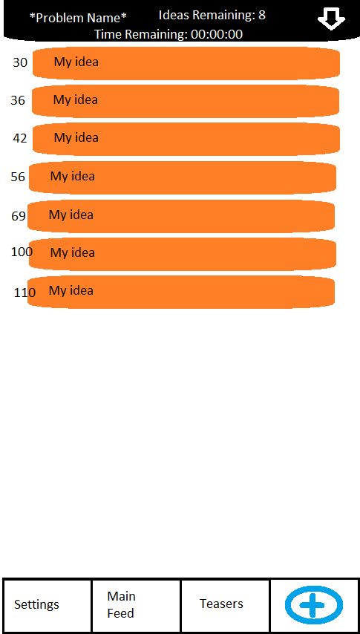
Description | This screen is a list of ideas generated solely by the user logged in
Security Group | Moderator, User
Data | - Problem Name: The name of this session  - Time Remaining: The time remaining before this session closes  - Ideas Remaining: The ideas remaining before this session closes, or ideas remaining for the user to generate  - Idea Entries: These entries are ideas generated by the current user
Actions | There are four menu options for this screen.  - Settings: This will open a dialog for the user to select simple setting options like font size  - Main Feed: This will take the user to screen 4.1.4  - Teasers: This will take the user to screen 4.1.3  - Add an Idea: This will open a dialog for adding a new idea

4.1.6 Group List

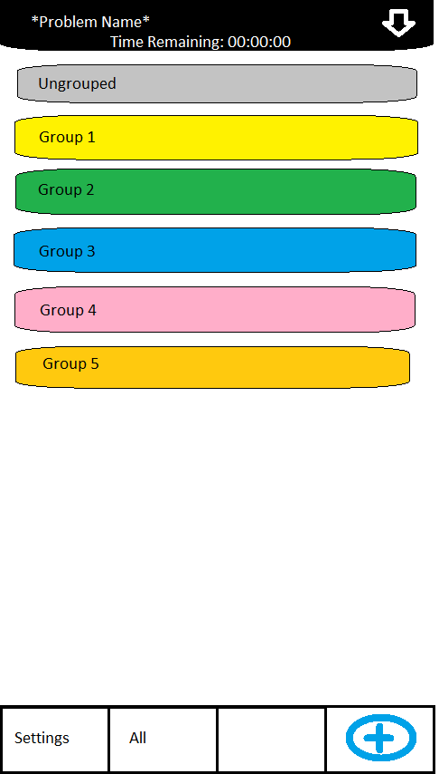
Description | This screen allows moderators to view all created idea groups for the session
Security Group | Moderator
Data | - Problem Name: The name of this session  - Time Remaining: The time remaining before this session closes  - Group Entries: These entries are groups created by a moderator
Actions | There are three menu options for this screen and one action for clicking on a group.  - Settings: This will open a dialog for the user to select simple setting options like font size  - All: This will take the user to screen 4.1.7  - Add a Group: This will open a dialog for adding a new group  - Clicking a Group: This will take the user to screen 4.1.8 populated with data for the group selected

4.1.7 Grouped Idea List

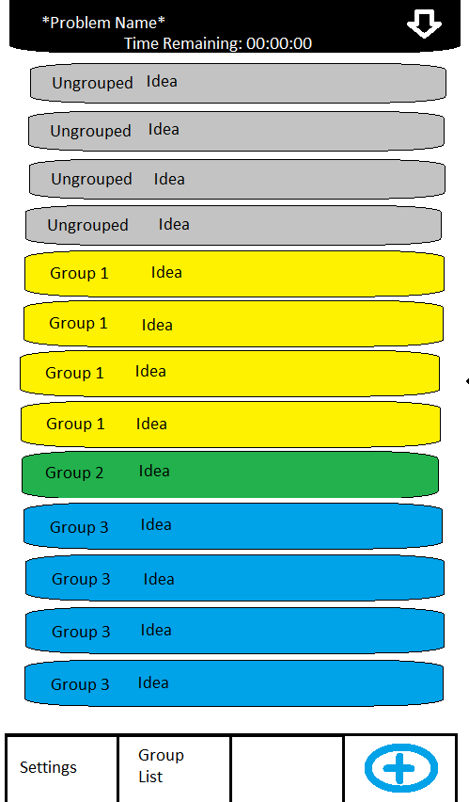
Description | This is a list of all ideas ordered by group
Security Group | Moderator
Data | - Problem Name: The name of this session  - Time Remaining: The time remaining before this session closes  - Idea Entries: These entries are ideas created by a user and are displayed in order by group that they are affiliated with
Actions | There are three menu options for this screen and one action for clicking on an idea.  - Settings: This will open a dialog for the user to select simple setting options like font size  - Group List: This will take the user to screen 4.1.6  - Add a Group: This will open a dialog for adding a new group  - Clicking an Idea: This will open a dialog for assigning or changing an assigned group for the selected idea

4.1.8 Ideas In a Group List

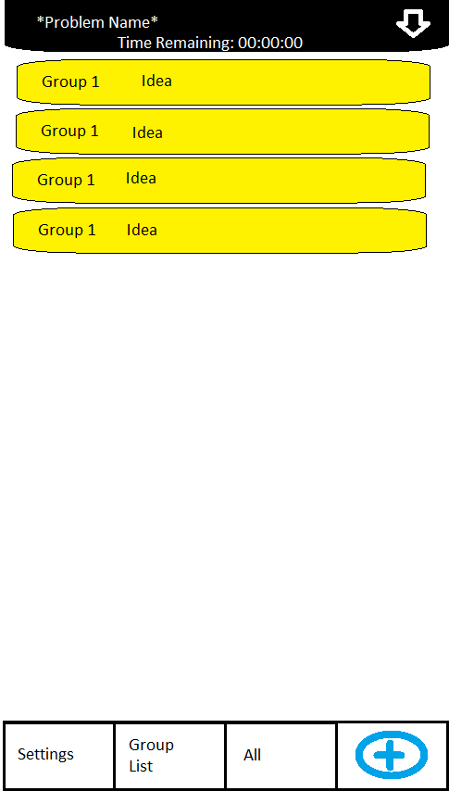
Description | This screen is a list of ideas in a single group
Security Group | Moderator
Data | - Problem Name: The name of this session  - Time Remaining: The time remaining before this session closes  - Idea Entries: These entries are ideas that were generated by users and are only displayed if they are in the selected group filter
Actions | There are four menu options for this screen and one action for clicking on an idea.  - Settings: This will open a dialog for the user to select simple setting options like font size  - Group List: This will take the user to screen 4.1.6  - All: This will take the user to screen 4.1.7  - Add a Group: This will open a dialog for adding a new group  - Clicking an Idea: This will open a dialog for assigning or changing an assigned group for the selected idea

4.1.9 Voting Screen

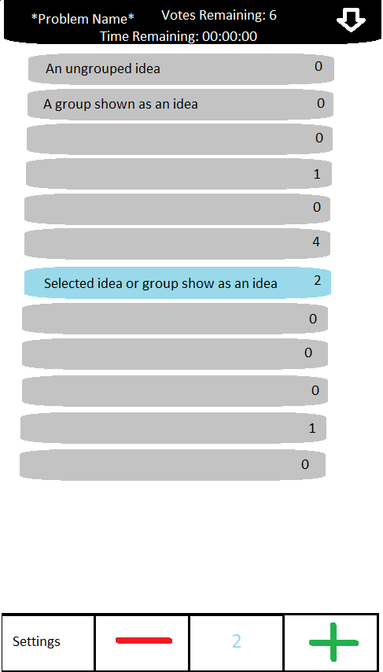
Description | This screen is used for voting on ideas and groups of ideas
Security Group | Moderator, User
Data | - Problem Name: The name of this session  - Time Remaining: The time remaining before this session closes  - Votes Remaining: The votes remaining for the user to allocate to an idea or group of ideas  - Idea or Group Entries: These entries are either ideas that were not added to groups or a group of ideas. The groups will be displayed as one idea in order to hide multiplicity  - Idea Count: The block at the bottom of the screen that shows the ideas allotted to the selected idea or group
Actions | There are three menu options for this screen and one action for clicking on an idea.  - Settings: This will open a dialog for the user to select simple setting options like font size  - Add Vote: This will add a vote to the selected idea or group and subtract one from the remaining votes for the user  - Remove Vote: This will remove a vote from the selected idea or group and add one to the remaining votes for the user  - Clicking an Idea: This will highlight the idea and update the current votes block on the bottom of the screen

4.1.10 Voting Results Screen

Put screenshot here
Description | This screen is a list of ideas and idea groups sorted by amount of votes received. The idea or group with the most votes at the top.
Security Group | Moderator
Data | Each entry will list the idea or group and the amount of votes it received.
Actions | There are no actions available at the screen.

4.1.11 Ideas by a User Screen

Put screenshot here
Description | This screen displays ideas generated by a specific user of choice
Security Group | Moderator
Data | This screen will display the name of the user whose ideas are being reviewed as well as their idea entries
Actions | There is one action available on this screen. Changing the filter based on the name of a user will result in a different users ideas being displayed

5. Business Layer
Define all of the objects necessary to support the presentation layer.
Figure 1: Activity Hierarchy

Figure 2: Database Tasking Pool

Figure 3: Phasing Logic
Figure 4: Session Management

Figure 5: Node Data Storage

6. Database Layer
No change to the database from previous projects has been made for the Session Management and Brainstorming FACETs Mobile tools.

7. Detailed Design to Functional Requirement Cross Reference Matrix
To ensure all functional requirements have been captured in the detailed design, cross-reference each functional requirement with it’s associated Detailed Design element.

Functional Requirement | Detail Design
Session Management  Sessions  GEN: 1-16, 19, 20, 23, 25  UI: 8  Brainstorm FACET  Idea Generation  GEN: 17, 18, 21, 22, 24  UI: 1, 2, 5, 6, 7, 9, 11, 12, 13  BS: 1-6, 8, 10, 14, 21  Grouping  UI: 5, 6  BS: 4, 7, 8, 9, 10, 13, 15, 16  Voting  UI: 5, 6, 9  BS: 12, 17, 18, 19, 22, 23  Results  UI: 4, 20  Application (ALL):  UI: 10  BS: 11, 24 | Screen 4.1.1 Create/Edit Session  Screen 4.1.2 Session List  Screen 4.1.3 Teaser List  Screen 4.1.4 Main Idea List  Screen 4.1.5 My Idea List  Screen 4.1.6 Group List  Screen 4.1.7 Grouped Idea List  Screen 4.1.8 Ideas in a Group List  Screen 4.1.9 Voting Screen  Screen 4.1.10 Voting Results Screen  Screen 4.1.11 Ideas By a User Screen

